Performance Stabilization of Lithium Sulfur Batteries Containing Sulfolane-based Electrolyte and Microporous Cathode by Controlling Working Voltage
Supplementary Information
Takeshi Tonoya ª, Yukiko Matsui ª, Hidenori Hinago ^{b}, Masashi Ishikawa ^{a,}*
ª Department of Chemistry and Materials Engineering, Faculty of Chemistry, Materials and Bioengineering, Kansai University, 3-3-35 Yamate-cho, Suita 564-8680, Japan
^{b} Asahi Kasei Corporation, 1-1-2 Yuraku-cho, Chiyoda-ku, Tokyo 100-0006, Japan
*E-mail address: masaishi@kansai-u.ac.jp (M. Ishikawa).

Figure S1 shows the effects of different operating voltage ranges on the positive and negative electrode potentials of Li-S batteries. Here, the voltage ranges of 1.4–3.4 V and 1.0–3.4 V were selected to confirm the influence of the lower voltage limit during discharge. A 1.0 V cutoff resulted in a large overpotential of the Li metal anode after approximately 10 cycles, whereas a 1.4 V cutoff provided a constant small overpotential throughout the cycle.
When the overpotential increased, the Li metal deposition morphology at the Li metal anode was observed using optical microscopy and SEM. Figure S2 shows the optical images of the Li metal anode and separator at the 5th and 20th cycles. Figure S3 shows the SEM image of the Li metal anode during the 20th cycle. For 5 cycles Li metal anode showed no difference in appearance at different working voltages. However, according to the optical image taken during the 20th cycle, the appearance of the Li metal was different. Furthermore, at the 1.0 V cutoff, the separator showed an apparent yellow coloration. This yellow coloration of the separator may be due to Li polysulfide, and such S species were leached from the pores of the activated carbon by discharging to 1.0 V.
The formation of Li precipitates was confirmed using SEM. Although differences were observed between the black and silver portions depending on the voltage range, a similar deposition pattern was observed regardless of the voltage range. Li metal precipitated in the form of moss in the black part and in the form of particles in the silver part.
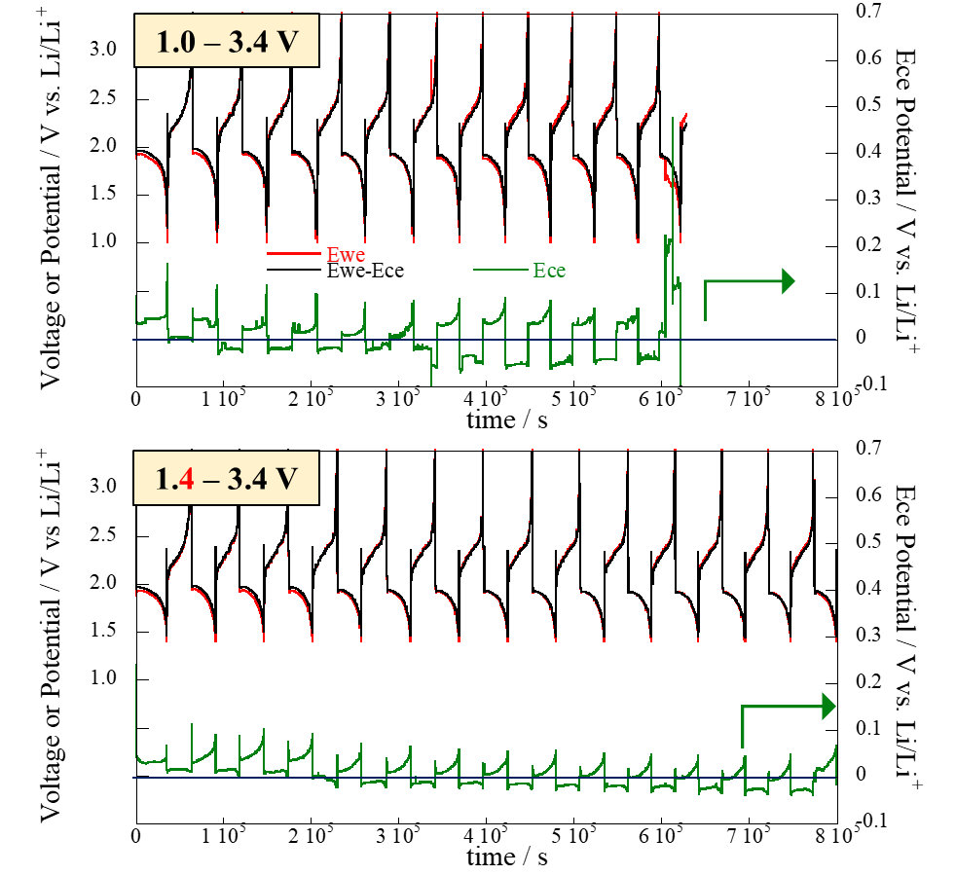

Figure S1. Potentials of cathode and anode and cell voltages of Li-S batteries with different voltage ranges.

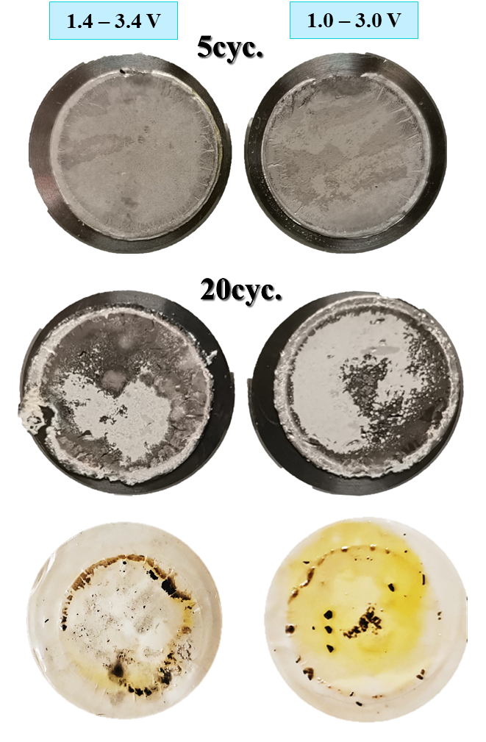
Figure S2. Photographs of Li metal anode and separator after 5 and 20 charge/discharge cycles with different voltage ranges

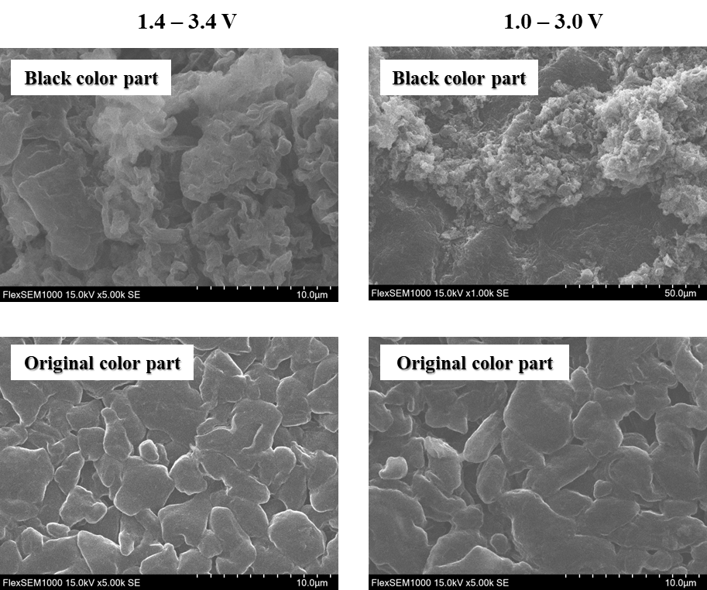
Figure S3. SEM images of black- and original- colored portions of Li metal anode after 20 charge/discharge cycles with different voltage-range operation.

