Supporting information for

Confinement Effects on the Rate Performance of Redox Active Molecules for Pseudocapacitive Flowable Electrodes

Daisuke TAKIMOTO,a,††,\*,§ Keisuke SUZUKI,b, Sho HIDESHIMA,a,b,†††,§ and Wataru SUGIMOTOa,b,§§

a Research Initiative for Supra-Materials (RISM), Shinshu University, 3-15-1 Tokida, Ueda, Nagano 386-8567, Japan

b Department of Chemistry and Materials, Faculty of Textile Science and Technology, Shinshu University, 3-15-1 Tokida, Ueda, Nagano 386-8567, Japan

\*Corresponding author: daitaki@sci.u-ryukyu.ac.jp

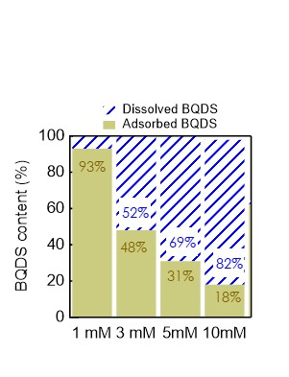

Figure S1. Ratio of adsorbed BQDS and dissolved BQDS for BQDS(*n* mM)/AC2 (*n* = 1, 3, 5, and 10). AC2 is micropore-rich steam-activated carbon (YP-50F, Kuraray).



Figure S2. Changes in the anodic and cathodic peak currents as a function of scan rate of (a) BQDS(1 mM)/AC, (b) BQDS(3 mM)/AC, (c) BQDS(5 mM)/AC, and (d) BQDS(10 mM)/AC dispersed in 0.5 M H2SO4.



Figure S3. Changes in the anodic and cathodic peak currents as a function of the square root of scan rate of (a) BQDS(1 mM)/AC, (b) BQDS(3 mM)/AC, (c) BQDS(5 mM)/AC, and (d) BQDS(10 mM)/AC dispersed in 0.5 M H2SO4.

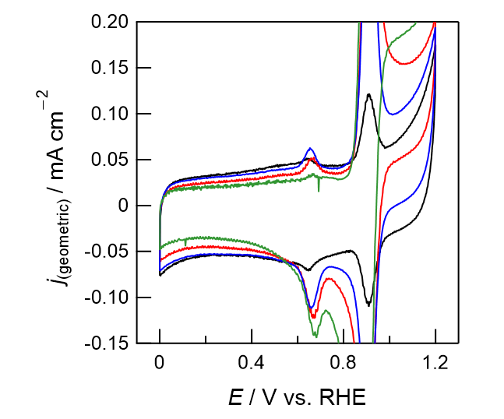

Figure S4. Cyclic voltammogramsof (a) BQDS(1 mM)/AC (black), (b) BQDS(3 mM)/AC (red), (d) BQDS(5 mM)/AC (blue), and (d) BQDS(10 mM)/AC (green) dispersed in 0.5 M H2SO4 at a scan rate of 5 mV s−1.