Supporting Information

**β-Scission by Direct Electrochemical Oxidation: Proton-coupled Electron Transfer Mechanism Dictated by Synthetic Study and Computation**

Rumi IZUMIYA,a Mahito ATOBE,*a,§ and Naoki SHIDA*a,§

*a* Graduate School of Science and Engineering, Yokohama National University

79-5 Tokiwadai, Hodogaya-ku, Yokohama 240-8501, Japan

*Corresponding Author: shida-naoki-gz@ynu.ac.jp (N.S.), atobe@ynu.ac.jp (M.A.)

§ ECSJ Active Member

ORCID:

Mahito ATOBE: 0000-0002-3173-3608, Naoki SHIDA: 0000-0003-0586-1216

**Table of Contents**

*General considerations S2*

*Synthetic Procedures S3*

*Supplementary data S4*

*Supporting references S20*

**1. General Consideration**

The chemicals and solvents were purchased from commercial sources and used without further purification. Nuclear magnetic resonance (NMR) spectroscopy measurements were performed on JEOL ECA500 (1H: 500 MHz) using CDCl3 solvent. The chemical shifts for 1H NMR spectra are given in δ (ppm) relative to internal tetramethylsilane, deuterated solvent, respectively. Multiplicities are abbreviated as singlet (s), doublet (d), doublet of doublets (dd), doublet of triplets (dt), multiplet (m). Benzaldehyde was used as the internal standard to calculate NMR yield after electrolysis. Thin layer chromatography was performed on Merck TLC glass plates (silica gel 60 F254) or Merck TLC aluminum sheets (silica gel 60 F254) and visualized under UV light (254 nm). Column chromatography was performed using silica gel 60 N (Kanto Chemical Co., particle size 63-210 μm), or using Biotage® Selekt Flash Purification System with pre-packed silica columns (Biotage® Sfär Silica HC D, 20 μm spherical particles). High-performance liquid chromatography (HPLC) was performed on a Shimadzu prominence system equipped with a UV/Vis detector (Shimadzu SPD-20A Prominence). Reverse phase HPLC column Mightysil RP-18GP II 250-4.6 (5 µm) from Kanto Chemical Co. was used for the analysis. Data was processed with Shimadzu Lab Solutions Version 5.106 software. All samples were run using CH3CN (0.1% deionized water, DIW) with a flow rate of 1.0 mL min–1. Electrochemical reactions and measurements were performed with Bio-Logic VSP-3e Potentiostats. Cyclic voltammetry (CV) simulations were performed using the DigiElch 8 software package (Elchsoft).

**2. Synthetic Procedures**

*2-1. Synthesis of* ***BK***

**

BK was synthesized according to the reported procedure.1 4’-methoxyphenacyl bromide (0.8796 g, 3.84 mmol, 1.0 eq.) was added to a stirred solution of K2CO3 (0.796 g, 5.76 mmol, 1.5 eq.) and 4-fluorophenol (0.473 g, 4.22mmol, 1.1 eq.) in acetone (40 mL). The reaction mixture was stirred and heated to reflux at 60 °C in an oil bath for 2 h. After cooling down to room temperature, the mixture was filtered off and concentrated under vacuum. The residue was dissolved in CH2Cl2 and washed with saturated aqueous NaHCO3, then the organic layer was dried over MgSO4, filtered, and concentrated under reduced pressure. The crude solid was recrystallized from hexane, and obtained crystal was washed with diethyl ether to afford **BK** as a white solid (0.843 g, 85%). 1H NMR spectrum corresponded to the reported data.1

**BK**: 1H NMR (500 MHz, CHLOROFORM-D) δ 8.02 – 7.94 (m, 2H, Ar), 7.00 – 6.92 (m, 4H, Ar), 6.92 – 6.83 (m, 2H, Ar), 5.18 (s, 2H, -C*H*2-Ar), 3.88 (s, 3H, -OC*H*3).

*2-2. Synthesis of* ***BA***

**

**BA** was synthesized according to the reported procedure.1 **BK** (7.385 g, 28.36 mmol, 1.0 eq.) was dissolved in the mixture of THF/H2O (v/v=4/1, 50 mL), and NaBH4 (1.609 g, 42.54 mmol, 1.5 eq.) was added portionwise to maintain a gentle evolution of gas. Then the mixture was stirred for 2 h at room temperature. The reaction mixture was quenched with saturated aqueous NH4Cl (50 mL) and diluted with water. The aqueous portion was extracted with CH2Cl2. The combined organic layers were dried over MgSO4, filtered and concentrated under vacuum to afford BA as a colorless oil (7.284 g, 98%). 1H NMR spectrum corresponded to the reported data.1

**BA**: 1H NMR (500 MHz, CHLOROFORM-D) δ 7.40 – 7.34 (m, 2H, Ar), 7.04 – 6.89 (m, 4H, Ar), 6.89 – 6.82 (m, 2H, Ar), 5.06 (ddd, J = 8.7, 3.3, 2.4 Hz, 1H, -C*H*(-OH)-Ar), 4.03 (dd, J = 9.5, 3.3 Hz, 1H, -CH(-OH)-C*H*2-OAr), 3.96 (dd, J = 9.5, 8.7 Hz, 1H, -CH(-OH)-C*H*2-OAr), 3.82 (s, 3H, -OC*H*3), 2.67 (d, J = 2.4 Hz, 1H, -O*H*).

**3. Supplementary Data**

*3-1. Bulk electrolysis*

The reaction was performed in a divided cell with a glass frit equipped with gold, platinum or glassy carbon plate (2 cm × 2 cm) as an anode, platinum plate (2 cm × 2 cm) as a cathode, and Ag/AgNO3 as a reference electrode. A solution of 0.1 M supporting electrolyte in acetonitrile was used as an electrolyte. To the anodic chamber were added substrate **BA** (0.1 mmol), base, and 10 mL of electrolyte solution. To the cathodic chamber was added 10 mL of electrolyte solution. Bulk electrolysis was performed at room temperature with the application of constant current of 2 mA (0.5 mA cm–2). After the reaction was completed, the anodic solution was collected, and the solvent was removed under reduced pressure. The crude products were extracted with CDCl3 and subjected to 1H NMR analysis to determine the molar amount of products and starting material, respectively.

*3-2. CV measurement*

A gold disk, a platinum disk or a glassy carbon disk (φ = 3 mm) was used as a working electrode and platinum plate (1 cm × 1 cm) as a counter electrode. Ag/AgNO3 was used as a reference electrode. The working electrode was polished for 60 seconds using 0.1 and 1 µm alumina and rinsed with deionized water in an ultrasonic bath before measurements. N2 gas was sparged to a solution of 0.1 M supporting electrolyte in acetonitril for 10-30 minutes and used as an electrolyte. After measuring the background, 5 mM of substrates were added, and measurements were performed.

*3-3. Characterization of products from entry 7, Table 1*

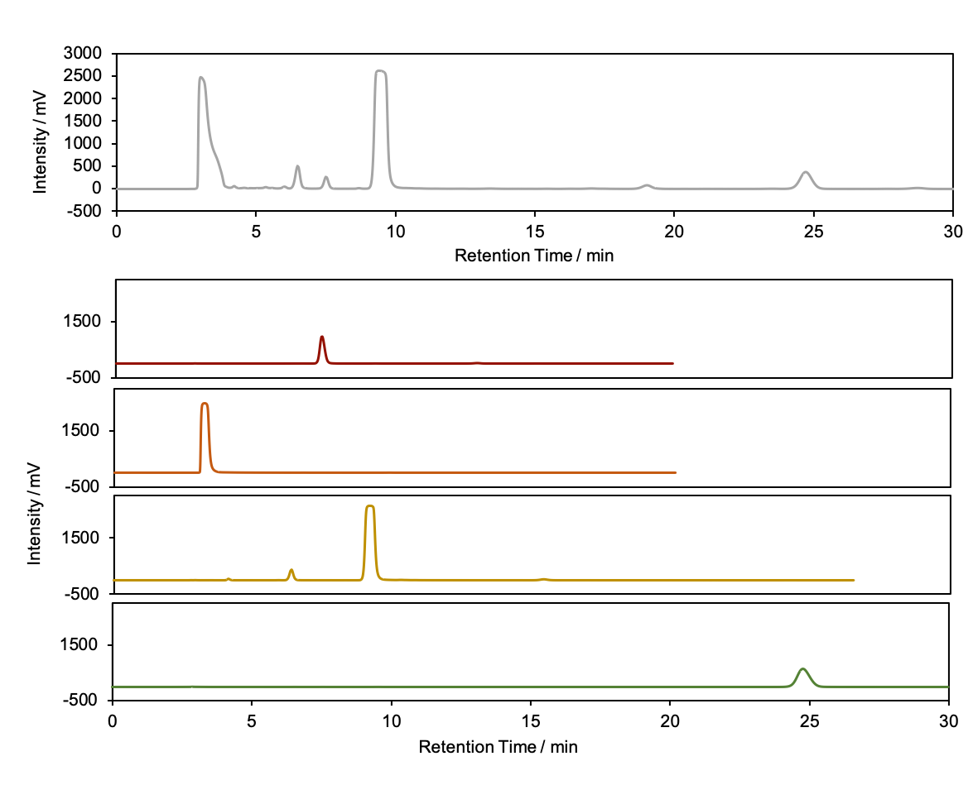

***p*-fluorophenol**

**collidine**

***p*-anisaldehyde**

**BA**

(a)

(b)

Figure S1. (a) HPLC chromatogram of the desalted solution after the electrolysis under the optimal condition. Experimental conditions: substrate, 10 mM of BA, 20 mM of collidine; Electrolyte, CH3CN/TFE (v/v=12/1) solution containing 0.1 M of LiTfO; Driving electrode, Au plate (2 cm×2 cm); Current density, 0.5 mA cm-2; Current passed, 1 F mol-1. (b) HPLC chromatograms of the pure products obtained from commercial sources and purified BA.



Figure S2. 1H NMR full spectrum of the desalted solution after the electrolysis under the optimal condition and expansion of the aromatic region. Experimental conditions: substrate, 10 mM of BA, 20 mM of collidine; Electrolyte, CH3CN/TFE (v/v=12/1) solution containing 0.1 M of LiTfO; Driving electrode, Au plate (2 cm×2 cm); Current density, 0.5 mA cm-2; Current passed, 1 F mol-1.

*3-4. Detection of formaldehyde*

Since formaldehyde was possibly generated with the formation of fluorophenol, detection of formaldehyde in the solution after the reaction was attempted. The detection was performed using dimedone. The condensation product of dimedone and formaldehyde is poorly soluble and obtained as precipitate in water. In this system, *p*-anisaldehyde should be also detected in addition to formaldehyde. Experiments were conducted based on previously report.2 As shown in Fig. S3, formaldehyde in dimedone adduct form (formaldemethone) was detected, and also *p*-anisaldehyde with another dehydration.

**

Scheme S1. Detection of aldehyde with dimedone

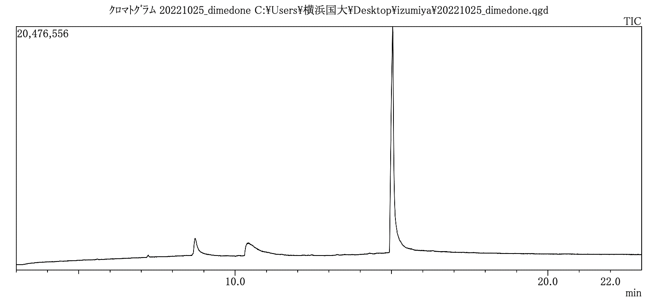

Figure S3. GC spectra of the precipitates

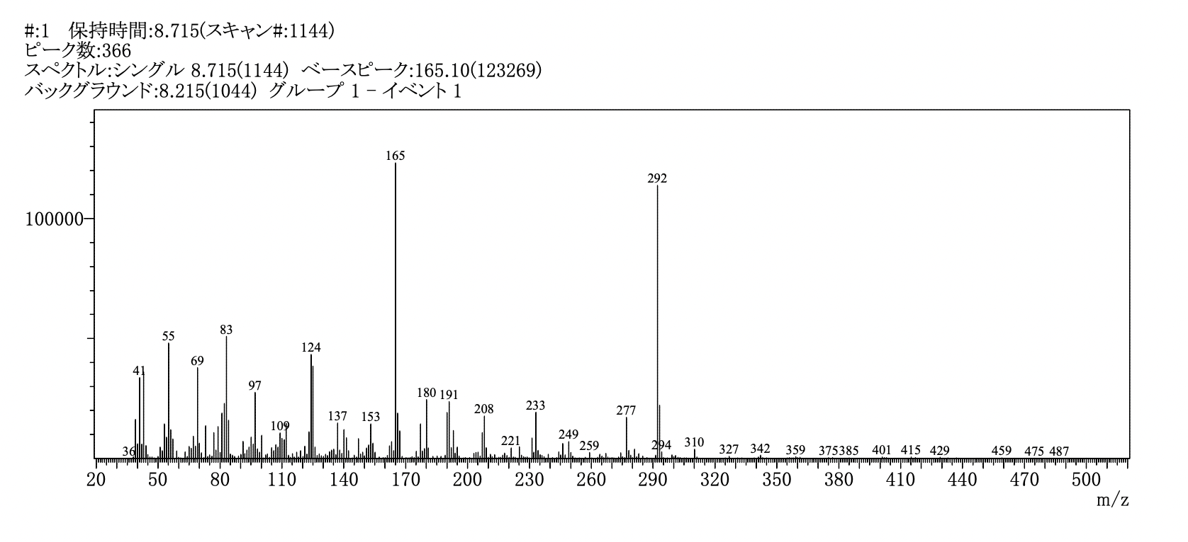

Figure S4. Mass spectra of a peak at a retention time of 8.715 min in GC/MS, corresponding to the formaldemethone.

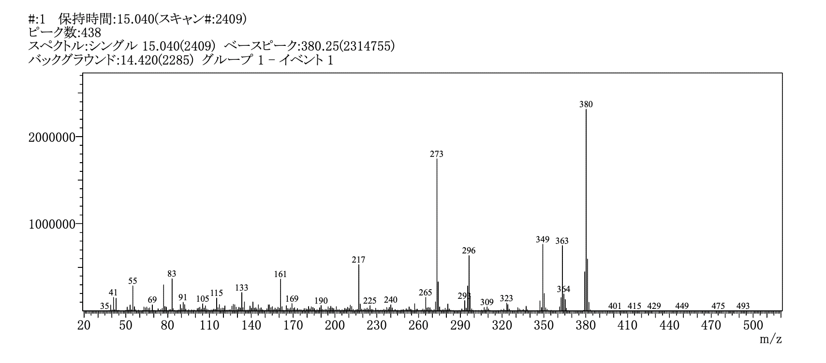

Figure S5. Mass spectra of a peak at a retention time of 15.040 min in GC/MS, corresponding to the dimedone-adduct of *p*-anisaldehyde.

*3-5. Optimization of reaction condition*

Table S1 shows the effect of electrode material on the reaction and gold plate gave the highest yield. The decreases in the current densities in CVs with platinum and glassy carbon disk are possibly due to the formation of passivating films on the electrode surface.

Table S1. Electrolysis of BA with various anode materials.

|  |  |  |  |  |
| --- | --- | --- | --- | --- |
| Entry*a* | Working electrode | Yield (%)*b* | | |
| anisaldehyde | fluorophenol | **BA** |
| 1 | Au plate | 27 | 21 | 63 |
| 2 | Pt plate | 13 | 3 | 73 |
| 3 | GC plate | 12 | 0 | 82 |
| *a*Experimental conditions: substrate, 10 mM of **BA**, 15 mM of lutidine; Electrolyte, Electrolyte, CH3CN solution containing 0.1 M of LiTfO; Current density, 0.5 mA cm**-**2. *b*Determined by 1H NMR using benzaldehyde as internal standard. | | | | |

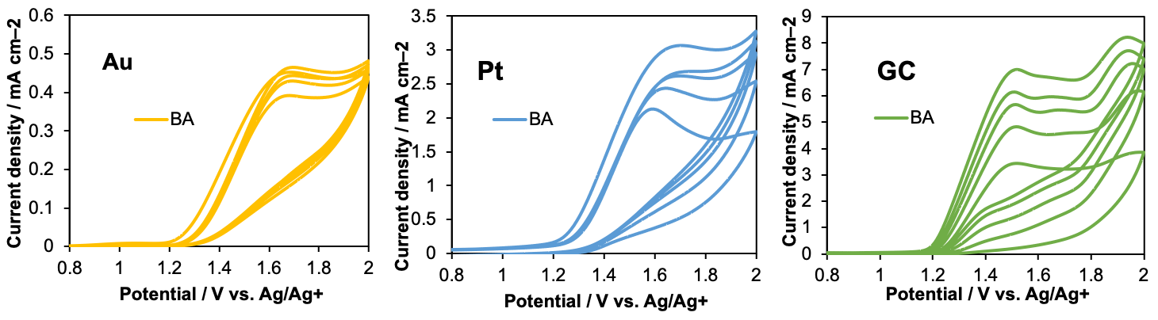

Figure S6. Repeated cyclic voltammograms of 5 mM BA with 0.1 M LiTfO in CH3CN at a scan rate of 0.1 V s-1.

Table S2. Electrolysis of BA with various bases and without a base.3–5

|  |  |  |  |  |  |  |  |  |  |  |  |  |  |  |  |  |  |  |  |  |  |  |  |  |  |  |  |  |  |  |  |  |  |  |  |  |  |  |  |  |  |  |  |  |  |  |  |  |  |  |  |  |  |  |  |  |
| --- | --- | --- | --- | --- | --- | --- | --- | --- | --- | --- | --- | --- | --- | --- | --- | --- | --- | --- | --- | --- | --- | --- | --- | --- | --- | --- | --- | --- | --- | --- | --- | --- | --- | --- | --- | --- | --- | --- | --- | --- | --- | --- | --- | --- | --- | --- | --- | --- | --- | --- | --- | --- | --- | --- | --- | --- |
| |  |  |  |  |  |  | | --- | --- | --- | --- | --- | --- | | Entry*a* | Base | *pK*a (BH+) | Yield (%)*b* | | | | anisaldehyde | *p*-fluorophenol | **BA** | | 1 | pyridine | 5.21 | 20 | 9 | 37 | | 2 | lutidine | 6.75 | 27 | 21 | 63 | | 3 | collidine | 7.43 | 38 | 12 | 61 | | 4 | 2,6-Di-tert-butylpyridine | 4.95 | 4 | n.d. | 54 | | 5 | NaH | 35 | 3 | n.d. | 65 | | 6 | no base | - | 2 | n.d. | n.d. | | *a*Experimental conditions: substrate, 10 mM of **BA**, 20 mM of base; Electrolyte, CH3CN solution containing 0.1 M of LiTfO; Driving electrode, Au plate (2 cm×2 cm); Current density, 0.5 mA cm–2. *b*Determined by 1H NMR using benzaldehyde as internal standard. | | | | | |   Table S3. Electrolysis of BA with various solvent.3 | | | | | |
| Entry*a* | Fluoroalcohol | *pK*a | Yield (%)*b* | | |
| anisaldehyde | *p*-fluorophenol | **BA** |
| 1 | none | - | 38 | 12 | 61 |
| 2 | TFE*c* | 12.5 | 44 | 30 | 25 |
| 3 | HFIP*d* | 9.3 | 29 | 15 | 29 |
| *a*Experimental conditions: substrate, 10 mM of **BA**, 20 mM of collidine; Electrolyte, CH3CN/ fluoroalcohol (v/v = 12/1) solution containing 0.1 M of LiTfO; Driving electrode, Au plate (2 cm × 2 cm); Current density, 0.5 mA cm–2. *b*Determined by 1H NMR using benzaldehyde as internal standard. *c*TFE: trifluoroethanol, *d*HFIP: 1,1,1,3,3,3-Hexafluoro-2-propanol. | | | | | |
|  | | | | | |

|  |  |  |  |  |
| --- | --- | --- | --- | --- |
| **Table S4.** Electrolysis of **BA** with various supporting electrolyte and different concentration of collidine. | | | | |
| Entry | Variation from standard conditions | Yield (%) | | |
| anisaldehyde | *p*-fluorophenol | **BA** |
| 1 | none | 44 | 30 | 25 |
| 2 | LiClO4 instead of LiTfO | 34 | 22 | 30 |
| 3 | KPF6 instead of LiTfO | 40 | 27 | 38 |
| 4 | 30 mM colidine | 40 | 25 | 45 |
| 5 | 100 mM colidine | 33 | n.d. | 40 |
| *a*Experimental conditions: substrate, 10 mM of **BA**; Electrolyte, CH3CN/TFE (v/v=12/1) solution containing 0.1 M of LiTfO; Driving electrode, Au plate (2 cm × 2 cm); Current density, 0.5 mA cm–2. *b*Determined by 1H NMR using benzaldehyde as internal standard. | | | | |

*3-6. Cyclic Voltammetry (CV) Simulations using DigiElch 8*

CV simulations were performed to interpret the experimental cyclic voltammograms using commercially available software DigiElch 8. We estimated how the voltammograms change with the addition of base using the probable parameter values shown below. Note that the charge transfer coefficient (α) was assumed 0.5. *E*0, *k*s, and *D* stand for standard potential, heterogeneous rate constant, and diffusion constant, respectively.

*3-6-1. Determination and estimation of diffusion coefficient for CV simulation*

Fig. S7 shows the cyclic voltammogram of **BA** depicted via variation of scan rate in the range of 0.1-3.0 V s–1. Plotted the oxidation peak current against the square root of scan rate, a linear relationship was obtained (Fig. S8). If the electrode reaction is irreversible, the peak current ${i_{p}}^{a}$ follows eq. 1.7

Here, assuming that the charge transfer coefficient of oxidation $α_{a}$ is 0.5 and the number of electrons in the rate-limiting process of charge transfer $n_{a}$ equals $n$, the apparent 𝐷 is obtained as follows.

*D $=({\frac{slope}{0.4958nFAC^{0}})}^{\frac{1}{2}}\frac{RT}{α_{c}n_{a}F} =1.0391 ×{10}^{-5} eq. 2$*

From these calculations, diffusion coefficients (*D*) for each species were defined as follows.

*D*BA = *D*BA2+ = 1×10–5 cm2 s–1 (from eq. 2 shown below)

*D*BA-CO *= D*BA-CO•+ = 9×10–6 cm2 s–1 (estimated value from molecular size)6

*D*collidine= 2×10–5 cm2 s–1 (estimated value from molecular size)6



**Figure S7.** Cyclic voltammograms of **BA** with 0.1 M KPF6 in CH3CN at the various scan rates in the range of 0.1-3.0 V s–1.

|  |  |  |
| --- | --- | --- |
| *ν* | *ν*1/2 |  |
| 0.1 | 0.31622777 | 0.63814262 $${i_{p}}^{a}$$ |
| 0.2 | 0.4472136 | 0.79269252 |
| 0.5 | 0.70710678 | 1.19337533 |
| 0.75 | 0.8660254 | 1.41401592 |
| 1 | 1 | 1.58084269 |
| 1.5 | 1.22474487 | 1.88172192 |
| 2 | 1.41421356 | 2.18423754 |
| 3 | 1.73205081 | 2.52523637 |

**Figure S8.** Plot of oxidation peak current against square root of scan rates and the best fit through the origin (R2 = 0.998).

*3-6-2. Experimental and simulated cyclic voltammograms*

We first hypothesized that the decrease of current value upon the addition of base observed in Fig. 3a derived from the formation of a complex with a large diffusion coefficient as a result of the hydrogen bonding interaction of **BA** and collidine. To test this hypothesis, CV simulations were performed with a different equilibrium constant for the complexation. All electron-transfer processes were defined as a single-electron transfers (*n* = 1). Fig. S9 represents CV simulations using different values for the equilibrium constant (*K*eq) for the complexation of **BA** and collidine. When *K*eq was set to 10 M–1, which is in the range of *K*eq values of common hydrogen bonding complexes, the current value showed only a small difference (Fig. S9a). Increasing *K*eq to unrealistically large value, 1000 M–1, showed only a slight decrease of current (Fig. S9b). Thus, we concluded that the change in the diffusion coefficient is not responsible for the drastic change of CVs observed in the experiment upon the addition of the base.

Simulation parameters for acid-base associated process:

**BA** **BA+** + e– *E*0 = 1.6 V; *k*s(BA) = 0.01 cm s-1

**BA +** collidine **BA-CO** *K*eq = 10, 1000 M–1

**BA-CO**  **BA-CO•+** + e– *E*0 = 1.5 V; *k*s(BA-CO) = 0.01 cm s-1

(b)

(a)



**Figure S9.** Simulated cyclic voltammograms of **BA** and 0, 1.0, 1.5, and 2.0 equiv. of collidine at a scan rate of 0.1 V s–1. *K*eq for the complexation was set to (a)10 M–1and (b)1000 M–1, respectively.

We then hypothesized that proton coupled-electron transfer (PCET) proceeds in the presence of collidine. To simulate the PCET process, a termolecular option in DigiElch 8 was applied. As mentioned in the manuscript, following four points were taken into account for this simulation.

(1) In the absence of collidine, oxidation of **BA** is a two-electron oxidation process, assuming uncontrolled reactions such as polymerization.

(2) In the presence of collidine, electron transfer becomes a bimolecular process, *i.e.*, PCET. This premise was implemented by using a termolecular option in DigiElch8

(3) Heterogeneous rate constant (*k*s) for **BA** in the presence of collidine, *k*s(BA+collidine), is larger than **BA** without collidine, *k*s(BA).

(4) PCET is a single-electron transfer process.

When *k*s(BA+collidine) was set to 1 cm s–1, which is 100 times higher than *k*s(BA), voltammetry closest to the experimental data was obtained. When *k*s(BA+collidine) of the oxidation of **BA** were set to 0.1 or 0.01 cm s–1, only a slight decrease in current is observed (Fig. S10).

Simulation parameters for PCET process:

**BA** **BA2+** + 2e– *E*0 = 1.6 V; *k*s(BA) = 0.01 cm s–1

 **BA** + collidine  **BA-CO•+** + e– *E*0 = 1.5 V; *k*s(BA+collidine) = 1, 0.1, 0.01 cm s–1



(b)

(a)

**Figure S10.** Simulated cyclic voltammograms of **BA** and 0 - 2.0 equiv. of collidine at a scan rate of 0.1 V s–1. *k*s(BA+collidine) was set to (a) 0.1 cm s–1 and (b) 0.01 cm s–1, respectively. Data for *k*s(BA+collidine) = 1 cm s–1 is shown in Fig. 3b.

*3-6-3. The change of voltammograms with different bases*



**Figure S11.** Cyclic voltammograms of 5 mM **BA** and 10 mM of various bases in 0.1 M LiTfO/CH3CN at a scan rate of 0.1 V s–1. DTBP: 2,6-Di-*tert*-butylpyridine.

*3-7. DFT Analysis*

*3-7-1. Gaussian setup*

All calculations were performed using Gaussian 16 software. Geometry optimizations and frequency calculations were performed at the UCAM-B3LYP level of theory with the D3 empirical dispersion correction and 6-311+G(d) basis set for all atoms.

*3-7-2. Supplementary data*

Table S7. Cartesian coordinates of the optimized structure for BA•.

|  |  |  |  |
| --- | --- | --- | --- |
| Symbol | X | Y | Z |
| C | -4.5047252 | 0.5570246 | -0.1016317 |
| C | -4.2109993 | -0.4283349 | 0.84038 |
| C | -2.9529868 | -1.0136046 | 0.8455017 |
| C | -1.97305 | -0.6171117 | -0.0567626 |
| C | -2.287236 | 0.3544566 | -1.0131454 |
| C | -3.534843 | 0.9415386 | -1.0310059 |
| H | -4.945146 | -0.7451502 | 1.5668218 |
| H | -2.7318904 | -1.7820942 | 1.5765788 |
| H | -1.5520463 | 0.6535172 | -1.7491311 |
| H | -3.7851881 | 1.7010783 | -1.7606408 |
| C | -0.6001351 | -1.2729058 | -0.0365196 |
| H | -0.5339348 | -1.9212588 | 0.8465131 |
| C | 0.5419485 | -0.2750081 | -0.0097196 |
| H | 0.5383864 | 0.3349062 | -0.9173483 |
| H | 0.4441466 | 0.3740212 | 0.8665616 |
| O | 1.738633 | -1.0372706 | 0.0636369 |
| C | 2.9313499 | -0.3807788 | 0.0888932 |
| C | 3.0637687 | 1.0036887 | 0.066657 |
| C | 4.0669941 | -1.1893486 | 0.1420167 |
| C | 4.332976 | 1.5765437 | 0.0977423 |
| C | 5.3279766 | -0.6221472 | 0.1729636 |
| H | 3.9428389 | -2.2645328 | 0.1579423 |
| C | 5.4351476 | 0.7561755 | 0.1498949 |
| H | 4.4579189 | 2.6513933 | 0.0812628 |
| H | 6.2194361 | -1.2343765 | 0.2138565 |
| H | 2.1995893 | 1.6506557 | 0.0264725 |
| F | 6.6734965 | 1.3160104 | 0.1798681 |
| O | -5.6948646 | 1.1901028 | -0.1947185 |
| C | -6.7300683 | 0.8418926 | 0.7186539 |
| H | -7.5794805 | 1.4679994 | 0.458355 |
| H | -7.0075173 | -0.209889 | 0.6155418 |
| H | -6.4292298 | 1.0456273 | 1.7492047 |
| O | -0.6357756 | -2.0226413 | -1.1932077 |

Table S8. Cartesian coordinates of the optimized structure for BA-CO•+.

|  |  |  |  |  |
| --- | --- | --- | --- | --- |
| Symbol | X | | Y | Z |
| C | -1.0652037 | 1.0062031 | | -0.7537635 |
| C | -0.8315863 | 2.2573892 | | -1.34472 |
| C | 0.1690065 | 3.0685143 | | -0.8674876 |
| C | 0.9824435 | 2.6464573 | | 0.1947921 |
| C | 0.7184787 | 1.4158257 | | 0.8005141 |
| C | -0.2835721 | 0.5876197 | | 0.3248694 |
| H | -1.4529223 | 2.5618137 | | -2.176942 |
| H | 0.3417701 | 4.0338636 | | -1.3281192 |
| H | 1.2983878 | 1.0937275 | | 1.6550507 |
| H | -0.4545575 | -0.365654 | | 0.8025745 |
| C | 2.0375518 | 3.5815981 | | 0.7527991 |
| H | 2.2159893 | 4.3975454 | | 0.0424327 |
| C | 3.3569659 | 2.9377715 | | 1.1155185 |
| H | 3.216907 | 2.185291 | | 1.895858 |
| H | 3.7944987 | 2.4678013 | | 0.228755 |
| O | 4.1865997 | 3.9865707 | | 1.5910918 |
| C | 5.4393395 | 3.680064 | | 2.0311174 |
| C | 5.9818841 | 2.3996864 | | 2.0167975 |
| C | 6.1893569 | 4.7513954 | | 2.5158181 |
| C | 7.275938 | 2.1935645 | | 2.4887094 |
| C | 7.474642 | 4.5483892 | | 2.9844815 |
| H | 5.7485023 | 5.7399709 | | 2.5187824 |
| C | 7.9935808 | 3.2670312 | | 2.9612769 |
| H | 7.7172611 | 1.2054736 | | 2.4865207 |
| H | 8.0708398 | 5.3677252 | | 3.3644694 |
| H | 5.4210777 | 1.5546363 | | 1.6447167 |
| F | 9.2560764 | 3.064984 | | 3.4217904 |
| O | -2.0658549 | 0.2886434 | | -1.2879019 |
| C | -2.3809908 | -0.9858569 | | -0.7286313 |
| H | -3.2114014 | -1.3682297 | | -1.3155493 |
| H | -1.5310384 | -1.6667645 | | -0.8087723 |
| H | -2.6843056 | -0.8874493 | | 0.3157838 |
| O | 1.3152226 | 4.0125433 | | 1.8505311 |
| H | -0.0999622 | 5.0235133 | | 1.5959862 |
| C | -2.1474059 | 4.9299526 | | 1.6387323 |
| C | -0.8652661 | 6.8045119 | | 0.9250248 |
| C | -2.0208411 | 7.502837 | | 0.6551696 |
| C | -3.2672143 | 6.9172624 | | 0.8752216 |
| H | -1.9473295 | 8.5104484 | | 0.2690044 |
| C | -3.3118485 | 5.6154238 | | 1.3716636 |
| H | -4.2605 | 5.1284345 | | 1.5523008 |
| C | -4.5269163 | 7.6792945 | | 0.6121419 |
| H | -4.8041 | 8.2383157 | | 1.5102066 |
| H | -4.3939002 | 8.3967914 | | -0.1970747 |
| H | -5.3517004 | 7.0103233 | | 0.368724 |
| C | -2.0956547 | 3.5304526 | | 2.1524875 |
| H | -3.0848116 | 3.2044537 | | 2.4654246 |
| H | -1.7392827 | 2.8580622 | | 1.3696536 |
| H | -1.4102032 | 3.4513914 | | 2.9972923 |
| C | 0.510574 | 7.3380897 | | 0.7021854 |
| H | 0.9736006 | 6.8374115 | | -0.1512241 |
| H | 0.4756951 | 8.4051975 | | 0.4951436 |
| H | 1.1411517 | 7.1672415 | | 1.5758361 |
| N | -0.9729435 | 5.5499152 | | 1.4065121 |

**5. Supporting References**

1. R. Izumiya, M. Atobe, and N. Shida, *ChemRxiv* (2022), DOI: 10.26434/chemrxiv-2022-324ps.

2. T. Fuchigami, T. Nonaka, C. Watanabe, and T. Sekine. *Denki Kagaku* *(presently Electrochemistry)*, **51**, 812 (1983).

3. <http://ccc.chem.pitt.edu/wipf/MechOMs/evans_pKa_table.pdf> referred on Jan 26, 2023.

4. Z. Rappoport, *CRC Handbook of Tables for Organic Compound Identification*, CRC Press, Boca Raton, FL, S. 438 (1984).

5. C. Kannigadu, J. Aucamp, and D. D. N’Da, *Drug. Dev. Res.*, **82**, 287 (2021).

6. D. P. Valencia, and F. J. González, *Electrochem. Commun.,* **13**, 129 (2011).

7. T Okajima. *Denki Kagaku* *(presently Electrochemistry)*, **81**, 655 (2013).