Supporting Information
Properties of composite electrodes for all-solid-state fluoride-ion secondary batteries processed by high-pressure torsion

Yanchang WANG ^{a,§§}, Sangmin LEE ^{b}, Kentaro YAMAMOTO ^{a,c,§,*}, Toshiyuki MATSUNAGA ^{a,§}, Hidenori MIKI ^{d,§}, Hideki IBA ^{d,§}, Koichi TSUCHIYA ^{b}, Tomoki UCHIYAMA ^{a,§}, Toshiki WATANABE ^{a,§}, Tsuyoshi TAKAMI ^{a,§} and Yoshiharu UCHIMOTO ^{a,§§§}

ªGraduate School of Human and Environmental Studies, Kyoto University, Yoshida-nihonmatsu-cho, Sakyo, Kyoto 606-8501, Japan
^{b}Research Center for Structural Materials, National Institute for Materials Science, 1-2-1 Sengen, Tsukuba, Ibaraki, 305-0047, Japan.
^{c}Faculty of Engineering, Nara Women's University, Kitauoyanishimachi, Nara 630-8506, Japan
^{d}Toyota Motor Corporation, Advanced Material Engineering Division, Higashifuji Technical Center, 1200 Mishuku, Susono, Shizuoka 410-1193, Japan
§ ECSJ Active Member (Individual Member and person who belongs Corporate Member)
§§ ECSJ Student Member
§§§ ECSJ Fellow

Supplementary Figure S1. Illustration of the testing cell for EIS measurement.

Supplementary Figure S2. (a) XRD pattern and (b) Arrhenius plot of total ionic conductivity with Nyquist plots (inset) of solid electrolyte PbSnF₄

Supplementary Figure S3. Lattice constant of Cu in the cathode composite after HPT processing with different rotation numbers.

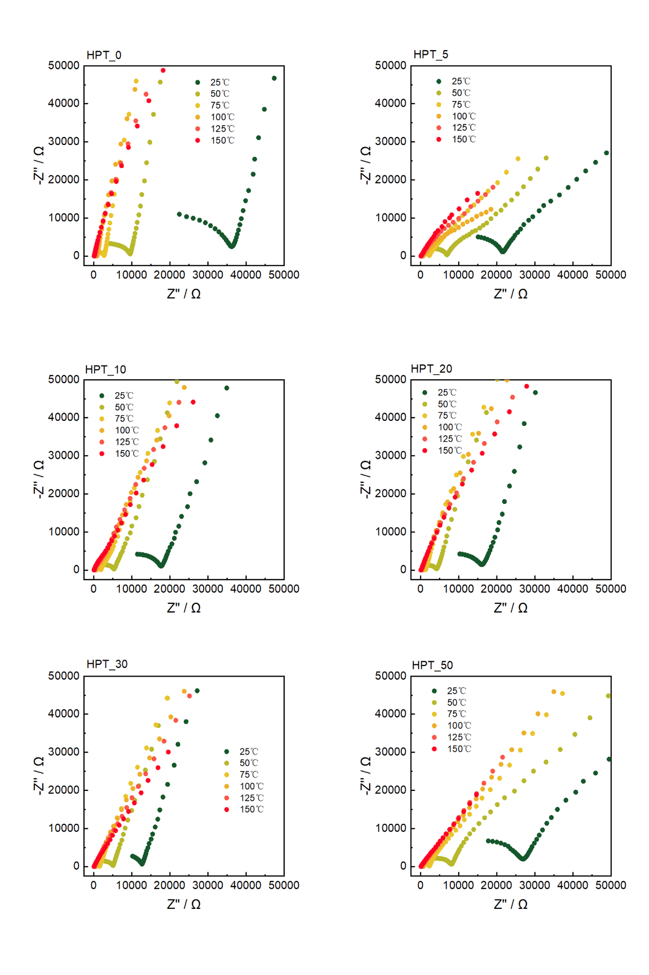
Supplementary Figure S4. Nyquist plots of the cathode composites after HPT processing with different rotation numbers under 25, 50, 75, 100 and 125 ℃.

Supplementary Figure S5. Charge/discharge curves of the cathode composites after HPT processing with different rotation numbers at 0.01 C under 140°C.

Supplementary Table S1. The fitting parameters of the EIS results of the cathode composite after HPT processing with different rotation numbers.
