"Supporting Information"

Revealing Impacts of Anion Defect Species on Fluoride-Ion Conduction

of Ruddlesden-Popper Oxyfluoride Ba2ScO3F

Kota MOTOHASHI,a,†,§ Takanori SANADA,a Takashi NAKAMURA,b,§ Yuta KIMURA,b,§ Yoshiharu UCHIMOTO,c,§§ and Koji AMEZAWAb,\*,§

a Graduate School of Engineering, Tohoku University, 6-6-1 Aramaki-Aoba, Aoba-ku, Sendai 980-8579, Japan.

b Institute of Multidisciplinary Research for Advanced Materials, Tohoku University, 2-1-1 Katahira Aoba-ku, Sendai, Miyagi, 980-8577, Japan.

c Graduate School of Human and Environmental Studies, Kyoto University, Yoshida-nihonmatsu, Sakyo-ku, Kyoto 606-8501, Japan.

† Present address: Graduate School of Engineering, Osaka Metropolitan University, 1-1 Gakuen, Naka-ku, Sakai, Osaka 599-8531, Japan.

§ ECSJ Active Member

§§ ECSJ Fellow

\*Corresponding author: koji.amezawa.b3@tohoku.ac.jp

[ORCID]

Kota MOTOHASHI: 0000-0001-9318-7588

Yuta KIMURA: 0000-0002-3525-1366

Takashi NAKAMURA: 0000-0001-5461-9958

Yoshiharu UCHIMOTO: 0000-0002-1491-2647

Koji AMEZAWA: 0000-0002-3430-6927

The simple fluorides with perovskite and layered perovskite structures, K2(Mg0.9Li0.1)F3.9, K2MgF4, K(Ca0.9Li0.1)F2.9, K(Ca0.9Li0.1)F2.9, K(Mg0.9Na0.1)F2.9, (Ba0.9K0.1)LiF2.9, and BaLiF3, were synthesized from KF, BaF2, LiF, MgF2, CaF2, and NaF by solid-state reaction. The raw materials were mixed in appropriate stoichiometric ratios by ball-milling at 500 rpm for 1 hour in Ar. The mixtures were calcined at 923 K for 10 hours in Ar. The obtained powders were characterized by X-ray diffraction with Cu *K*a radiation.

Figure S1 shows powder X-ray diffraction patterns of K2(Mg0.9Li0.1)F3.9, K2MgF4, K(Ca0.9Li0.1)F2.9, K(Ca0.9Li0.1)F2.9, K(Mg0.9Na0.1)F2.9, (Ba0.9K0.1)LiF2.9, and BaLiF3. The main phases could be indexed with the cubic or layered perovskite structures for all the samples. However, some impurities, such as raw materials and layered perovskite phases, were also detected. We measured electrical conductivities of the sintered compacts of these materials. As results, the conductivities were very low both in non-doped and doped materials, and the improvement of conductivity by doping ani-valent cation was not observed in all the samples. These imply that the dopants are not dissolved and fluoride-ion vacancy which is effective for fluoride-ion conduction was not significantly introduced in the simple fluorides with perovskite and layered perovskite structures.

Figure S1. Powder X-ray diffraction patterns of K2(Mg0.9Li0.1)F3.9, K2MgF4, K(Ca0.9Li0.1)F2.9, K(Ca0.9Li0.1)F2.9, K(Mg0.9Na0.1)F2.9, (Ba0.9K0.1)LiF2.9, and BaLiF3.

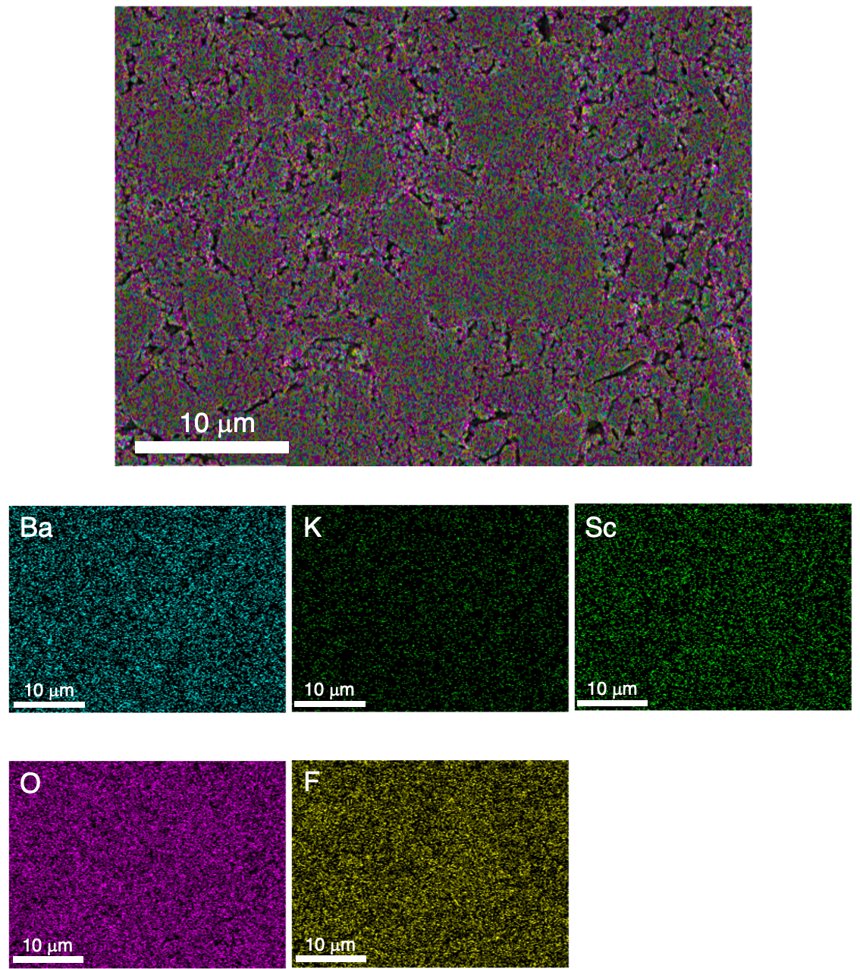

Figure S2. SEM image and EDS elemental mapping on the cross section of the (Ba1.95K0.05)ScO3F0.95 sintered compact.