Supporting information for:
Theoretical consideration of side reactions between the VS₄ electrode and carbonate solvents in lithium–metal polysulfide batteries

Satoshi Hagiwara,^{a,∗,†} Jun Haruyama,^{b} Minoru Otani,^{a,†}
Yuki Umemura,^{c} Tomonari Takeuchi,^{c} and Hikari Sakaebe^{c}

ªResearch Center for Computational Design of Advanced Functional Materials (CD-FMat), National Institute of Advanced Industrial Science and Technology (AIST), 1-1-1, Umezono, Tsukuba, Ibaraki 305-8568, Japan
^{b}The Institute for Solid State Physics, The University of Tokyo, 5-1-5 Kashiwanoha, Kashiwa, Chiba 277-8581, Japan
^{c} Research Institute of Electrochemical Energy, Department of Energy and Environment, National Institute of Advanced Industrial Science and Technology (AIST), 1-8-31, Midorigaoka, Ikeda, Osaka 563-8577, Japan
†Present affiliation: Center for Computational Sciences, University of Tsukuba, 1-1-1 Ten-nodai, Tsukuba, Ibaraki 305-8577, Japan

E-mail: hagiwara@ccs.tsukuba.ac.jp

S1. Decomposition Products and Broken Bond Positions for DMC and PC Solvents

Figures S1 and S2 show molecular structures of assumed decomposition products and bond positions to be broken for DMC and PC molecules, respectively.

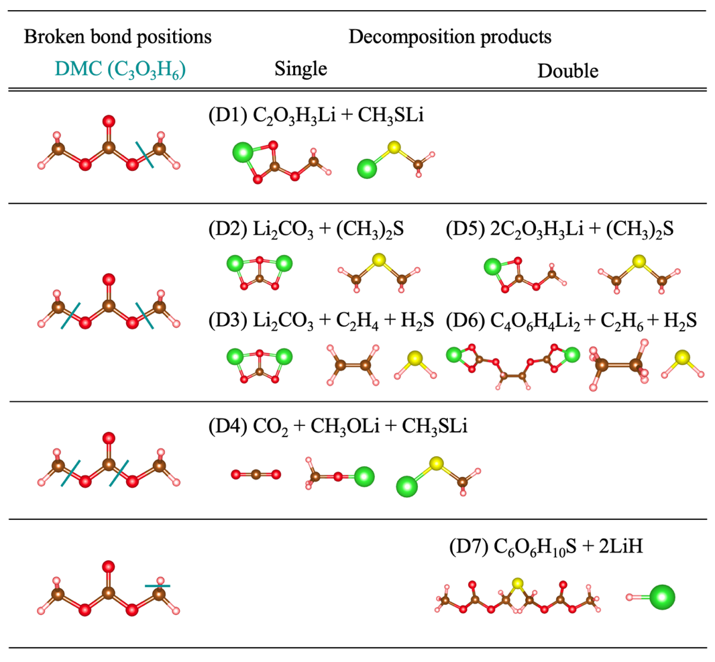
Figure S1: Molecular structures of considered decomposition products and assumed bonds to be broken for DMC. Green lines denote broken bond positions. The products labeled by D1-D4 and D5-D7 are from singly and doubly reacting molecules, respectively.

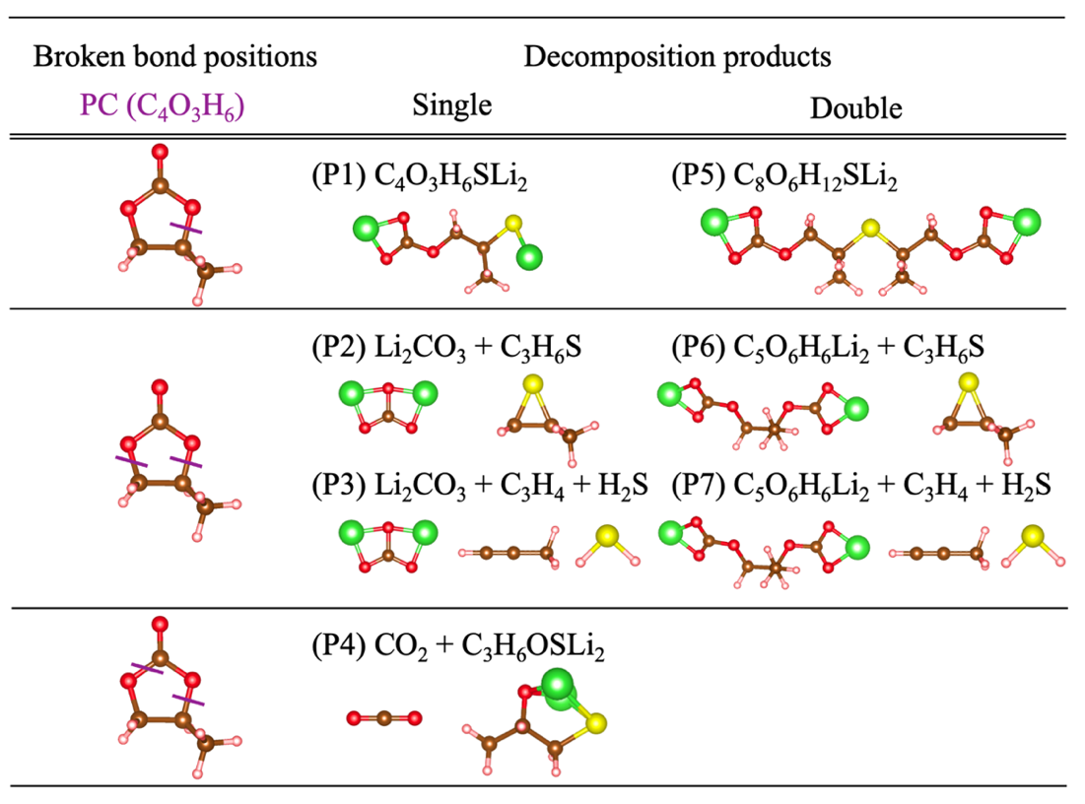
Figure S2: Molecular structures of considered decomposition products and assumed bonds to be broken for PC. Purple lines denote broken bond positions. The products labeled by P1-P4 and P5-P7 are from singly and doubly reacting molecules, respectively.

S2. Detailed Method for Calculating the Change in the Gibbs Free Energy and Equilibrium Potential for Decomposition Reactions

In this section, we describe the calculation method for the change in the Gibbs free energy ΔG using the thermodynamic method, and the equilibrium potential V_{eq} using the electromotive force (EMF) formula for the decomposition reactions.

S2.1. Change in the Gibbs Free Energy ΔG using the Thermodynamic Method

In the ΔG₁ calculation, we used the total energy E_{DFT} obtained by the first-principles density functional theory (DFT) for ΔG calculation as follows:

ΔG₁ = E_{DFT}(Li₂S) − 2E_{DFT}(Li) – 1 / 128E_{DFT}(S₁₂₈). (S1)

Here, we assumed that Li₂S, Li, and S₁₂₈ are in their solid states, and the α-S bulk for the solid state of S₁₂₈, which contains 128 S atoms in the unit cell. ^{S1} Note that the pressure and entropy terms are neglected in Eq. (S1).
ΔG₁ can be converted to the electromotive force (EMF) E_{EMF} as follows:

E_{EMF} = ΔG₁ / nF, (S2)

where n and F indicate the number of reacted electrons and the Faraday constant, respectively. The result of E_{EMF} [V vs. Li/Li⁺] is 2.12 V. This result agrees well with the average EMF (2.15 V) of the lithium sulfur battery.^{S2}
ΔG₂ can be represented as follows:

ΔG₂ = ΔG_{at}(Li) + ΔG_{at}(S) − ΔG_{solv}(EC). (S3)

Here, ΔG_{at}(Li), ΔG_{at}(S), and ΔG_{solv}(EC) denote the atomization free energies for Li and S, and the solvation free energy for EC. We calculated ΔG_{at} as the difference in the E_{DFT} between the isolated atomic and solid states. Note that, to determine ΔG_{at}(Li) and ΔG_{at}(S), the experimental value of the standard molar entropy term that is taken from the thermodynamic table^{S3} is added to E_{DFT} for the isolated atoms. The results of ΔG_{at}(Li) and ΔG_{at}(S) are respectively 1.22 eV and 2.82 eV, which are respectively in good agreement with the experimental values of 1.31 eV and 2.45 eV.^{S4} ΔG_{solv}(EC) is determined by the one-dimensional reference interaction site model (1D-RISM). We did not consider the special correction terms for ΔG_{solv}, because the entropic contribution is included in ΔG_{solv}(EC) within the RISM theory.^{S5–S7} The result of ΔG_{solv}(EC) is −0.39 eV, which is in reasonable agreement with the range of the theoretical values from −0.36 eV to −0.50 eV^{S8, S9}.
ΔG₃ and ΔG₄ correspond to the gas-phase formation and solvation free energies of the decomposition products, respectively. For ΔG₃, the zero-point vibration and translational and rotational energies are included in the total energy. Pressure and standard molar entropy terms are calculated by the equation of states for the ideal gas formulated under the canonical ensemble, which are added to the total energy to determine the Gibbs free energy. All thermodynamic parameters for the gas-phase atoms and molecules were calculated at the temperature of 298.15 K. ΔG₄, which corresponds to ΔG_{solv}(EC) for the decomposition product, were evaluated by 1D-RISM calculations.

S2.2. The Equilibrium Potential V_{eq} using Electromotive Force Formula

Here, we describe details of V_{eq} calculation with Eq. (1) using electrochemical reactions discussed in section 2.4. The Gibbs free energies for left and right components (G_{L} and G_{R}) in reaction 3 can be written as follows, respectively:

G_{L} = G(VS₄) + G(EC) + 3G(Li), (S4)
G_{R} = G(C₃O₃H₄SLi₂) + G(LiVS₃). (S5)

Since ΔG in Eq. (1) is obtained by the difference between G_{L} and G_{R}, equations (S4) and (S5) can be combined with Eq. (1), and then we obtain

V_{eq} = −[G(C₃O₃H₄SLi₂) + G(LiVS₃) – {G(VS₄) + G(EC) + 3G(Li)}] / nF
= {G(VS₄) + G(EC) + 3G(Li) – G(C₃O₃H₄SLi₂) – G(LiVS₃)} / nF. (S6)

By using the above procedure and Li negative electrode, we also obtain EMF for reaction 4 E_{EMF}(4) vs. Li/Li⁺ as follows:

E_{EMF}(4) = {G(VS₄) + 3G(Li) – G(Li₂S) – G(LiVS₃)} / nF. (S7)

By Eq. (S7), Eq. (S6) can be re-written as

V_{eq} = E_{EMF}(4) + {G(Li₂S) + G(EC) – G(C₃O₃H₄SLi₂)} / nF. (S8)

The second term on the right-hand side in Eq. (S8) corresponds to the negative value of the change in the Gibbs free energy ΔG for reaction 5 divided by nF, which is obtained by the thermodynamic cycle discussed in sections 2.4 and S3.2. Therefore, we calculate V_{eq} for the decomposition reaction referencing to the Li/Li⁺ potential by the following simple form:

V_{eq} = E_{EMF}(4) – ΔG / nF. (S9)

S3. Computational Details for Calculations with Quantum ESPRESSO

Here, we provide computational details for the calculations of the Quantum ESPRESSO. ^{S10, S11} Cut-off energies for the wavefunctions and augmented charges were 50 Ry and 400 Ry, respectively. For the Li bulk and atom, we used 80 Ry and 640 Ry as the cut-off energies for the wavefunctions and augmented charges, respectively. We performed the structure optimization until the forces acting on the atoms became smaller than 1.0×10⁻³ Ry/Bohr. Cell optimization was also carried out with the criteria of 0.5 Kbar. We summarize the k-point samplings and spin-states used in this study, as well as the optimized lattice parameters shown in Table S1. Here, NM, FM, and AFM denote the non-magnetic, ferromagnetic, and antiferromagnetic states, respectively. For Li and Li₂S, we only show the results of the lattice constants for the a-axes due to the symmetry of the lattice structures. Figure S3 shows the optimized crystal structures. In this study, we used ultrasoft-pseudopotential^{S12-S14} within the nonlinear core correction scheme^{S15} for the valence-core interaction. The valence electron configurations for the Li, S, and V atoms were 1s²2s¹, 3s²3p⁴, and 3s²4s²3p⁶3d³, respectively. For isolated Li and S atoms, a unit cell with a size of 20×20×20 Å³, and only the Γ-point was adopted for the k-point sampling.

Table S1: Summary of k-point samplings, structures, spin-states and optimized lattice parameters for Li, Li₂S, α-S, VS₄, Li₃VS₄ and LiVS₃. The experimental lattice parameters taken from the AtomWork database are also shown in parentheses^{S16}. Note that, for Li₃VS₄ and LiVS₃, we show the initial lattice parameter taken from the Materials Project database in parentheses^{S17}.
 | k-points | Structure  (space group) | Spin | a [Å] | b [Å] | c [Å]
Li | 12×12×12 | BCC | NM | 3.429 (3.436)
Li₂S | 12×12×12 | Fluorite  (Fm-3m) | NM | 5.694 (5.715)
α-S | 2×2×1 | Orthorhombic  (Fddd) | NM | 10.319 (10.46) | 12.777 (12.837) | 24.399 (24.417)
VS₄ | 4×4×4 | Monoclinic  (C2/c) | AFM | 6.771 (6.78) | 8.250 (8.2215) | 8.250 (8.2215)
Li₃VS₄ | 8×8×8 | Cubic  (P43m) | NM | 5.894 (5.955)
LiVS₃ | 8×8×8 | Triclinic  (P1) | FM | 5.873 (5.808) | 6.337 (6.487) | 6.696 (6.670)

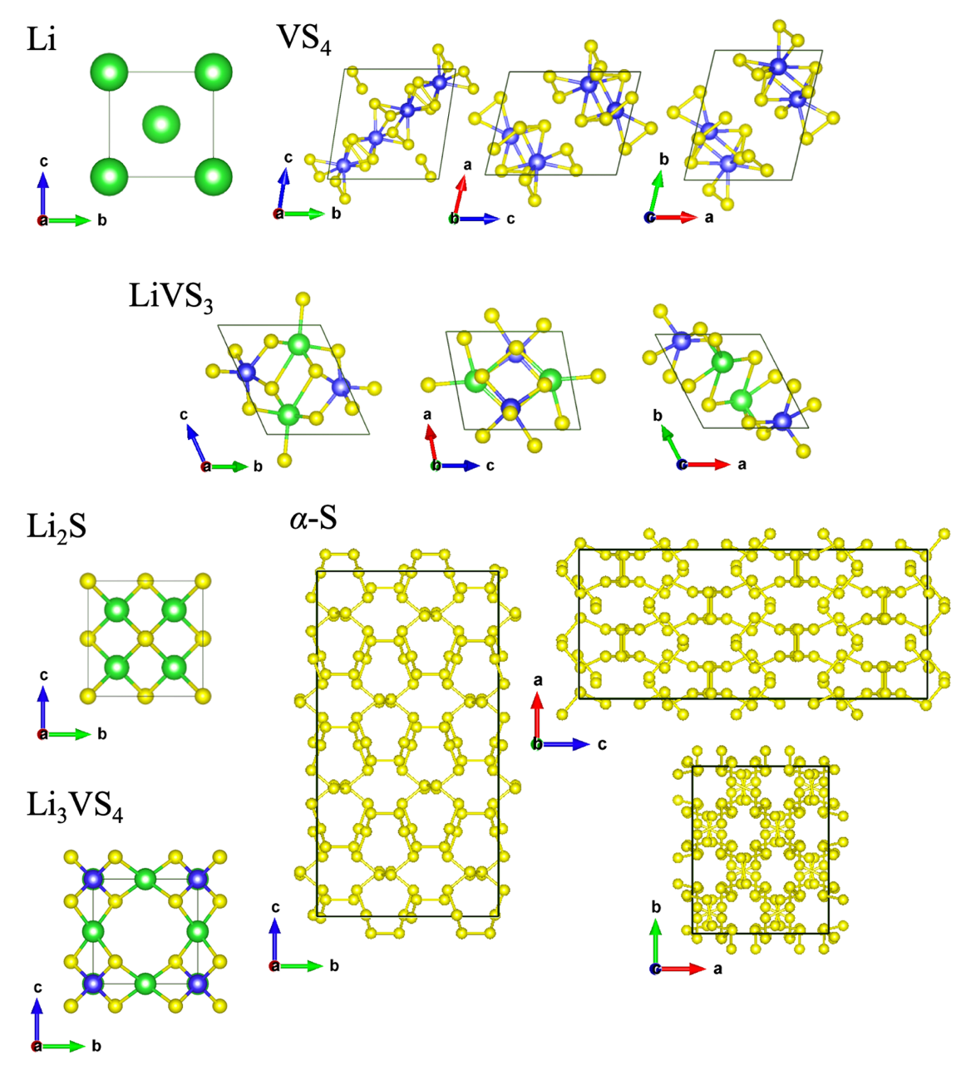
Figure S3: Optimized crystal structures of Li, Li₂S, α-S, VS₄ and LiVS₃.

S4. Determination of U parameter for 3d-orbital of the Vanadium Atom

We used the DFT + U method^{S18} for the 3d-orbital of the vanadium atom. In this study, we adjusted the value of the Hubbard U parameter to reproduce the experimental lattice parameters and bandgap E_{g} of the VS₄ bulk. Table S2 shows the results of lattice parameters and E_{g} for VS₄ with changes in the value of U. Here, we used NM, FM, and AFM states for initial spin polarization. For U = 0.0 eV, all magnetic states show the same result. We checked the values of the magnetic moment, and zero magnetic moments were found for all initial spin states. When the DFT + U calculation was switched on, the AFM state showed a lower total energy. Thus, the AFM state is the grand-state of VS₄ at the finite value of U. For U = 1.0 eV in the AFM state, the lattice parameter results agree well with the experimental data; however, E_{g} is underestimated compared to the experiment. The lattice parameters and E_{g} for U = 2.0 eV in the AFM state reproduce the experimental data well. For U = 3.0 eV, the lattice parameter results deviate slightly from the experiment, and E_{g} is overestimated. From the above discussion, we used the value of U = 2.0 eV throughout this paper.

Table S2: The results of lattice parameters, band-gap energy E_{g} and total energy E_{DFT} for VS₄ with various combinations of U parameter and spin-states.
U [eV] | Spin | a [Å] | b [Å] | c [Å] | α [°] | β [°] | γ [°] | E_{g} [eV] | E_{DFT} [Ry]
0.0 | NM | 6.761 | 8.171 | 8.171 | 78.8 | 73.5 | 73.5 | 0.84 | −948.852
 | FM | 6.762 | 8.171 | 8.171 | 78.8 | 73.5 | 73.5 | 0.84 | −948.852
 | AFM | 6.761 | 8.171 | 8.171 | 78.8 | 73.5 | 73.5 | 0.84 | −948.852
1.0 | NM | 6.766 | 8.175 | 8.175 | 78.8 | 73.5 | 73.5 | 0.92 | −948.489
 | FM | 6.770 | 8.175 | 8.175 | 78.9 | 73.5 | 73.5 | 0.92 | −948.489
 | AFM | 6.764 | 8.216 | 8.216 | 78.0 | 73.7 | 73.7 | 0.99 | −948.500
2.0 | NM | 6.766 | 8.185 | 8.185 | 78.7 | 73.3 | 73.3 | 0.93 | −948.127
 | FM | 6.740 | 8.290 | 8.290 | 76.3 | 75.0 | 75.0 | 0.97 | −948.131
 | AFM | 6.771 | 8.250 | 8.250 | 77.4 | 73.9 | 73.9 | 1.36 | −948.173
3.0 | NM | 6.771 | 8.191 | 8.191 | 78.7 | 73.2 | 73.2 | 0.95 | −947.766
 | FM | 6.805 | 8.348 | 8.348 | 76.3 | 75.2 | 75.2 | 1.37 | −947.829
 | AFM | 6.767 | 8.297 | 8.297 | 76.9 | 74.3 | 74.3 | 1.48 | −947.858
Expt. | -- | 6.78ª | 8.2217ª | 8.2215ª | 78.647ª | 74.056ª | 74.056ª | 1.35^{b} | --
a: Taken from Ref. S16, b: Taken from Ref. S19

S5. Results of Change in the Gibbs Free Energies for Decomposition Reactions

Table S3 shows the decomposition reactions and the corresponding results of ΔG, which are the original data for Fig. 5(a)−(c) in the manuscript.

Table S3: Results of ΔG for all decomposition reactions unit in eV.
Label | Decomposition Reactions | ΔG [eV]
E1 | Li₂S(solid) + EC(solv) → C₃O₃H₄SLi₂(solv) | −0.47
E2 | Li₂S(solid) + EC(solv) → Li₂CO₃(solv) + C₂H₄S(solv) | −0.80
E3 | Li₂S(solid) + EC(solv) → Li₂CO₃(solv) + C₂H₂(gas) + H₂S(gas) | +0.40
E4 | Li₂S(solid) + EC(solv) → CO₂(gas) + C₂OH₄SLi₂(solv) | +0.63
E5 | Li₂S(solid) + 2EC(solv) → C₆O₆H₈SLi₂(solv) | −1.49
E6 | Li₂S(solid) + 2EC(solv) → C₄O₆H₄Li₂(solv) + C₂H₄S(solv) | −1.06
E7 | Li₂S(solid) + 2EC(solv) → C₄O₆H₄Li₂(solv) + C₂H₂(gas) + H₂S(gas) | +0.13
D1 | Li₂S(solid) + DMC(solv) → C₂O₃H₃Li(solv) + LiCH₃S(solv) | +0.83
D2 | Li₂S(solid) + DMC(solv) → Li₂CO₃(solv) + (CH₃)₂S(solv) | −0.31
D3 | Li₂S(solid) + DMC(solv) → Li₂CO₃(solv) + C₂H₄(gas) + H₂S(gas) | −1.38
D4 | Li₂S(solid) + DMC(solv) → CO₂(gas) + LiCH₃O(solv) + LiCH₃S(solv) | −0.82
D5 | Li₂S(solid) + 2DMC(solv) → 2C₂O₃H₃Li(solv) + (CH₃)₂S(solv) | −1.68
D6 | Li₂S(solid) + 2DMC(solv) → C₄O₆H₄Li₂(solv) + C₂H₆(gas) + H₂S(gas) | −1.90
D7 | Li₂S(solid) + 2DMC(solv) → C₆O₆H₁₀S(solv) + 2LiH(solv) | +4.93
P1 | Li₂S(solid) + PC(solv) → C₄O₃H₆SLi₂(solv) | −0.25
P2 | Li₂S(solid) + PC(solv) → Li₂CO₃(solv) + C₃H₆S(solv) | −0.76
P3 | Li₂S(solid) + PC(solv) → Li₂CO₃(solv) + C₃H₄(gas) + H₂S(gas) | +0.49
P4 | Li₂S(solid) + PC(solv) → CO₂(gas) + C₃H₆OSLi₂(solv) | −0.28
P5 | Li₂S(solid) + 2PC(solv) → C₈O₆H₁₂SLi₂(solv) | −1.23
P6 | Li₂S(solid) + 2PC(solv) → C₅O₆H₆Li₂(solv) + C₃H₆S(gas) | −0.87
P7 | Li₂S(solid) + 2PC(solv) → C₅O₆H₆Li₂(solv) + C₃H₄(gas) + H₂S(gas) | +0.38

S6. Experimental Results of LC-MS Analysis

We carried out the experiment of LC-MS^{S20}, a VS₄/Li battery with 1M-LiPF₆ EC/DMC (1:1 vol%) and EC/PC (1:1 vol%), to investigate the qualitative features of sulfur-containing decomposition products. Here, we focus on LC-MS components containing VS₄ electrode materials, such as vanadium and sulfur. The experimental conditions and procedures are explained as follows.
First, after the 10th discharge/charge cycle, we took a battery cell apart in the glove box under an Ar atmosphere and collected the electrolyte solutions. The electrolyte solutions were then diluted with super-dehydrated acetonitrile in a glove box under N₂ atmosphere. Finally, we measured the mass spectra using high-performance LC-MS. As the reference sample of electrolyte solutions, we also carried out LC-MS analysis on pure 1M-LiPF₆ EC/DMC and EC/PC solutions. Liquid chromatography and mass spectrometry were carried out using Nexera X2 (Shimazu Corporation) and TripleTOF 5600+ (AB Sciex Pte. Ltd, respectively). The mass spectrum was observed in the range of 50–1000 m/z. When the intensity of the mass spectrum was sufficient for further analysis, we carried out LC-MS/MS analysis to more precisely estimate the chemical formulae of sulfur-containing decomposition products.
For the battery cycle test, we used the VS₄ based composite consisting of the VS₄/KB/binder, with a weight ratio of 85.3: 10.7: 4 as a positive electrode and a coating weight of 3.2 mg/cm². The discharge/charge cycle test was carried out in a voltage range of 1.5−2.6 V utilizing a discharge/charge rate of 0.1 C.
Figure S4(a) and (b) show the results of the total ion chromatogram (TIC) for the 1M-LiPF₆ EC/DMC solution before and after the battery cycles, respectively. Here, we only show the TIC for 1M-LiPF₆ EC/DMC as a representative of LC-MS data. We observed a change in the TIC between the reference sample and the sample after the 10th discharge/charge cycle. By mass analysis, we obtained the signal from the sulfur-containing decomposition products of organic solvents. The formulae of the decomposition products found in 1M-LiPF₆ EC/DMC and 1M-LiPF₆ EC/PC are listed in Tables S4 and S5, respectively. For the EC/DMC solution, the detected decomposition products are referred to as carbonate-based structures with one or two sulfur atoms, where the sulfur atoms are from the VS₄ electrode. For the EC/PC solution, the decomposition products were similar to those for EC/DMC. In addition, we identified the decomposition product derived from the decomposed LiPF₆ in peak No. 2.
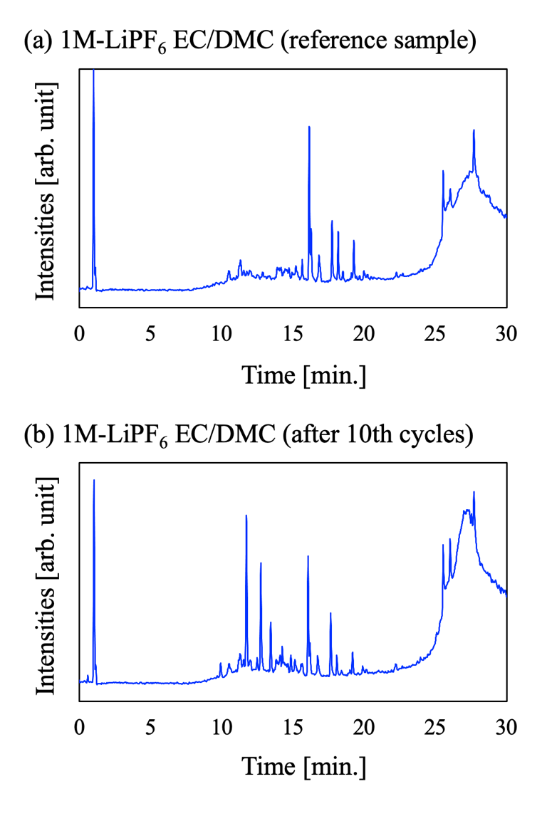
Figure S4: Total ion chromatogram (TIC) of 1M-LiPF₆ EC/DMC solution (a) for reference sample and (b) for the solution after the battery cycles. Time of flight with a range from 0 to 30 min. is shown.

Table. S4: The sulfur contained decomposition products of organic solvents detected by LC-MS and LC-MS/MS analysis for 1M-LiPF₆ EC/DMC. The peak No. was in the descending order of the mass spectrum intensity including sulfur component. Time-of-flight (TOF) in min., intensity, ionic mass per the number of ionic charges (m/z) and estimated chemical formula are listed.
Peak No. | TOF [min.] | Intensity | m/z | Chemical formula
1 | 13.4 | 2008248 | 372.13 | C₁₃H₂₂O₉S
2 | 13.4 | 1700418 | 344.10 | C₁₁H₁₈O₉S
3 | 14.2 | 656949 | 316.08 | C₁₀H₁₈O₆S₂
4 | 14.2 | 645427 | 344.11 | C₁₂H₂₂O₆S₂
5 | 14.8 | 578496 | 432.13 | C₁₅H₂₆O₉S₂

Table. S5: The sulfur contained decomposition products of organic solvents detected by LC-MS and LC-MS/MS analysis for 1M-LiPF₆ EC/PC. The peak No. was in the descending order of the mass spectrum intensity including sulfur component. Time-of-flight (TOF) in min., intensity, ionic mass per the number of ionic charges (m/z) and estimated chemical formula are listed.
Peak No. | TOF [min.] | Intensity | m/z | Chemical formula
1 | 10.5 | 13853 | 316.12 | C₁₁H₂₂O₅S₂
2 | 12.0 | 11852 | 376.12 | C₁₃H₂₃O₆FS₂
3 | 10.5 | 6034 | 293.04 | C₉H₁₈O₅S₂
4 | 10.7 | 5213 | 225.04 | C₇H₁₂O₆S
5 | 12.3 | 4731 | 285.04 | C₉H₁₆O₆S₂

References
S-3

S1. A, Manthiram, Y. Fu, S.-H. Chung, C. Zu, and Y.-S. Su, Chem. Rev., 114, 11751 (2014).
S2. H. Momida, T. Yamashita, and T. Oguchi, J. Phys. Soc. Jpn., 83, 124713 (2014).
S3. NIST-JANAF: https://janaf.nist.gov/periodic_table.html
S4. https://webbook.nist.gov/chemistry/
S5. H.-A. Yu and M. Karplus, J. Chem. Phys., 89, 2366 (1988).
S6. H.-A. Yu, B. Roux, and M. Karplus, J. Chem. Phys., 92, 5020 (1990).
S7. A. Kovalenko and F. Hirata, J. Chem. Phys., 113, 2793 (2000).
S8. T. Li and P. B. Balbuena, Chem. Phys. Lett., 317, 421 (2000).
S9. W. Cui, Y. Lansac, H. Lee, S.-T. Hong, Y. H. Jang, Phys. Chem. Chem. Phys., 18, 23607 (2016).
S10. P. Giannozzi, S. Baroni, N. Bonini, M. Calandra, R. Car, C. Cavazzoni et al., J. Phys.: Condens. Matter, 21, 395502 (2009).
S11. P. Giannozzi, O. Andreussi, T. Brumme, O. Bunau, M. B. Nardelli, M. Calandra et al., J. Phys.: Condens. Matter, 29, 465901 (2017).
S12. D. Vanderbilt, Phys. Rev. B, 41, 7892 (1990).
S13. A. M. Rappe, K. M. Rabe, E. Kaxiras, and J. D. Joannopoulos, Phys. Rev. B, 41, 1227 (1990).
S14. D. Corso, Comput. Mater. Sci., 95, 337 (2014).
S15. S. G. Louie, S. Froyen, and M. L. Cohen, Phys. Rev. B, 26, 1738 (1982).
S16. National Institute for Materials Science (NIMS) AtomWork <http://crystdb.nims.go.jp/>
S17. Materials Project, https://materialsproject.org/
S18. V. I. Anisimov, J. Zaanen, and O. K. Andersen, Phys. Rev. B, 44, 943 (1991).
S19. C. S. Rout, B. -H. Kim, X. Xu, J. Yang, H. Y. Jeong, D. Odkhuu, et al., J. Am. Chem. Soc., 135, 8720 (2013).
S20. H. Mokudai, T. Takeuchi, H. Sakaebe, H. Kobayashi, and E. Matsubara, Energy Fuels, 11, 22307 (2021).

