Supplementary Information
Facile synthesis of templated activated carbon from cellulose nanofibers and MgO nanoparticles via integrated carbonization-activation method as an eco-friendly supercapacitor
Mark Adam FERRYª, Jun MARUYAMA^{b,*,§}, Taka-Aki ASOH^{b}, Hiroshi UYAMA^{a,**,§}
ª Osaka Graduate School of Engineering, Division of Applied Chemistry, 2-1 Yamadaoka, Suita, Osaka, 565-0871 Japan
^{b} Osaka Research Institute of Industrial Science and Technology, Research Division of Environmental Technology, 1-6-50 Morinomiya, Osaka, 536-8553 Japan
*Corresponding author: maruyama@orist.jp (J. M), uyama@chem.eng.osaka-u.ac.jp (H. U.)

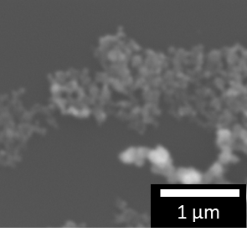
Figure S1. SEM image of MgO NPs with an average size of 52.6 ± 5.9 nm.

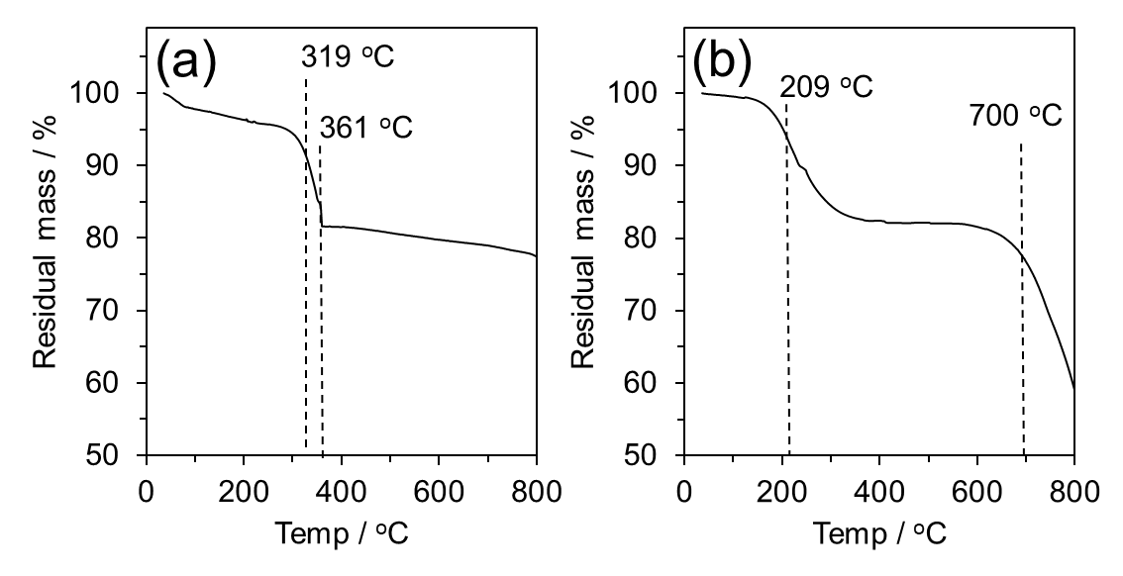
Figure S2. TGA curves of a) formed Mg(OH)₂ formed as a result of mixing TOCN with MgO in water, and b) KOH.

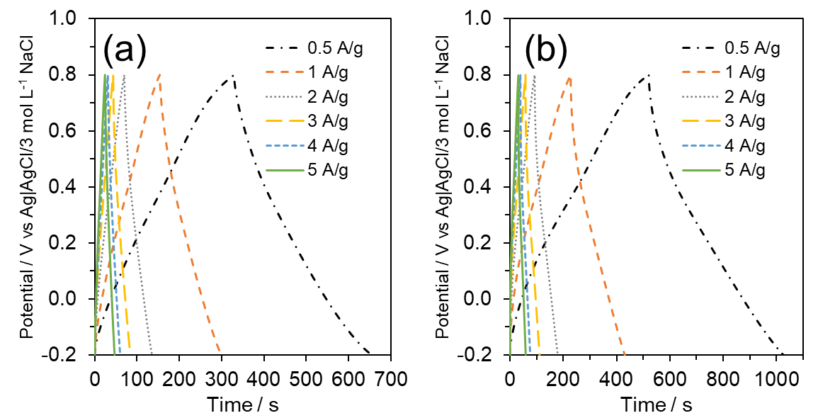
Figure S3. GCD curves of a) TAC-C600 and b) TAC-C700 at varying current densities.

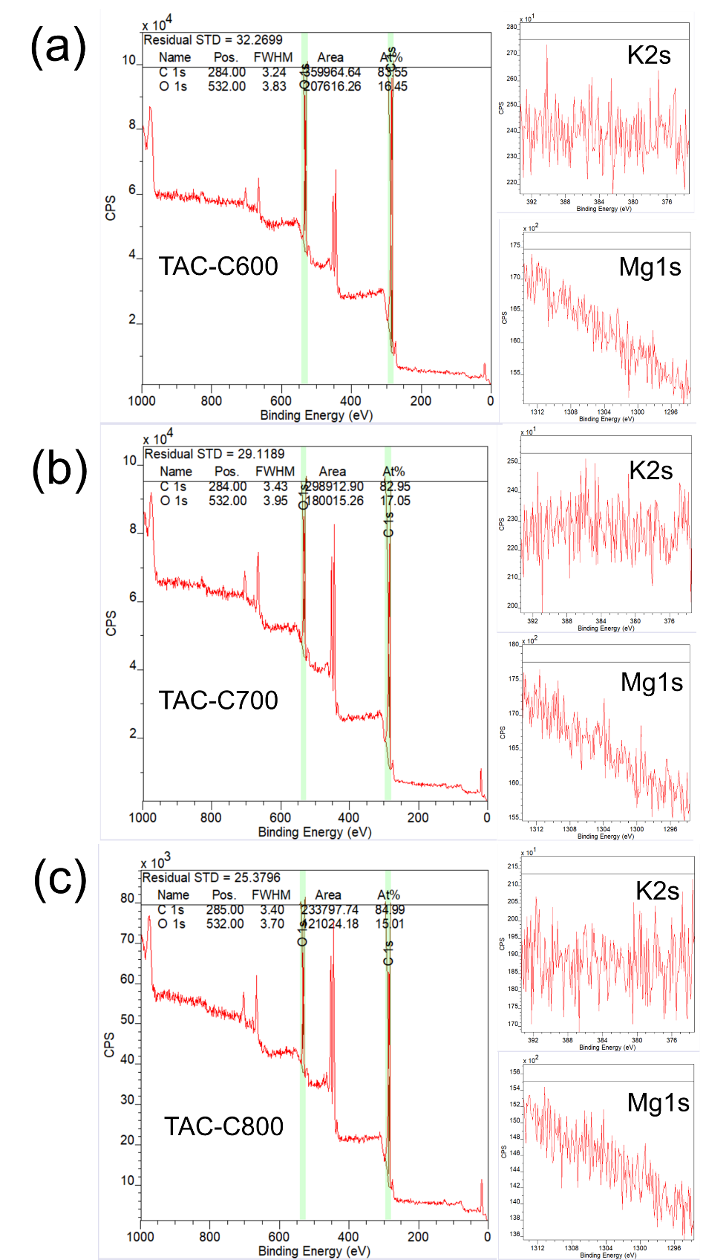
Figure S4. XPS spectra (wide, K2s, and Mg1s) of a) TAC-C600, b) TAC-C700, and c) TAC-C800. Note that the non-highlighted peaks are all from the indium pellet used to adhere the powdered TAC onto for XPS analysis.
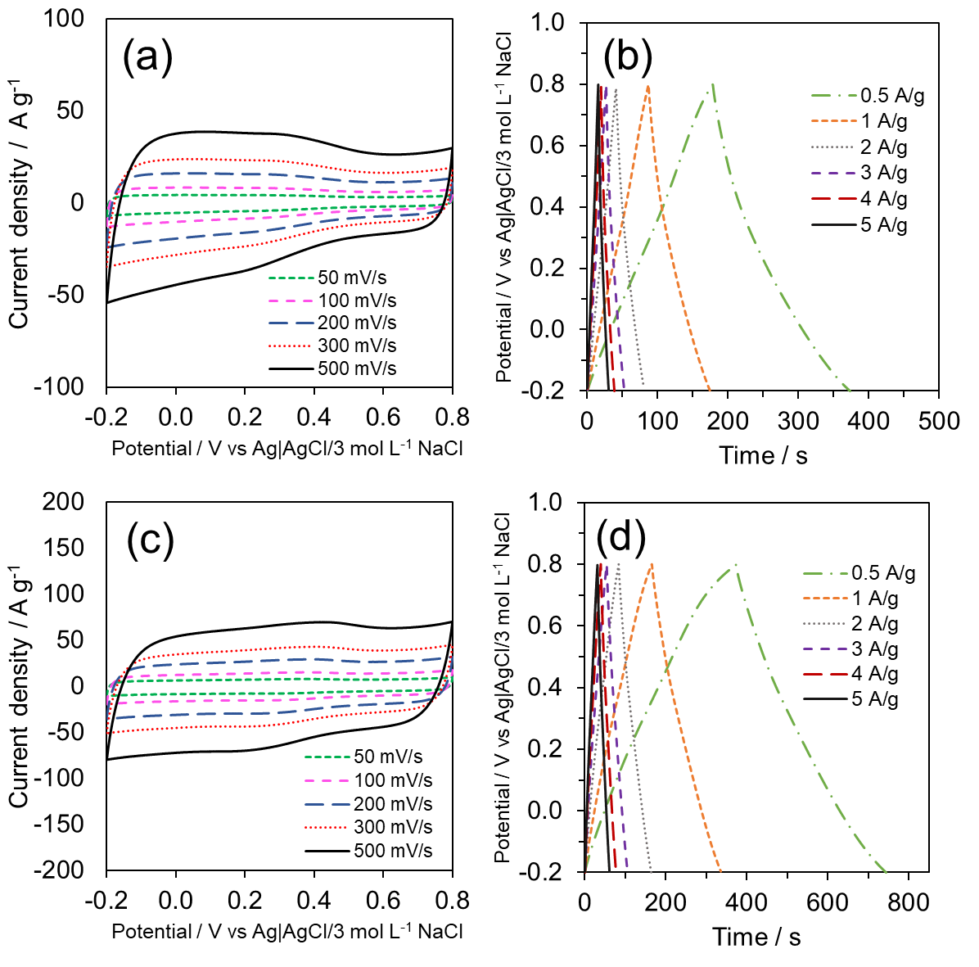
Figure S5. CV and GCD curves for TAC-KxM30 (a, b), and TAC-K5Mx (c, d), respectively.

Table S1. S_{BET}, BJH pore volume analysis, and XPS elemental composition of TAC-K5Mx and TAC-KxM30.
Sample | S_{BET} / | BJH V_{total} / | BJH  V_{micro} / |  | BJH  V_{meso-macro} / |  | XPS
 | m² g⁻¹ | cm³ g⁻¹ | cm³ g⁻¹ | % | cm³ g⁻¹ | % | C at% | O at% | O/C
TAC-K5Mx | 1343 | 0.40 | 0.32 | 79.7 | 0.08 | 20.3 | 87.49 | 12.51 | 0.143
TAC-KxM30 | 1196 | 0.61 | 0.18 | 27.6 | 0.48 | 72.4 | 90.46 | 9.54 | 0.105

Table S2. Deconvoluted Raman spectra peaks and their corresponding ratios with respect to the G-band for TAC samples with varying amounts of KOH.
Sample | I_{D}/I_{G} | I_{P}/I_{G} | I_{Am}/I_{G}
TAC-K2 | 1.18 | 0.43 | 0.54
TAC-K5 | 1.15 | 0.35 | 0.51
TAC-K7 | 1.20 | 0.35 | 0.49
TAC-K10 | 1.20 | 0.40 | 0.62

Table S3. XPS C1s and O1s narrow spectra peak identification for TAC with varying amounts of KOH.
Sample | C1s |  |  |  | O1s
 | C at% | Group | B.E. eV | Conc. at% | O at% | Group | B.E. eV | Conc. at%
TAC-K2 | 86.35 | C-C/C=C | 284.8 | 37.9 | 13.65 | C-O | 532.3 | 92.5
 |  | C-O | 286.1 | 23.3 |  | C=O | 536.6 | 7.5
 |  | C=O | 288.2 | 35.6
 |  | π→π* | 292.2 | 1.2
TAC-K5 | 88.07 | C-C/C=C | 285.0 | 50.2 | 11.93 | C-O | 532.4 | 90.3
 |  | C-O | 286.5 | 19.4 |  | C=O | 537.1 | 9.7
 |  | C=O | 288.3 | 18.9
 |  | π→π* | 290.7 | 11.5
TAC-K7 | 86.24 | C-C/C=C | 285.0 | 40.0 | 13.76 | C-O | 532.4 | 92.7
 |  | C-O | 286.4 | 42.1 |  | C=O | 536.5 | 7.3
 |  | C=O | 289.0 | 6.7
 |  | π→π* | 290.1 | 11.2
TAC-K10 | 86.69 | C-C/C=C | 284.9 | 45.9 | 13.31 | C-O | 532.4 | 88.5
 |  | C-O | 286.3 | 19.2 |  | C=O | 536.7 | 11.5
 |  | C=O | 288.6 | 34.9

Table S4. Deconvoluted Raman spectra peaks and their corresponding ratios with respect to the G-band for TAC samples with varying amounts of MgO.
Sample | I_{D}/I_{G} | I_{P}/I_{G} | I_{Am}/I_{G}
TAC-M5 | 1.18 | 0.28 | 0.48
TAC-M10 | 1.15 | 0.35 | 0.51
TAC-M30 | 1.26 | 0.48 | 0.65
TAC-M50 | 1.21 | 0.42 | 0.64

Table S5. XPS C1s and O1s narrow spectra peak identification for TAC with varying amounts of MgO.
Sample | C1s |  |  |  | O1s
 | C% | Group | B.E. eV | Conc. at% | O% | Group | B.E. eV | Conc. at%
TAC-M5 | 83.46 | C-C/C=C | 285.0 | 44.0 | 16.54 | C-O | 532.3 | 89.5
 |  | C-O | 286.4 | 31.8 |  | C=O | 536.4 | 10.5
 |  | C=O | 289.0 | 17.7
 |  | π→π* | 291.4 | 6.5
TAC-M10 | 88.07 | C-C/C=C | 285.0 | 50.2 | 11.93 | C-O | 532.4 | 90.3
 |  | C-O | 286.5 | 19.4 |  | C=O | 537.1 | 9.7
 |  | C=O | 288.3 | 18.9
 |  | π→π* | 290.7 | 11.5
TAC-M30 | 84.99 | C-C/C=C | 285.0 | 43.2 | 15.01 | C-O | 532.3 | 94.3
 |  | C-O | 285.4 | 16.0 |  | C=O | 537.1 | 12.11
 |  | C=O | 288.0 | 31.2
 |  | π→π* | 291.4 | 9.7
TAC-M50 | 87.34 | C-C/C=C | 284.9 | 41.0 | 12.66 | C-O | 532.3 | 89.8
 |  | C-O | 286.1 | 24.7 |  | C=O | 536.2 | 10.2
 |  | C=O | 287.8 | 20.6
 |  | π→π* | 290.7 | 13.7

Table S6. Deconvoluted Raman spectra peaks and their corresponding ratios with respect to the G-band for TAC samples activated at varying temperatures.
Sample | I_{D}/I_{G} | I_{P}/I_{G} | I_{Am}/I_{G}
TAC-C600 | 0.996 | 0.400 | 0.687
TAC-C700 | 1.184 | 0.408 | 0.641
TAC-C800 | 1.255 | 0.475 | 0.649

Table S7. XPS C1s and O1s narrow spectra peak identification for TAC activated at varying temperatures.
Sample | C1s |  |  |  | O1s
 | C at% | Group | B.E. eV | Conc. at% | O at% | Group | B.E. eV | Conc. at%
TAC-C600 | 83.55 | C-C/C=C | 284.6 | 44.2 | 16.45 | C-O | 532.4 | 90.25
 |  | C-O | 286.3 | 34.5 |  | C=O | 536.8 | 9.75
 |  | C=O | 289.2 | 16.2
 |  | π→π* | 291.9 | 5.1
TAC-C700 | 82.95 | C-C/C=C | 284.9 | 47.3 | 17.05 | C-O | 532.3 | 89.5
 |  | C-O | 286.4 | 15.8 |  | C=O | 537.5 | 10.5
 |  | C=O | 288.3 | 26.2
 |  | π→π* | 291.2 | 10.7
TAC-C800 | 84.99 | C-C/C=C | 285.0 | 43.2 | 15.01 | C-O | 532.3 | 94.3
 |  | C-O | 285.4 | 16.0 |  | C=O | 537.1 | 12.11
 |  | C=O | 288.0 | 31.2
 |  | π→π* | 291.4 | 9.7

