Supporting Information

Degradation analysis of Pt/Nb–Ti4O7 as PEFC cathode catalysts with controlled arc plasma–deposited platinum content.

Yongbing Maa,§, Hirokata Kajimaa, Yuta Shimasakib, Takaaki Nagaic, Teko W. Nappornc,d, Hiroaki Wadab,e, Kazuyuki Kurodab,e, Yoshiyuki Kurodaa,c,§§, Akimitsu Ishiharac,§§, Shigenori Mitsushimaa,c,§§,*

a *Graduate School of Engineering Science, Yokohama National University, Tokiwadai, Hodogaya-Ku, Yokohama 240-8501, Japan.*

b *Department of Applied Chemistry, Faculty of Science and Engineering, Waseda University, 3-4-1 Ohkubo, Shinjuku-Ku, Tokyo 169-8555, Japan.*

c *Advanced Chemical Energy Research Center, Institute of Advanced Sciences, Yokohama National University, Tokiwadai, Hodogaya-Ku, Yokohama 240-8501, Japan.*

d *IC2MP UMR 7285 CNRS University of Poitiers, 4 rue Michel Brunet B27 TSA 51106 86073, Poitiers Cedex 09, France.*

e *Kagami Memorial Research Institute for Materials Science and Technology, Waseda University, 2-8-26 Nishiwaseda, Shinjuku-Ku, Tokyo 169-0051, Japan.*

**\*** *Corresponding Authors:* [*mitsushima-shigenori-hp@ynu.ac.jp*](mailto:mitsushima-shigenori-hp@ynu.ac.jp)*, Tel: +81-45-339-4020, Fax: +81-45-339-4024*

§ ECSJ Student Member

§§ ECSJ Active member

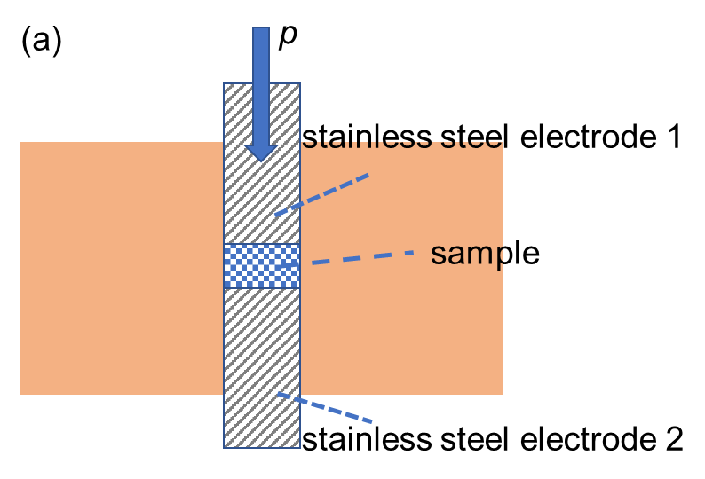

Project Path: UNTITLED.opju
PE Folder: /UNTITLED/
Short Name: Graph1

**Figure S1.** (a) Sectional schematic diagram of powder conductivity test, changes in powder thickness and conductivity with pressure, (b) conductivity, and (c) thickness.

Project Path: UNTITLED.opju
PE Folder: /UNTITLED/
Short Name: Graph1

**Figure S2.** Relationship between conductivity and surface area of various titan

ium oxide–based supports: (a) this study, (b) ref 22, (c) ref 29, (d) ref 51, (e) ref 52, (f) ref 53, (g) ref 54.

**Table S1**. Information of supports in reported studies

|  |  |  |
| --- | --- | --- |
| Ref | support | size |
| 51 | * 5 at%_Nb–TiO2 500 °C, 2 h, air. | 2 – 4 μm |
| 52 | * MoO2 | nanowire. width of 30–40 nm and length of 0.2–0.3 µm |
|  | * Co–N–MnO2 |
| 53 | * Ta–SnO2 − δ | 16.7 nm |
|  | * Nb–SnO2 − δ | 14.6 nm |
| 54 | * Ti4O7 950 °C, 3 h, H2 | 500 nm |
| 29 | * Anatase (poor) and rutile (rich) phases reduction@ 750oC w/o Si, H2 | – 1 μm |
|  | * Rutile phase (rich)   reduction@ 850oC w/o Si, H2 |
|  | * Rutile and Magnéli phases on surface   reduction@ 950oC w/o Si, H2 |
|  | * Rutile/Ti4O7 on surface   reduction@ 1000oC w/o Si, H2 |
|  | * Anatase (rich) and rutile (poor) phases   reduction@ 750oC with Si, H2 |
|  | * Anatase and rutile phase (mixed)   reduction@ 850oC with Si, H2 |
|  | * Rutile and Magnéli phases on surface   reduction@ 950oC with Si, H2 |
|  | * Rutile/Ti4O7 on surface   reduction@ 1000oC with Si, H2 |

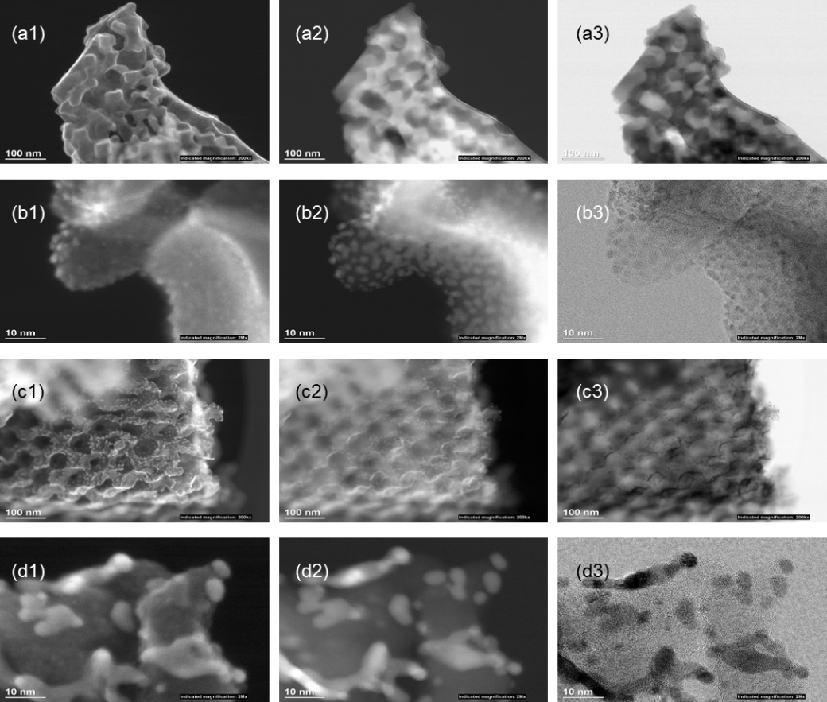

**Figure S3**. STEM images of 2 wt%_Pt/Nb–Ti4O7: (a1, b1) SEM images before electrochemical test, (a2, b2) ADF–STEM images before electrochemical test, (a3, b3) BF–STEM images before electrochemical test, (c1, d1) SEM images after electrochemical test, (c2, d2) ADF–STEM images after electrochemical test, (c3, d3) BF–STEM images after electrochemical test.

**Figure S4**. STEM images of 5 wt%_Pt/Nb–Ti4O7: (a1, b1) SEM images before electrochemical test, (a2, b2) ADF–STEM images before electrochemical test, (a3, b3) BF–STEM images before electrochemical test, (c1, d1) SEM images after electrochemical test, (c2, d2) ADF–STEM images after electrochemical test, (c3, d3) BF–STEM images after electrochemical test.

**Figure S5**. STEM images of 10 wt%_Pt/Nb–Ti4O7: (a1, b1) SEM images before electrochemical test, (a2, b2) ADF–STEM images before electrochemical test, (a3, b3) BF–STEM images before electrochemical test, (c1, d1) SEM images after electrochemical test, (c2, d2) ADF–STEM images after electrochemical test, (c3, d3) BF–STEM images after electrochemical test.

Project Path: UNTITLED.opju
PE Folder: /UNTITLED/
Short Name: Graph2

**Figure S6.** CVs before ADT: (a) 2 wt%_Pt/Nb–Ti4O7; (b) 5 wt%_Pt/Nb–Ti4O7; (c) 10 wt%_Pt/Nb–Ti4O7; (d) Pt/C.

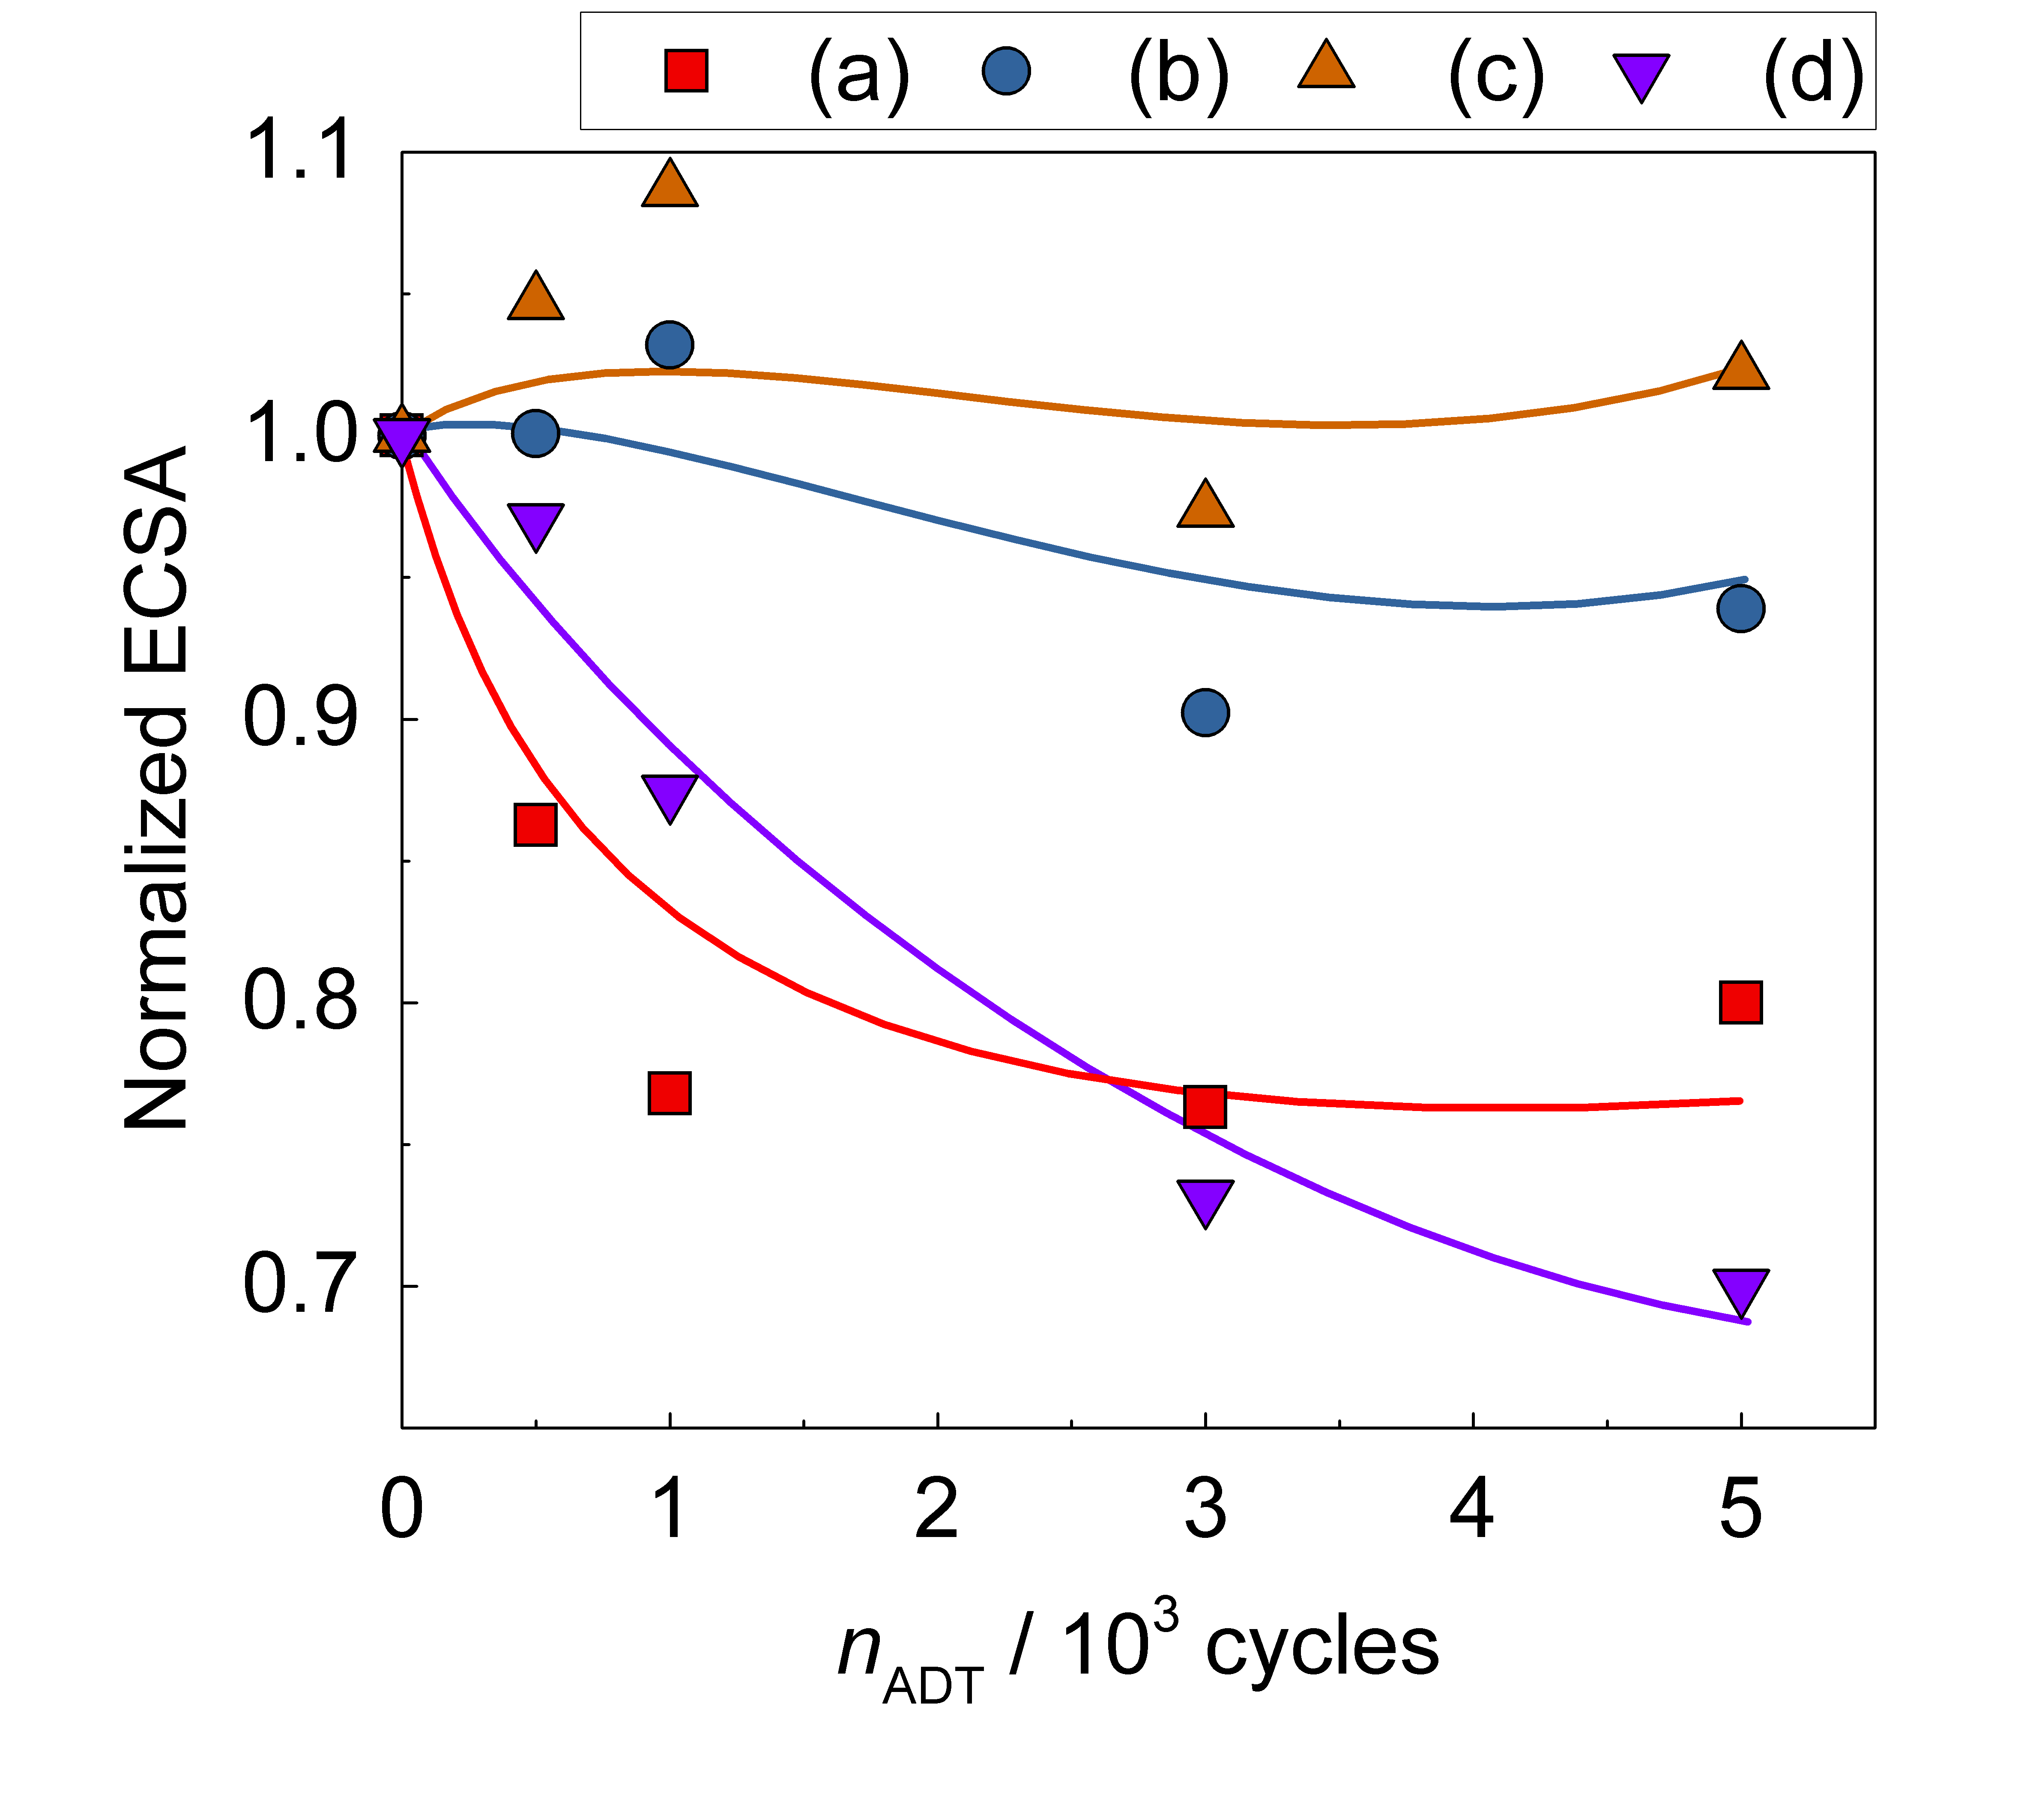

**Figure S7.** Normalized ECSAs (a) 2 wt%_Pt/Nb–Ti4O7, (b) 5 wt%_Pt/Nb–Ti4O7, (c) 10 wt%_Pt/Nb–Ti4O7, and (d) Pt/C as a function of ADT cycles (*n*ADT).

Project Path: UNTITLED.opju
PE Folder: /UNTITLED/
Short Name: Graph1

**Figure S8.** Tafel plots of MAs of catalysts before ADT: (a) 2 wt%_Pt/Nb–Ti4O7, (b) 5 wt%_Pt/Nb–Ti4O7, (c) 10 wt%_Pt/Nb–Ti4O7, and (d) Pt/C.

Project Path: UNTITLED.opju
PE Folder: /UNTITLED/
Short Name: Graph3

**Figure S9.** Relationship between the SA and the *E*Pt–O of the catalysts: (a) 2 wt%_Pt/Nb–Ti4O7, (b) 5 wt%_Pt/Nb–Ti4O7, (c) 10 wt%_Pt/Nb–Ti4O7, and (d) Pt/C.

**Table 1**. Comparison with other Pt/metal oxides catalysts

|  |  |  |  |  |  |  |  |  |  |  |
| --- | --- | --- | --- | --- | --- | --- | --- | --- | --- | --- |
|  |  |  | Before ADT | | | After ADT | | |  |  |
|  | support | Pt | ECSA | MA | SA | ECSA | MA | SA | T / oC | ADT |
|  | wt% | m2 g-1 | A g-1 | A m-2 | m2 g-1 | A g-1 | A m-2 |
|  |  |  |  | ＠ 0.9 V vs. RHE | |  | ＠ 0.9 V vs. RHE | |  |  |
| This study | Nb–Ti4O7 | 2 | 45 | 117 | 2.59 | 36 | 79 | 2.19 | 60 | 1.0–1.5 V 500 mV s-1 (5k cyc) |
| 5 | 29 | 72 | 2.51 | 27 | 60 | 2.23 |
| 10 | 28 | 36 | 1.29 | 29 | 36 | 1.26 |
| Ketjen black | 46.43 | 97 | 47 | 0.49 | 68 | 41 | 0.61 |
| Ref (25) | Nb–TiO2 Fibers | 40 ALD cycles | 14.74 |  | 2.1 |  |  | 1.6 |  | 0.6–1.0 V 100 mV s-1 (30k cyc) |
| Ref (26) | TiO2 | 20 | 14.17 | 1.83 | 0.129 |  | 1.02 |  | 25 | 0.6–1.0 V 25 mV s-1 (5k cyc) |
| TiO2–HT *HT=heat treatment* |  | 10.22 | 1.01 | 0.099 |  | 3.69 |  |
| TiO2–HFT *HFT=heat treatment and hydrofluoric* *acid treatment* |  | 15.19 | 4.23 | 0.276 |  |  |  |
| TiO2–FT *FT=directly hydrofluoric acid treatment* |  | 15.67 | 2.07 | 0.132 |  |  |  |
| TiNbO2 |  |  | 13 | 0.65 |  |  |  |
| TiNbO2–HFT |  |  | 24 | 1.3 |  |  |  |
| Ref (29) | TiOx | 17.93 |  | 1.37 | 0.49 |  | 0.47 |  | 25 | 0.6–1.0 V 25 mV s-1 (5k cyc) |
| 18.03 |  | 0.97 | 0.35 |  |  |  |  |
| Ref (33) | Nb–TiO2 | 20 | 42.5 | 70 | 1.65 |  |  |  | 25 |  |
| Ref (51) | Nb–doped TiO2 | 20 | 30 | 5.3 | 0.85 | 26.4 | 3.6 |  | 20 | 1.2–0.2 V 100 mVs-1 (1k cyc) |
| Ref (54) | Ti4O7 | 39.28 | 39.28 |  | 9.73 |  |  |  |  |  |