Supporting Information

Title
Compensative electrochromic device utilizing electro-deposited plasmonic silver nanoparticles and manganese oxide to achieve retention of chromatic color

Authors
Shunsuke KIMURA,^{a,b,§} Hikaru WAKATSUKI,^{a,§} Kazuki NAKAMURA,^{a,§§} and Norihisa KOBAYASHI^{a,}*,§§§

ª Graduate School of Science and Engineering, Chiba University, 1-33 Yayoi-cho, Inage-ku, Chiba-shi, Chiba, 263-8522 Japan
^{b} Research Fellowships of Japan Society for the Promotion of Science for Young Scientists

*Corresponding Author : koban@faculty.chiba-u.jp

§ ECSJ Student Member
§§ ECSJ Active Member
§§§ ECSJ Fellow

ORCID:
Shunsuke KIMURA : 0000-0001-7314-5540
Kazuki NAKAMURA : 0000-0003-1556-3263
Norihisa KOBAYASHI : 0000-0002-3326-8033

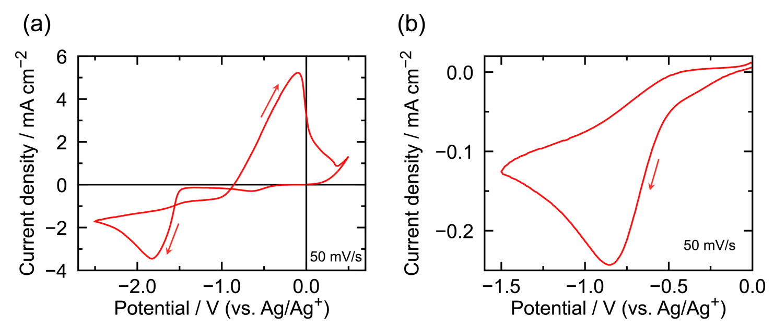

Figure S1. Cyclic voltammograms for DMSO-based solutions containing the below solutes. ITO electrodes were used as the working electrode. (a) 50 mmol L^{–1} AgNO₃, 5 mmol L^{–1} CuCl₂, and 250 mmol L^{–1} LiBr. (b) 5 mmol L^{–1} CuCl₂, and 250 mmol L^{–1} LiBr.

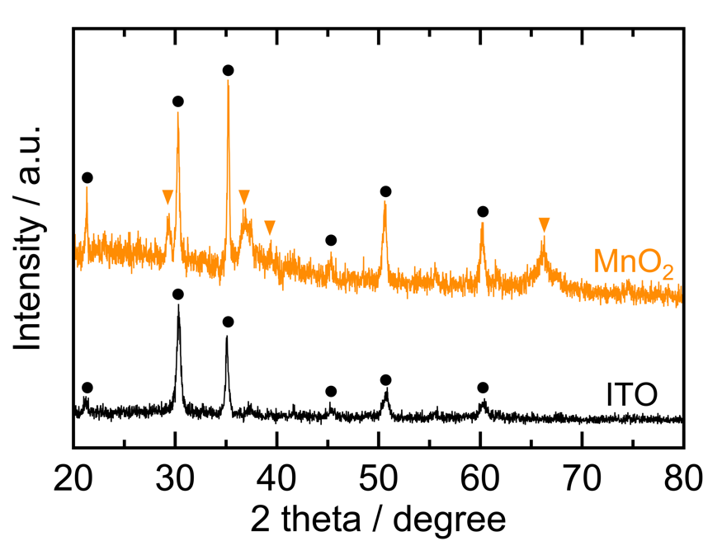

Figure S2. X‐ray diffraction pattern of the MnO₂ film obtained on the ITO electrode. X‐ray diffraction pattern of the ITO electrode is also denoted by a black line. Peaks attributed to MnO₂ and ITO are indicated by orange triangle symbols and black circle symbols, respectively.

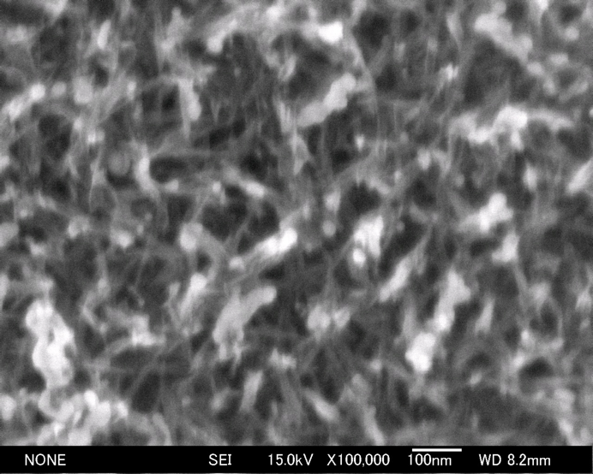
Figure S3. FE-SEM image of the surface of obtained MnO₂ film.

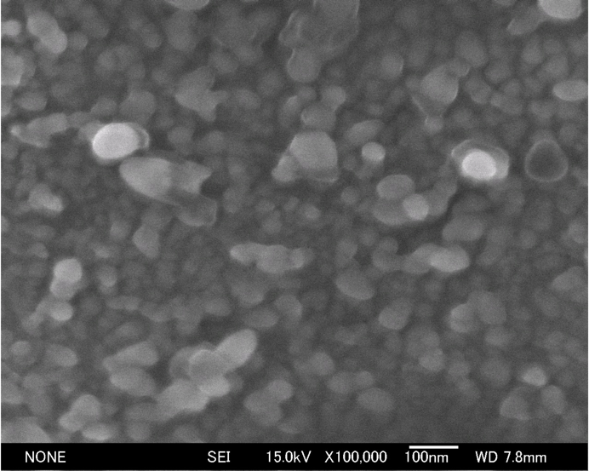
Figure S4. FE-SEM image of electrode surface where silver nanoparticles were electrochemically deposited. Voltage application sequence: V₁ = –3.0 V, t₁ = 80 ms; and V₂ = –1.4 V, t₂ = 60 s.

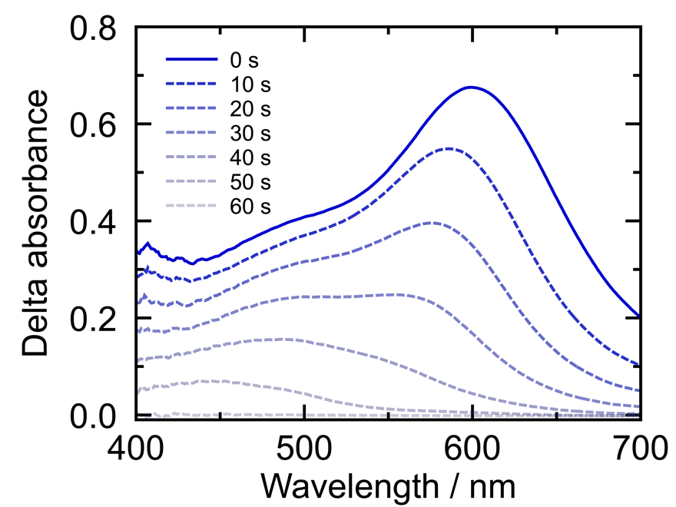

Figure S5. Change in the absorption spectra of the previous device containing CuCl₂ in the electrolyte solution under the open-circuit condition. The initial cyan state (0 s) is observed immediately after finishing voltage application. Voltage application sequence: V₁ = –3.4 V, t₁ = 70 ms; and V₂ = –1.7 V, t₂ = 80 s. As a reference, the device was used in its initial state. Therefore, delta absorbance indicates an absorption caused only by deposited silver.

