Supporting Information

Peak attribution of the differential capacity profile of a LiCoO₂-based three-electrode Li-ion laminate cell

Shuo LI,§ Sachiyo TSUTSUMI,§ Sayoko SHIRONITA,§§ and Minoru UMEDA*,§§

Department of Materials Science and Technology, Nagaoka University of Technology, 1603-1 Kamitomioka, Nagaoka, Niigata 940-2188, Japan

*Corresponding Author: mumeda@vos.nagaokaut.ac.jp

§ ECSJ Student Member
§§ ECSJ Individual Member

ORCID:
Shuo LI: 0000-0003-2031-6101
Sayoko SHIRONITA: 0000-0002-2611-719X
Minoru UMEDA: 0000-0001-7142-7552
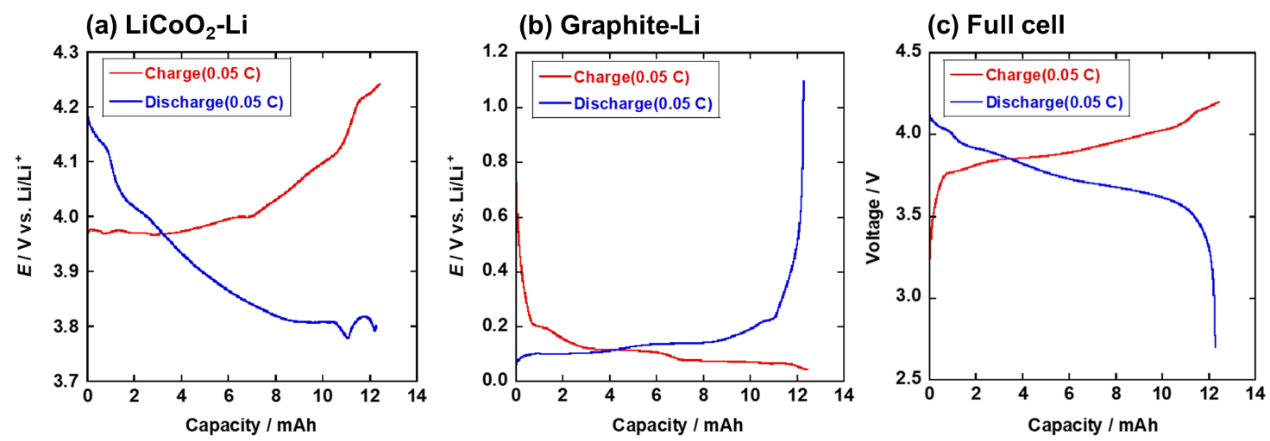
Fig. S1. Charge/discharge curves of (a) LiCoO₂-Li, (b) graphite-Li, and (c) full cell surveyed at 25 °C and a constant current of 0.05 C.

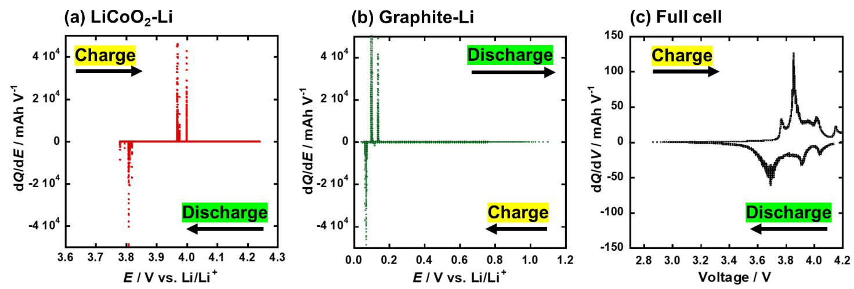
Fig. S2. Original profiles of Figs. 3a–3c before the adjustment.

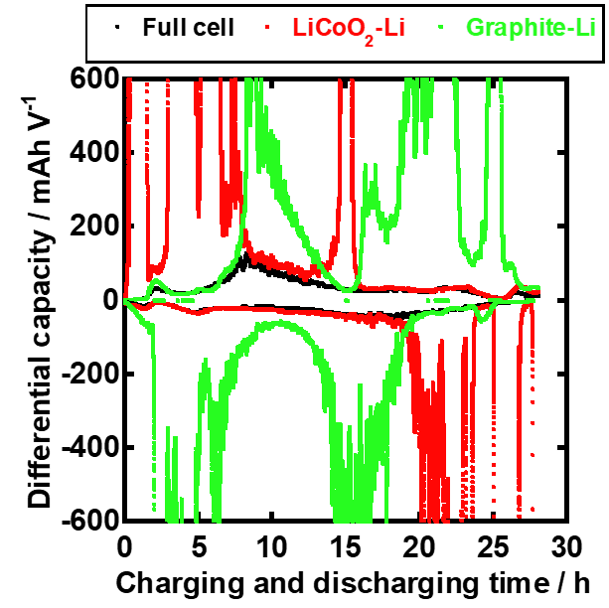
Fig. S3. Original profile before the adjustment (Fig. 4).

