Supporting Information

Mechanochemical synthesis of pyrite Ni_{1-x}Fe_{x}S₂ electrode for all-solid-state sodium battery
Gaku Shirota, Akira Nasu, Atsushi Sakuda*, Minako Deguchi, Kota Motohashi, Masahiro Tatsumisago, and Akitoshi Hayashi
Department of Applied Chemistry, Graduate School of Engineering, Osaka Prefecture University, 1-1, Gakuen-cho, Naka-ku, Sakai, Osaka 599-8531, Japan

*Corresponding author:
Atsushi Sakuda (Ph. D., Associate Professor)
Department of Applied Chemistry, Graduate School of Engineering, Osaka Prefecture University, 1-1 Gakuen-cho, Naka-ku, Sakai, Osaka 599-8531, JAPAN
Tel.: +81-72-2549333 Fax: +81-72-2549910
E-mail address: saku@chem.osakafu-u.ac.jp

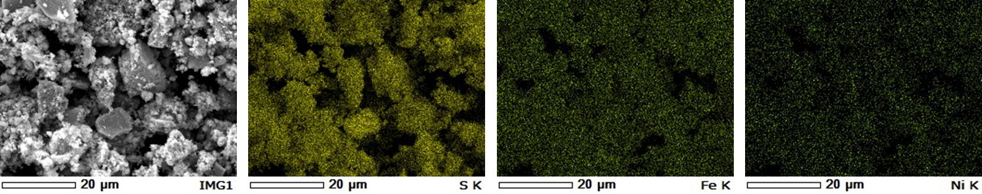
Fig. S1 The EDS mapping of the Ni_{0.3}Fe_{0.7}S₂ particle.

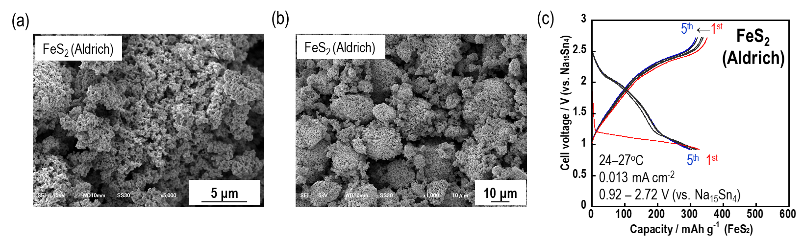
Fig. S2 (a, b) The SEM images of FeS₂ (99.9%, Aldrich). (c) Discharge-charge curve of Na₁₅Sn₄ / Na₃PS₄ / FeS₂ (99.9%, Aldrich) in all-solid-state cell.

