Discharge performance of the non-rechargeable lithium-air batteries with a waterproof and breathable film in an open environment
Xiaohua Xie^{1, *}, Zhongfa Yang², Jian Zhang¹, Baojia Xia¹
1. Shanghai Institute of Microsystem and Information Technology, Chinese Academy of Sciences, Shanghai, 200050, China
2. State Key Laboratory of Advanced Chemical Power Sources, Guizhou Meiling Power Sources Co. Ltd., Zunyi, Guizhou 563003, China
*Corresponding author:
Tel: (+86) 021-69976909
Fax: (+86) 021-69976911
E-mail address: xiexiaohua@mail.sim.ac.cn
Shanghai Institute of Microsystem and Information Technology, Chinese Academy of Sciences, Shanghai, 200050, China

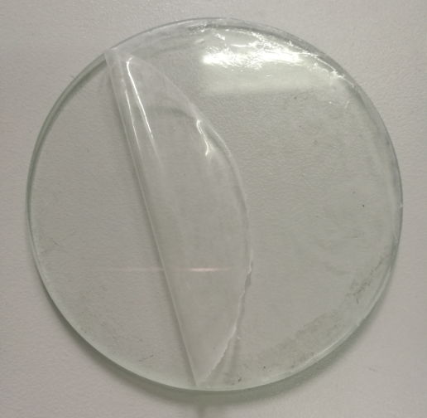
PDMS
Fig. S1 PDMS film

Fig. S2 Discharge curve of battery with different thickness PDMS film

Fig. S3 The impedance of the batteries with and without hot pressure

Fig.S4 Photos of coin-type and pouch-type lithium-air battery

Fig.S5 The discharge curve of battery in the constant temperature and humidity box (25°C, 30%RH)
Fig.S6 XRD patterns of air electrode of lithium air battery after discharge

