Supporting Materials for:
Room temperature operation of magnesium rechargeable batteries with a hydrothermally treated ZnMnO₃ defect spinel cathode

Toshihiko MANDAI,^{a,*,§} Ayaka KUTSUMA,^{b} Masashi KONYA,^{b} Yukihiro NAKABAYASHI,^{b} and Kiyoshi KANAMURA^{b,§§}

ªCenter for Advanced Battery Collaboration, Center for Green Research on Energy and Environmental Materials, National Institute for Materials Science (NIMS), 1-1 Namiki, Tsukuba, Ibaraki 305-0044, Japan
^{b}Department of Applied Chemistry for Environment, Graduate School of Urban Environmental Sciences, Tokyo Metropolitan University, 1-1 Minami-Osawa, Hachioji, Tokyo 192-0397, Japan

§ECSJ Active Member, §§ECSJ Fellow

ORCID
Toshihiko MANDAI: 0000-0002-2403-7794

*Corresponding author:
T. M.: Tel: +81-29-860-4464, E-mail: MANDAI.Toshihiko@nims.go.jp
Fig. S1. XRD profiles of the sample obtained from the pH13 precursor hydrothermally treated at 180 °C for 24h.

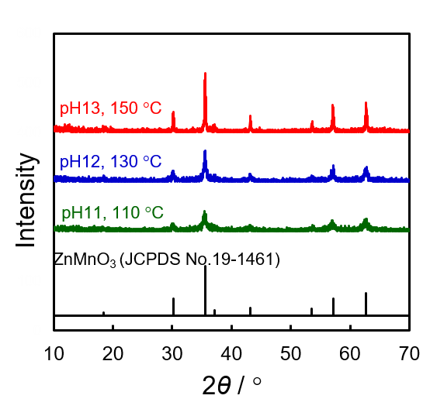
Fig. S2. XRD profiles of the ZnMnO₃ particles prepared using the three different experimental conditions shown in Table 1 in the main text.

Fig. S3. Effect of hydrothermal duration on the crystallinity of ZnMnO₃ obtained from the (a) pH 11 precursors treated at 110 °C and the (b) pH 12 precursors at 130 °C.

Fig. S4. Effect of hydrothermal duration on the crystallinity of ZnMnO₃ obtained from the pH 10 precursors treated at 110 °C.

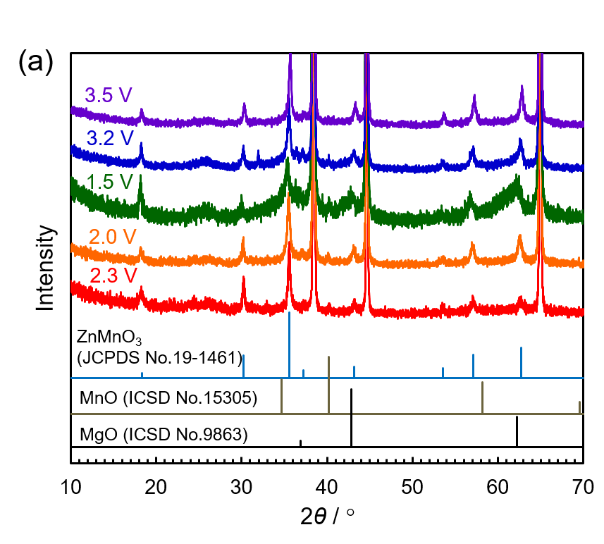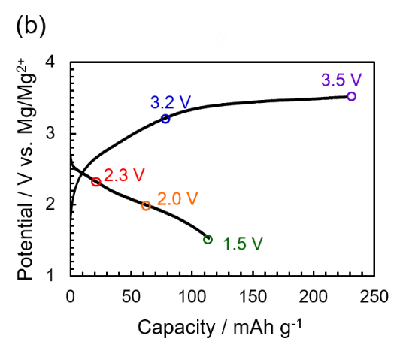
Fig. S5. (a) XRD profiles of the ZMO cathode retrieved from the cells at different discharged and charged states. (b) The corresponding discharge–charge curve.

Fig. S6. GITT curves of ZMO-10, -11, and -12 recorded at 150 °C.

Fig. S7. EDX mapping results of the (a) pristine and (b) cycled ZMO-12.

Fig. S8 (a) Galvanostatic discharge–charge curves for the first and second cycles of the ZnMnO₃ prepared by a coprecipitation method. (b) Corresponding discharge capacities as a function of the cycle number.

