Supplementary information of a novel evaluation method of powder electrocatalyst for gas evolution reaction

Kensaku NAGASAWA,^{a,}* Issei MATSUURA,^{b} Yoshiyuki KURODA,^{a,b} and Shigenori MITSUSHIMA^{a,b}

ªInstitute of Advanced Sciences, Yokohama National University, 79-5 Tokiwadai, Hodogaya-ku, Yokohama 240-8501, Japan
^{b}Graduate school of Engineering Science, Yokohama National University, 79-5 Tokiwadai, Hodogaya-ku, Yokohama 240-8501, Japan

Corresponding author: Kensaku Nagasawa, Tel: +81-45-339-4013, Fax: +81-45-339-4024.
E-mail: nagasawa-kensaku-st@ynu.ac.jp

S1 Synthesis method of LaNiO₃
LaNiO₃ Powder catalyst was synthesized by the sol-gel method. La(NO₃)₃･6H₂O (Wako Pure Chemical corp., 99.9%) was dried at 150ºC for 2 hours and then mixed at 150ºC for 2 hours with 100 ml 2-Methoxyethanol. (CH₃COO)₂Ni･4H₂O (Junsei Chemical Co. Ltd., 98.0%) was dried at 200ºC for 2 hours and then mixed at 150ºC for 2 hours with 50 ml 2-methoxyethanol and 50 ml 2-Aminoethanol. Two precursors were mixed at 150ºC for 2 hours. 10 ml mixed-solution was heated at 150ºC for 24 hours and then 400ºC for 1 hours in alumina crucible by muffle furnace. After clash in agate mortar for 10 min, the powder catalyst was heat-treated at 800ºC for 12 hours and clashed for 10 min.

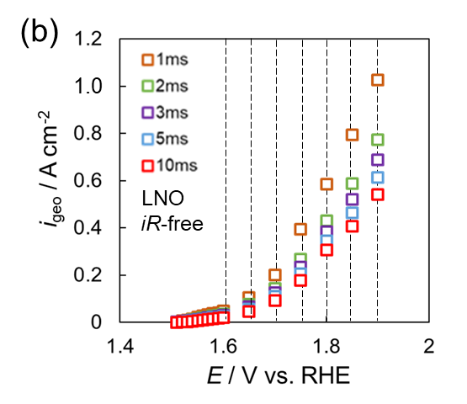
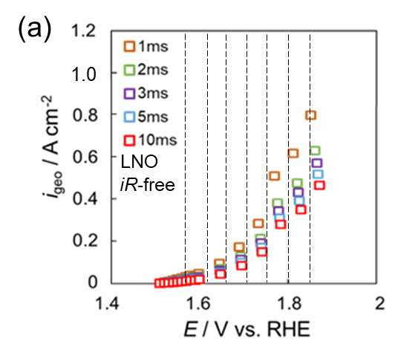
S2 Interpolation process after iR corrected

Figure S1(a) Before and (b) after interpolation process for i-E plots after iR corrected.

