Supporting Information

Synthesis and lithium-ion conductivity of Sr(La_{1−x}Li_{3x})ScO₄ with a K₂NiF₄ structure
Guowei ZHAO,^{a,b} Kota SUZUKI,^{a,c,d} Masaaki HIRAYAMA,^{a,c,d} Ryoji KANNO^{a,c,d,*}
ª All-Solid-State Battery Unit, Institute of Innovation Research, Tokyo Institute of Technology, 4259 Nagatsuta, Midori-ku, Yokohama 226-8502, Japan
^{b} College of Chemistry and Chemical Engineering, Huanggang Normal University, 438000 Huanggang, Hubei Province, China
^{c} Research Center for All-Solid-State Battery, Institute of Innovation Research, Tokyo Institute of Technology, 4259 Nagatsuta, Midori-ku, Yokohama 226-8502, Japan
^{d} Department of Chemical Science and Engineering, School of Materials and Chemical Technology, Tokyo Institute of Technology, 4259 Nagatsuta, Midori-ku, Yokohama 226-8502, Japan
*Corresponding author: kanno@echem.titech.ac.jp

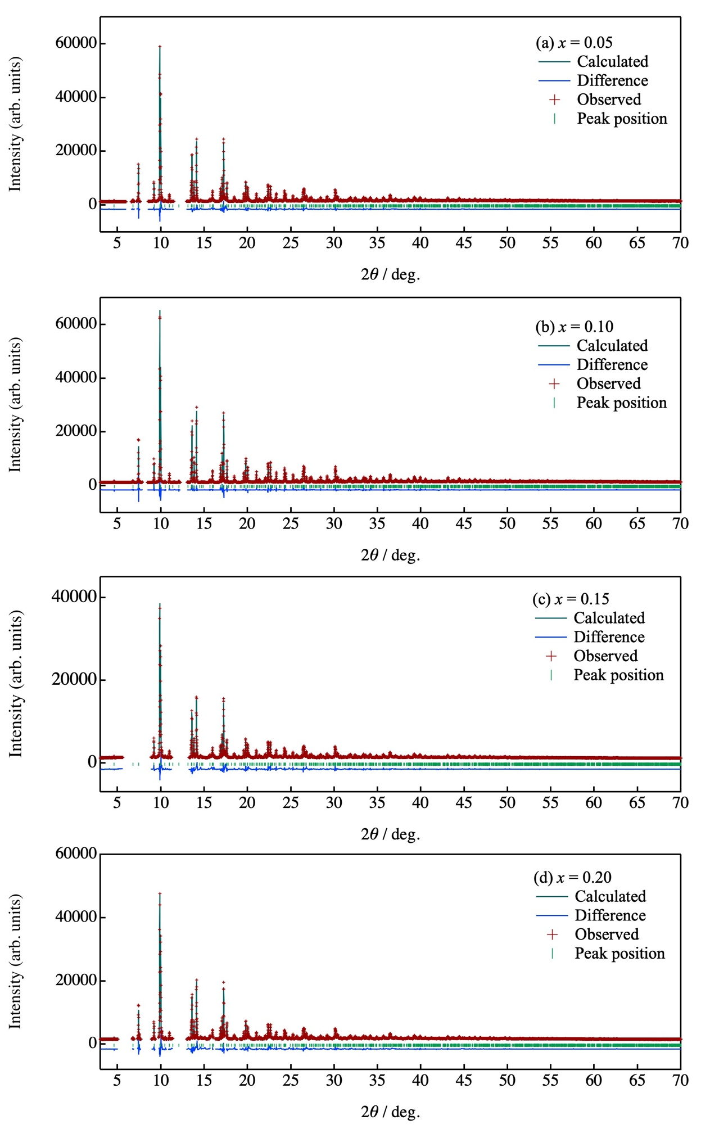
Figure. S1. Synchrotron powder diffraction and Rietveld refinement patterns for Sr(La_{1−x}Li_{3x})ScO₄ (x = 0.05, 0.10, 0.15 and 0.20) at 300 K: (a) x = 0.05, (b) x = 0.10, (c) x = 0.15, and (d) x = 0.20. Red: observed intensities; Black: calculated intensities; blue: difference plot. The green markers indicate the positions of the diffraction lines.

Table S1. Results obtained from the Rietveld refinement of the synchrotron X-ray diffraction pattern of Sr(La_{1−x}Li_{3x})ScO₄.ª
Atom | Site | g^{b} |  | x | y |  | z | B_{iso} (Å²)^{c}
(1) x = 0.05, SrLa_{0.95}Li_{0.15}ScO₄, space group: Abma (No. 64), a = 5.7654(15) Å, b = 5.7574(13) Å, c = 12.4825(2) Å, V = 414.41(16) Å³, R_{wp} = 6.018, R_{p} = 3.271, R_{e} = 2.313, S = R_{wp}/R_{e} = 2.602, R_{f} = 1.229
Li1/Li | 8f | 0.025 |  | =x(La) |  | =y(La) | =z(La) | =B_{iso.} (La)
Sr | 8f | 0.5 |  | =x(La) |  | =y(La) | =z(La) | =B_{iso.} (La)
La | 8f | 0.475 |  | 0.0140(3) |  | 0 | 0.35674(6) | 0.57(2)
Sc | 4a | 1.0 |  | 0 |  | 0 | 0 | 0.58(5)
O1 | 8e | 1.0 |  | 0.25 |  | 0.25 | 0.0183(8) | 2.0(2)
O2 | 8d | 1.0 | 0.437(17) |  |  | 0 | 0.3268(5) | 0.7(2)
(2) x = 0.10, SrLa_{0.90}Li_{0.30}ScO₄, space group: Abma (No. 64), a = 5.76376(8) Å, b = 5.75654(8) Å, c = 12.4725(13) Å, V = 413.829(9) Å³, R_{wp} = 5.156, R_{p} = 2.970, R_{e} = 2.370, S = R_{wp}/R_{e} = 2.175, R_{f} = 1.317
Li1/Li | 8f | 0.05 | =x(La) |  |  | =y(La) | =z(La) | =B_{iso.} (La)
Sr | 8f | 0.5 | =x(La) |  |  | =y(La) | =z(La) | =B_{iso.} (La)
La | 8f | 0.45 | 0.0129(19) |  |  | 0 | 0.35701(5) | 0.38(15)
Sc | 4a | 1.0 | 0 |  |  | 0 | 0 | 0.69(4)
O1 | 8e | 1.0 | 0.25 |  |  | 0.25 | 0.0167(6) | 1.0(13)
O2 | 8d | 1.0 | 0.438(13) |  |  | 0 | 0.3297(4) | 1.5(2)
(3) x = 0.15, SrLa_{0.85}Li_{0.45}ScO₄, space group: Abma (No. 64); a = 5.7681(14) Å, b = 5.7602(12) Å, c = 12.4913(17) Å, V = 415.03(14) Å³, R_{wp} = 6.642, R_{p} = 3.785, R_{e} = 2.582, S = R_{wp}/R_{e} = 2.572, R_{f} = 2.703
Li1/Li | 8f | 0.075 | =x(La) |  |  | =y(La) | =z(La) | =B_{iso.} (La)
Sr | 8f | 0.5 | =x(La) |  |  | =y(La) | =z(La) | =B_{iso.} (La)
La | 8f | 0.425 | 0.0141(4) |  |  | 0 | 0.35681(8) | 0.61(2)
Sc | 4a | 1.0 | 0 |  |  | 0 | 0 | 1.04(7)
O1 | 8e | 1.0 | 0.25 |  |  | 0.25 | 0.021(12) | 3.1(3)
O2 | 8d | 1.0 | 0.443(3) |  |  | 0 | 0.3248(7) | 0.7(2)
(4) x = 0.20, SrLa_{0.80}Li_{0.60}ScO₄, space group: Abma (No. 64), a = 5.7655(2) Å, b = 5.7569(19) Å, c = 12.4837(3) Å, V = 414.36(2) Å³, R_{wp} = 6.510, R_{p} = 3.518, R_{e} = 2.246, S = R_{wp}/R_{e} = 2.899, R_{f} = 1.555
Li1/Li | 8f | 0.1 | =x(La) |  |  | =y(La) | =z(La) | =B_{iso.} (La)
Sr | 8f | 0.5 | =x(La) |  |  | =y(La) | =z(La) | =B_{iso.} (La)
La | 8f | 0.4 | 0.0137(4) |  |  | 0 | 0.35681(8) | 0.63(3)
Sc | 4a | 1.0 | 0 |  |  | 0 | 0 | 1.34(7)
O1 | 8e | 1.0 | 0.25 |  |  | 0.25 | 0.020(10) | 2.5(3)
O2 | 8d | 1.0 | 0.438(2) |  |  | 0 | 0.3243(6) | 1.4(3)
ªSpace group: Abma (64); ^{b}site occupancy, g; and ^{c}isotropic atomic displacement parameter, B_{iso}.

Table S2.
Numerical fitting results of the sample spectra obtained using electrochemical impedance spectroscopy at a representative temperature of 250 ℃. Chi-square is an ideality factor used to evaluate the goodness of the fit.
Sample composition | Sr(La_{0.95}Li_{0.15})ScO₄  (x = 0.05) | Sr(La_{0.90}Li_{0.30})ScO₄  (x = 0.1)
Chi square | 0.05 | 0.003
CPE1-T (CPE1, total) | 4.05E−11 | 6.07E−11
CPE1-P (n1, total) | 0.99 | 0.92
R1 (total/Ω) | 3315400 | 1250300
Ws1-R | 3.6E5 | 1.25E6
Ws1-T | 52.26 | 13.15
Ws1-P | 0.84 | 0.63
Thickness (L)[cm] | 0.1 | 0.1
Area (S)[cm²] | 0.071 | 0.071
Total conductivity (σ_{total}) [S/cm] | 3.32 × 10⁻⁷ | 4.66 × 10⁻⁶
Sample composition | Sr(La_{0.85}Li_{0.45})ScO₄  (x = 0.15) | Sr(La_{0.8}Li_{0.60})ScO₄  (x = 0.2)
Chi square | 0.003 | 0.013
CPE1-T (CPE1, total) | 1.33E−11 | 7.51E−11
CPE1-P (n1, total) | 0.95 | 0.95
R1 (total/Ω) | 255690 | 956210
Ws1-R | 6.25E6 | 4.36E6
Ws1-T | 52.7 | 22.83
Ws1-P | 0.95 | 0.60
Thickness (L)[cm] | 0.09 | 0.11
Area (S)[cm²] | 0.075 | 0.075
Total conductivity (σ_{total}) [S/cm] | 1.13 × 10⁻⁶ | 1.52 × 10⁻⁶

Table S3.
Summary of the total conductivity (σ_{total}) measured at different temperatures and the activation energy (E_{a}) fitted with the conventional Arrhenius law in the lower-temperature region (<270 °C).
Temperature  T / ℃ | Resistance  R / Ω | σ_{total}  / Scm⁻¹ | E_{a}  / kJ mol⁻¹
Sr(La_{0.95}Li_{0.15})ScO₄
210 | 3.31E+07 | 4.00E-08 | 117.6
250 | 3.32E+06 | 4.00E-07
275 | 1.01E+06 | 1.31E-06
310 | 2.01E+05 | 6.60E-06
350 | 5.64E+03 | 2.35E-04
375 | 1.08E+03 | 1.22E-03
400 | 1.27E+02 | 1.04E-02
Sr(La_{0.90}Li_{0.30})ScO₄
150 | 7.02E+07 | 2.01E-08 | 94.3
200 | 1.16E+07 | 1.21E-07
225 | 4.59E+06 | 3.08E-07
250 | 1.25E+06 | 1.13E-06
275 | 4.69E+05 | 3.02E-06
300 | 1.04E+05 | 1.36E-05
325 | 1.41E+04 | 1.00E-04
350 | 5.14E+02 | 2.75E-03
375 | 2.92E+02 | 4.85E-03
400 | 3.40E+02 | 4.16E-03
Sr(La_{0.85}Li_{0.45})ScO₄
150 | 5.67E+07 | -17.67781 | 103.4
200 | 3.04E+06 | -14.75003
225 | 1.09E+06 | -13.72873
250 | 2.56E+05 | -12.27574
275 | 6.71E+04 | -10.93801
300 | 7.27E+03 | -8.715665
325 | 2.60E+02 | -5.384697
350 | 8.00E+01 | -4.206042
375 | 3.50E+01 | -3.379364
Sr(La_{0.8}Li_{0.60})ScO₄
200 | 1.97E+07 | 7.40E-08 | 99.3
250 | 9.56E+05 | 1.52E-06
275 | 2.92E+05 | 4.98E-06
300 | 3.30E+04 | 4.42E-05
325 | 4.35E+02 | 3.35E-03
350 | 5.30E+01 | 2.75E-02
375 | 3.40E+01 | 4.29E-02

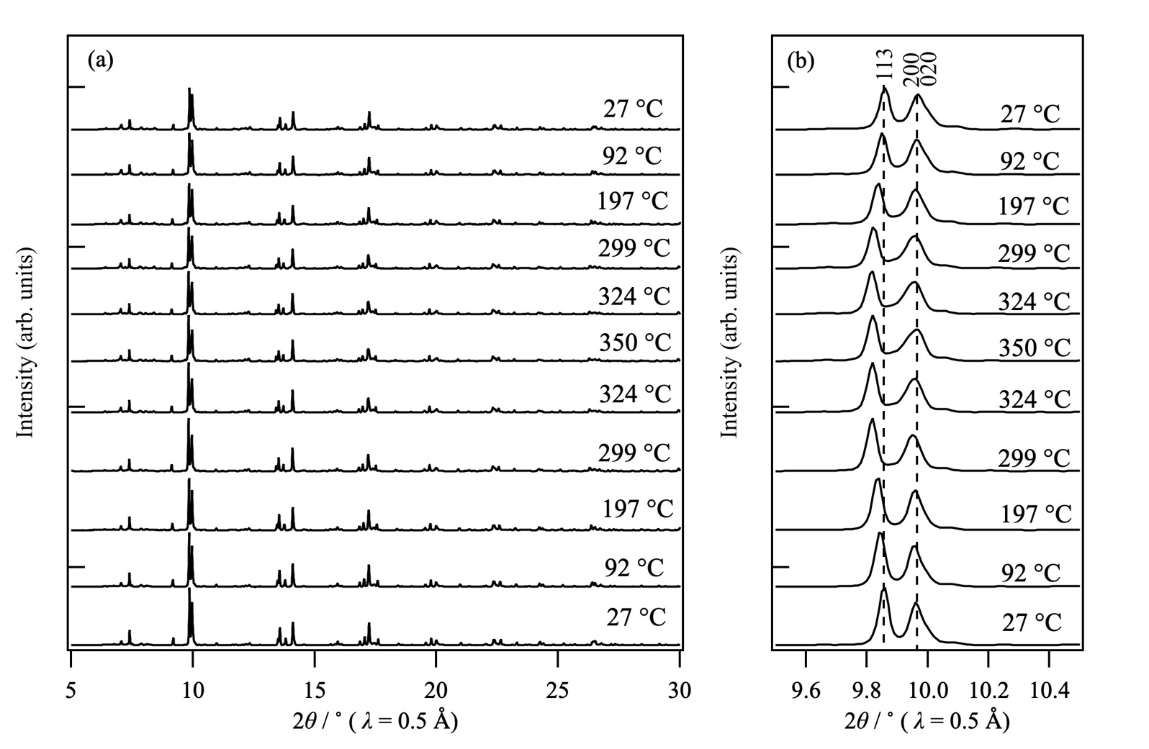
Figure. S2. High-temperature X-ray diffraction patterns of Sr(La_{1−x}Li_{3x})ScO₄ (x = 0.15): (a) in 2θ range of 5°–30°; (b) in 2θ range of 9.6°–10.4°, showing the peaks corresponding to the 113, 200, and 020 reflections. The powder sample was heated to 350 °C, and then cooled to 27 °C. The X-ray diffraction patterns are arranged in the order of heating process and cooling process, from bottom to top.

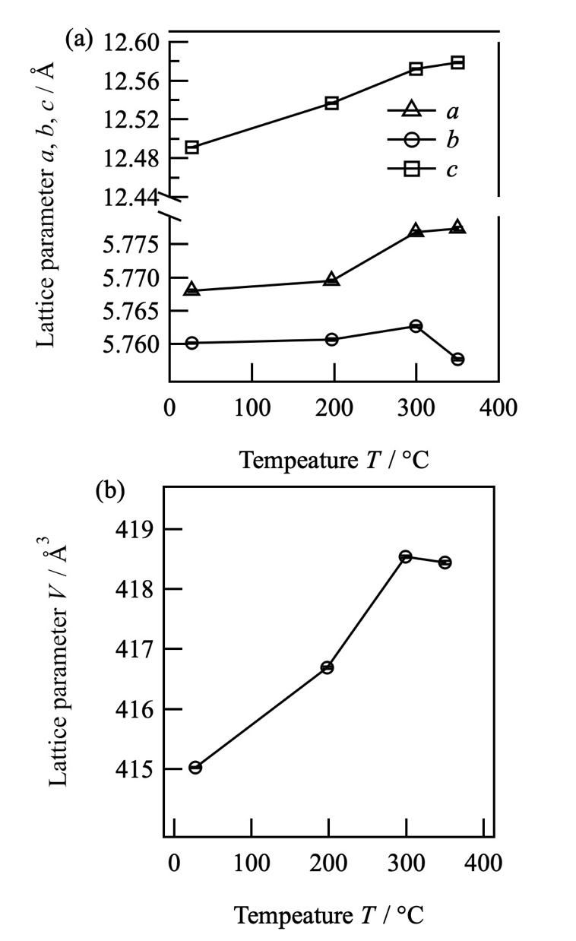

Figure. S3. Temperature dependence of the lattice parameters of Sr(La_{1−x}Li_{3x})ScO₄ (x = 0.15), determined by the Rietveld analysis of the X-ray diffraction data.

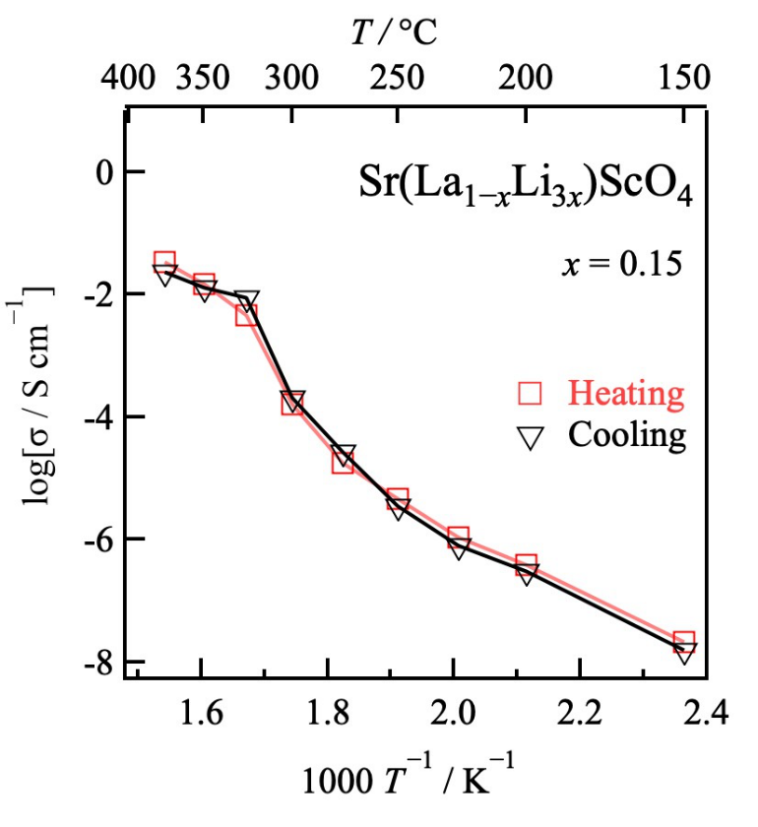
Figure. S4. Temperature-dependence of the conductivities of Sr(La_{1−x}Li_{3x})ScO₄ (x = 0.15) during heating and cooling processes.

