Supporting Information

Rapid and Highly Sensitive Electrochemical Technique for Cell Viability Assay via Monitoring of Intracellular NADH with New Double Mediator System

Mohammad ABDUL ALIM,^{1, 2,*,†} Minoru SUGA,^{3,†,§} and Hiroaki SHINOHARA^{1, 3,*,†,§}

¹Graduate School of Innovative Life Science, University of Toyama, 3190 Gofuku,
Toyama 930-8555, Japan
²Bangabandhu Sheikh Mujibur Rahman Science and Technology University
Gopalganj, 8100, Bangladesh
³Faculty of Engineering, Academic Assembly, University of Toyama, 3190 Gofuku,
Toyama 930-8555, Japan

* Corresponding authors: alimbsmrstu@gmail.com and
hshinoha@eng.u-toyama.ac.jp

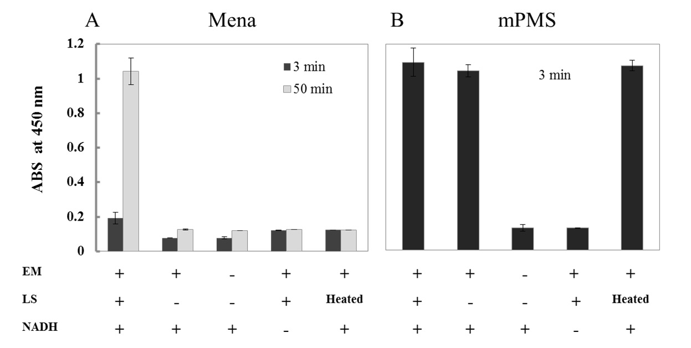

Fig. S1 Cytosolic enzyme-dependency of the reduction of WST-1 by NADH through the mediatation of Mena or mPMS. Produced formazan from WST-1 was measured by absorbance at 450 nm with various conditions described under the bottom of the figures (EM = Electron mediator, e.i., Mena and mPMS. LS = Lysate supernatant). Measurment was done during 75 min after mixing of the compounds. The results are expressed as the mean ± SD from three experiments. (A) Mena was used as the electron mediator. Produced formazan increased as time passed after addition of PC12 cell lysate (LS), however no absorbance increase was observed by addition of LS heated for 30 min. This data demonstrated that cytosolic enzyme was essential for WST-1 reduction by NADH through the mediation of Mena. (B) mPMS was used as the electron mediator. Enough formazan was produced quickly within 3 min and kept constantly in both of the absence and the presence of LS. Same amount of formazan was produced in the presence of heated LS. This data demonstrated that WST-1 reduction occurred by non-enzymatically through the mediation of mPMS. From these results, it was confirmed that the electron transfer from NADH to Mena was dependent on cytosolic enzyme and the reduction rate of Mena was slow incontrast to mPMS which takes electron from NADH enzyme-independenly and very fastly.

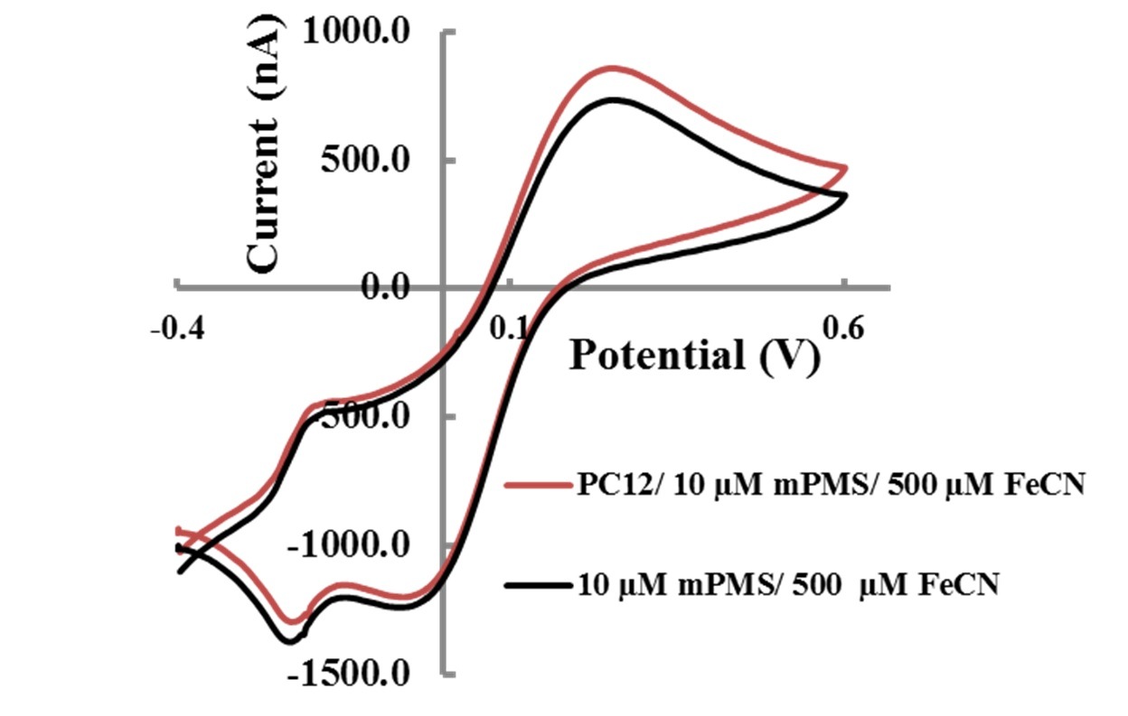

Fig. S2 Cyclic voltammograms of double mediators in the presence and absence of PC12 cells. The PC12 cells (3${×10}^{5}$ cells/ well) were incubated with 10 µM mPMS and 500 µM FeCN for 10 min under 5% CO₂ at 37$℃$ . After incubation, accumulated ferrocyanide was measured by cyclic voltammetry. Cells with 10 µM mPMS and 500 µM FeCN, the oxidation current was significantly increased as compared to control (without cells). The voltammograms supported that Scheme1 might be suitable to detect the cell viability.

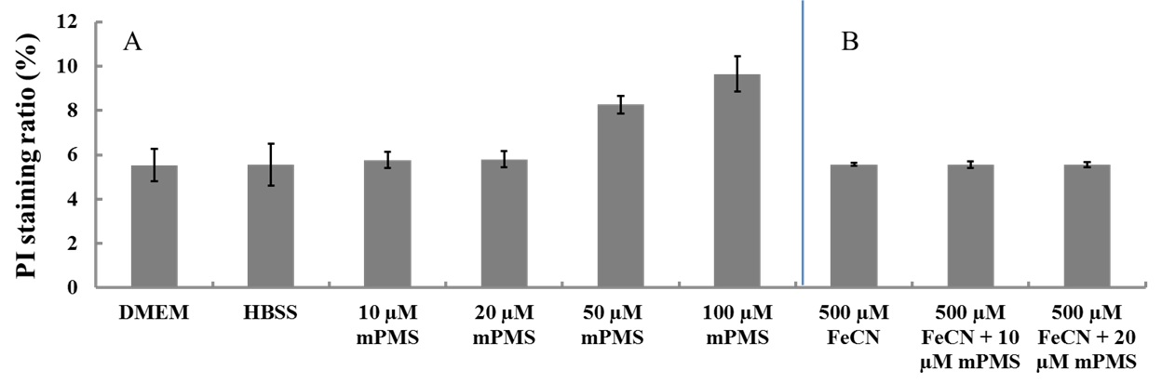

Fig. S3 Determination of cytotoxicity of mPMS (A) and the mixture of mPMS and K₃[Fe(CN)₆] (B) on PC12 cells. Cells were incubated with mPMS or the mixture of 1-mPMS and 500 µM K₃[Fe(CN)₆] for 60 min at 37$℃$ under 5% CO₂. 20 µL propidium iodide (final conc.1.5 µM) was added and again incubated for 15 min. Every case, total volume of experimental cell suspension was maintained to 150 µL with DMEM or HBSS. It was observed that more than 50 µM mPMS was toxic on PC12 cells. On the other hand, 10 or 20 µM mPMS coexisting 500 µM K₃[Fe(CN)₆] (or only 500 µM K₃[Fe(CN)₆]) was not toxic on PC12 cells. The results were expressed as the mean ± SD from four experiments.

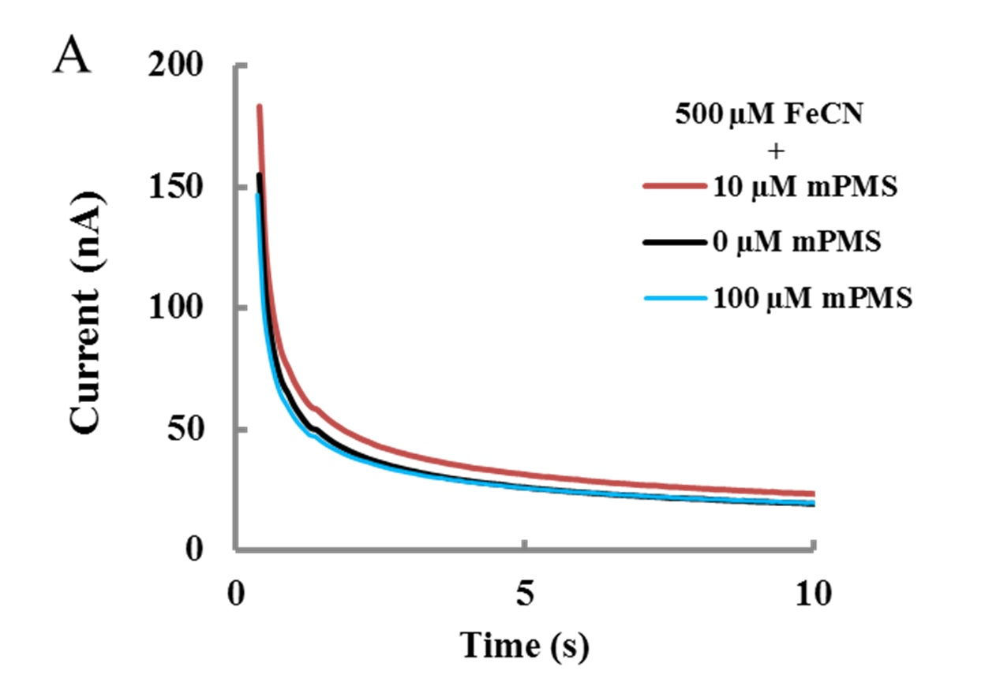

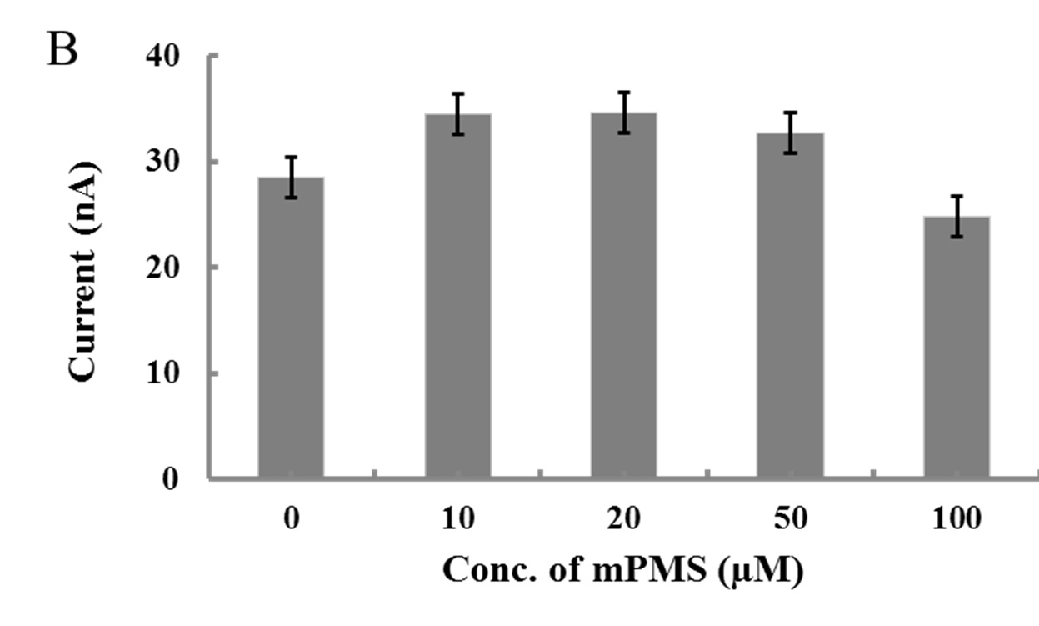

Fig. S4 Optimization of mPMS concentration for the electrochemical monitoring of intracellular NADH in PC12 cells. (A) Oxidation current profiles of double mediator solutions containing various concentrations of mPMS and 500 µM K₃[Fe(CN)₆] for monitoring intracellular NADH. (B) 1-mPMS concentration dependent oxidation current in the chronoamperogram.The PC12 cells (3${×10}^{5}$ cells/ well) were incubated in the mixed solutions with various concentration of mPMS and 500 µM K₃[Fe(CN)₆]. The oxidation current was measured at 5 s after +0.5 V application in chronoamperometry after 10 min incubation at 37$℃$ under 5% CO₂. It assumed that the coupling of 10 µM 1-mPMS and 500 µM K₃[Fe(CN)₆] was most suitable to monitor the intracellular NADH for this assay. The results are expressed as the mean ± SD from four experiments. In the absence of mPMS and presence of FeCN, we observed the big oxidation current. We are studying the origin of this current.
Read point = 5s

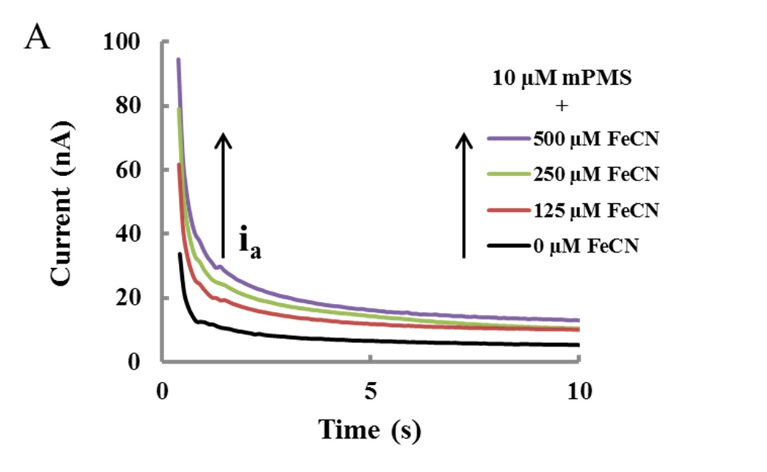
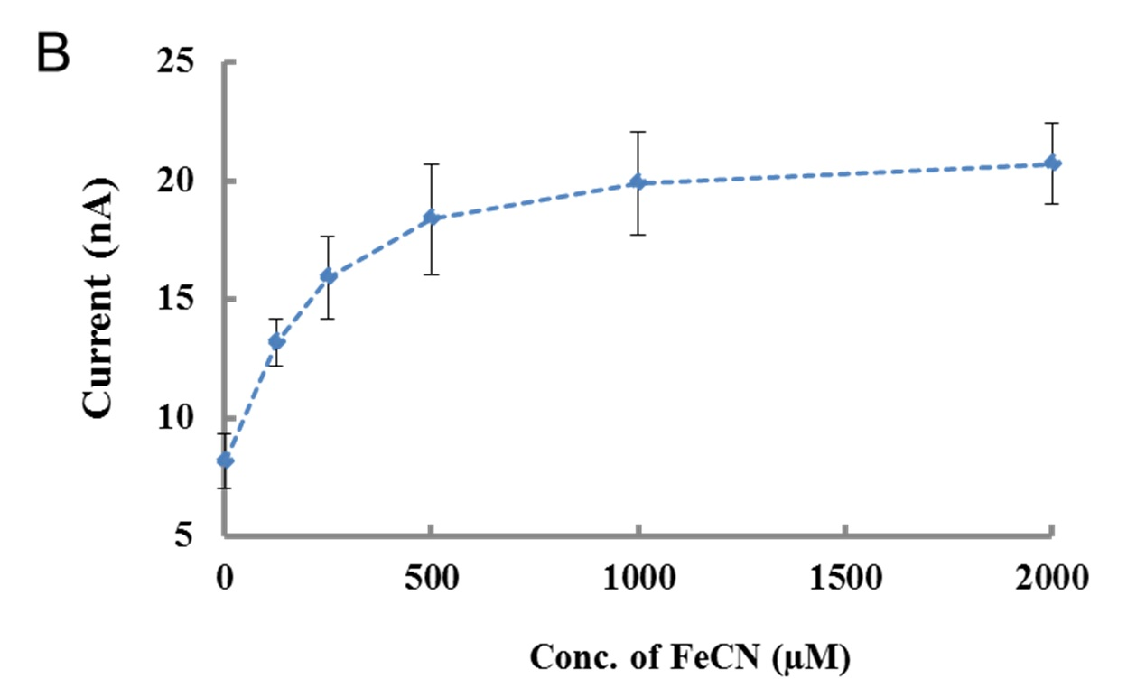
Fig. S5 (A) K₃[Fe(CN)₆] concentration-dependent chronoamperogram in PC12 cell suspension including the double mediators, (B) K₃[Fe(CN)₆] concentration-dependent oxidation current. PC12 cells (3${×10}^{5}$ cells/ well) were incubated for 10 min at 37$℃$ under 5% CO₂ in the mixed solutions with 10 µM mPMS and various concentrations of K₃[Fe(CN)₆]. Oxidation current in the chronoamperogram was read at 5 s after potential application at + 0.5 V. In case of 10 µM mPMS and 500 µM K₃[Fe(CN)₆], the oxidation current reached maximum and therefore these conditions were used for following all electrochemical measurements.

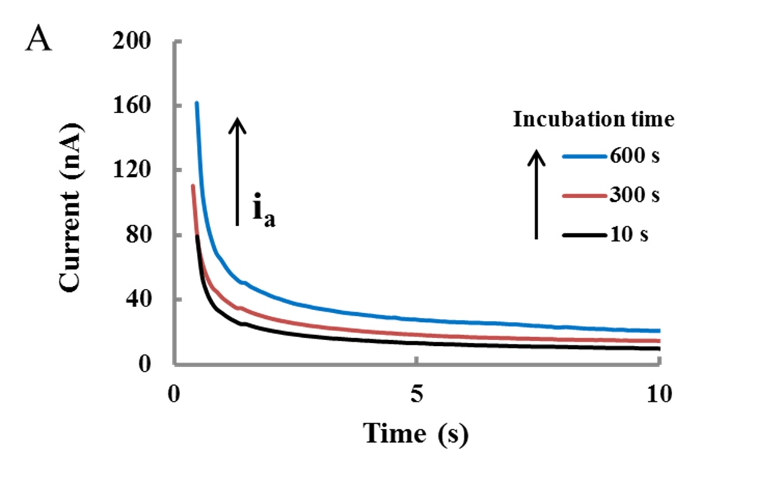
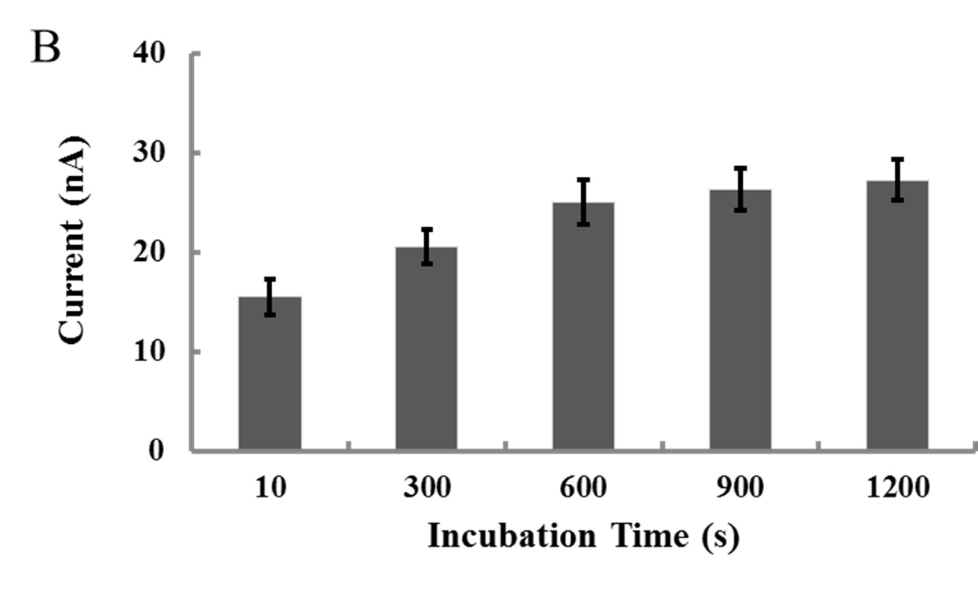

Fig. S6 Optimization of incubation time before electrochemical measurement. (A) Oxidation current profiles with same double mediator system and different incubation time for monitoring intracellular NADH. (B) Incubation time dependent oxidation current in the chronoamperograms. The oxidation current was read at 5 s after potential application at + 0.5 V. The oxidation current gradually increased by increasing incubation time up to 1200 s and 600 s was enough to facilitate mPMS-mediated intracellular NADH monitoring. These data indicated that 600 s was the optimized incubation time and further all electrochemical measurements were done by 600 s incubation of cells in double mediator solutions.
Read point = 5s

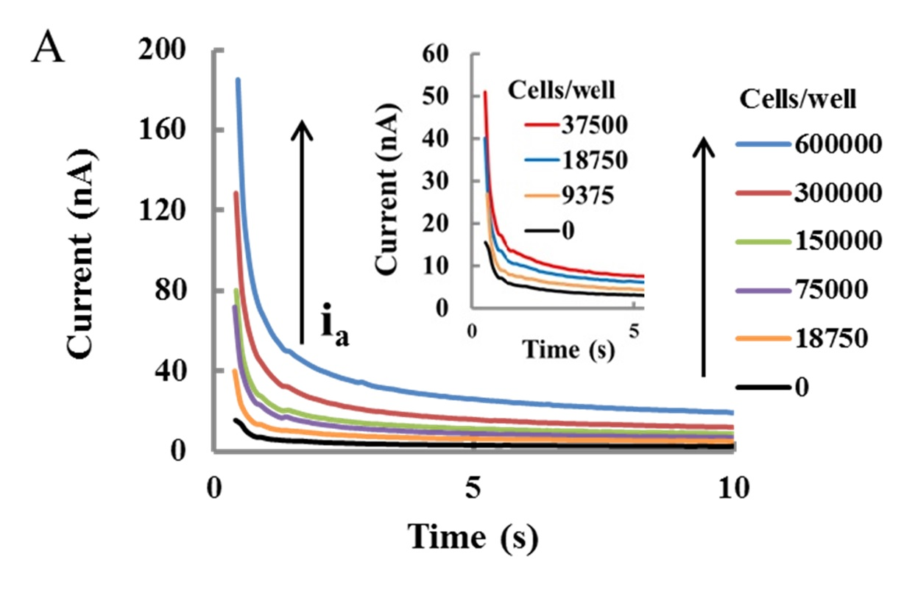

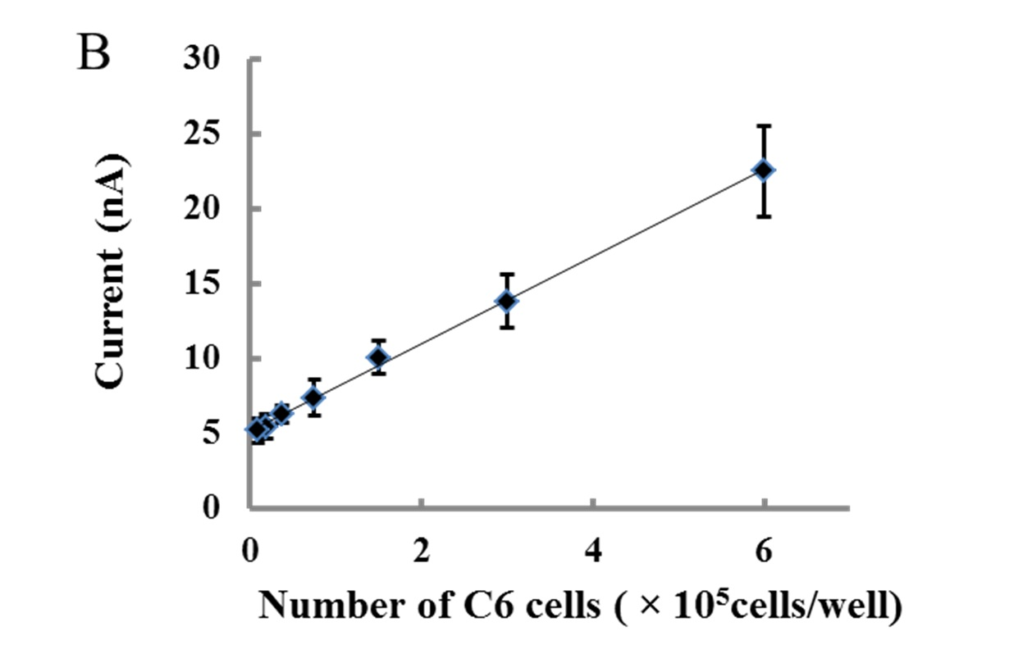
Fig. S7 (A) C6 cell number-dependent oxidation current profiles of double mediator system for monitoring intracellular NADH. Inset: Oxidation current profile to lower concentration of cells. (B) Calibration curve for C6 cell counting. The results are expressed as the mean ± SD from three experiments, R² = 0.998.

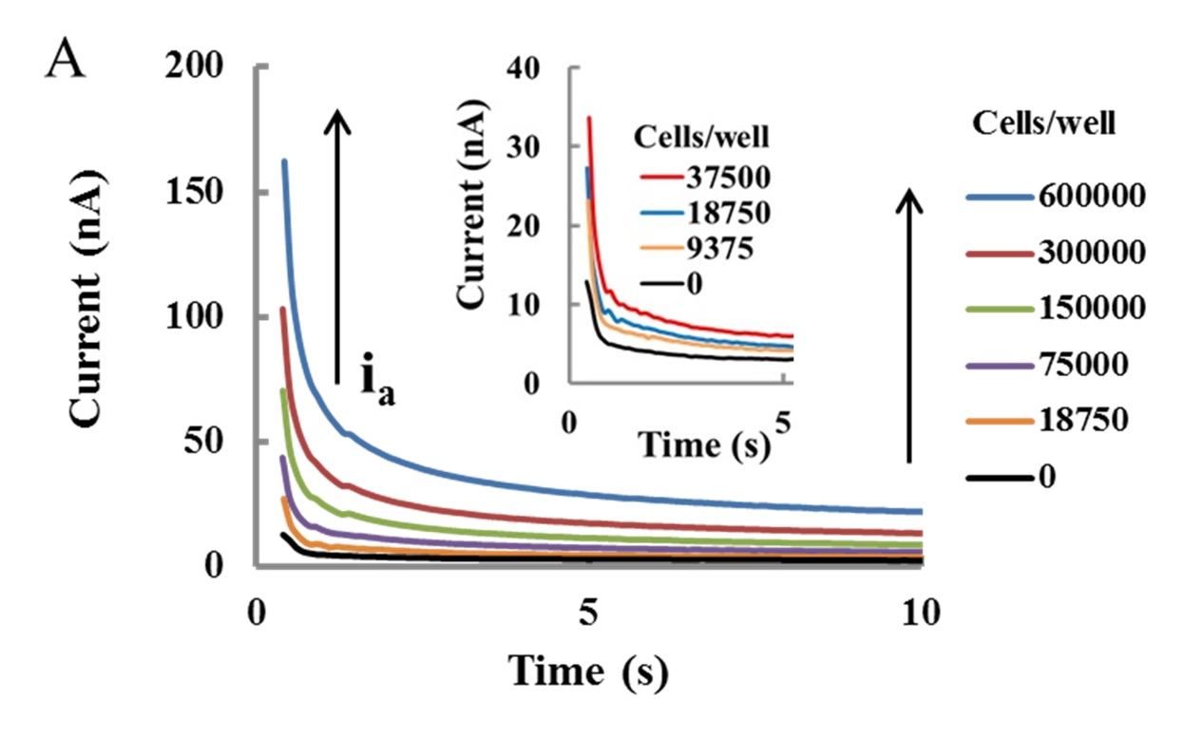

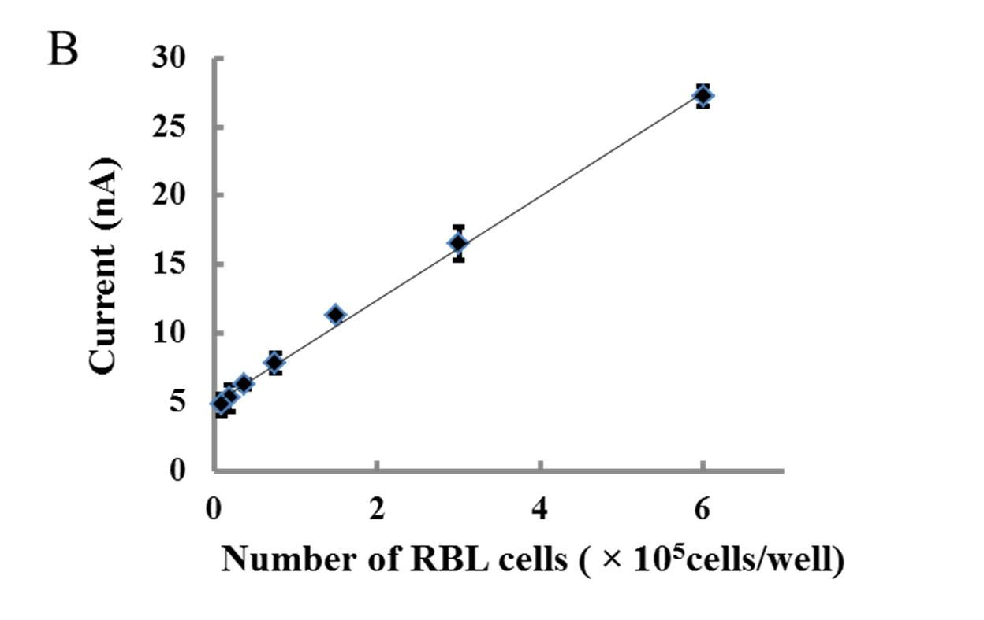

Fig. S8 (A) RBL-2H3 cell number-dependent oxidation current profiles of double mediator system for monitoring intracellular NADH. Inset: Oxidation current profile to lower concentration of cells. (B) Calibration curve for RBL-2H3 cell counting. The results are expressed as the mean ± SD from three experiments, R² = 0.997.

