Supporting Information for
Enhanced Electrochemical Performances of Ni-rich Cathode Materials for Lithium ion Batteries by Mixed Coating Layers

Zunzhi WANG, ^{a,b,*,†} Shengxian SHE, ^{a,b,*,†} Mengyao LV,^{b} Xujun YUAN,^{b} Hui SUN,^{b} Jun ZHAO,^{b} Jian YU, ^{b} and Xufeng YAN^{b}

ª School of Material Science and Engineering, Zhejiang University, Zheda Road No.38, Hangzhou, Zhejiang, 310000 China
^{b} Ningbo Ronbay New Energy Technology Co., Ltd., Tanjialing East Road No.39 , Ningbo, Zhejiang, 315400 China

Corresponding author: wzz@ronbaymat.com (Z. W.), ssx@ronbaymat.com (S. S.)

†These authors contributed equally to this work.

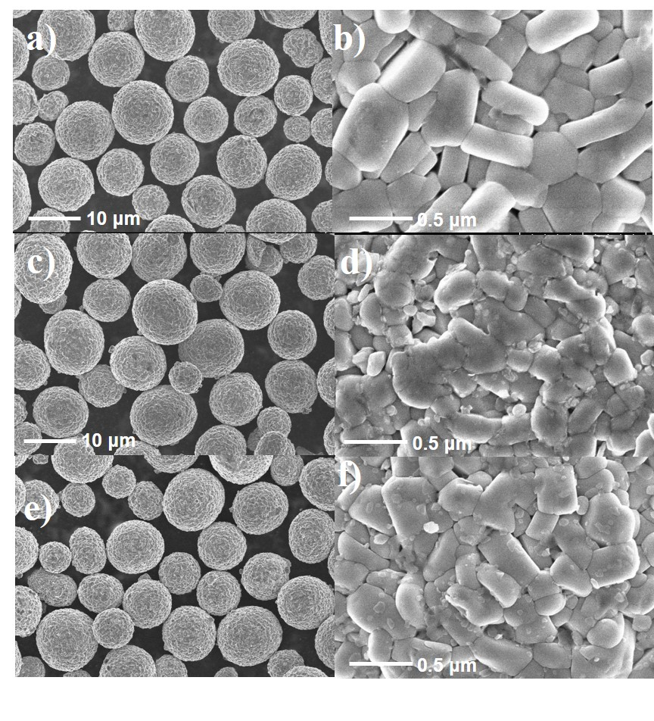
Figure S1. The SEM images of a), b) NCM9055; c), d) NCM9055-LPO; e), f)

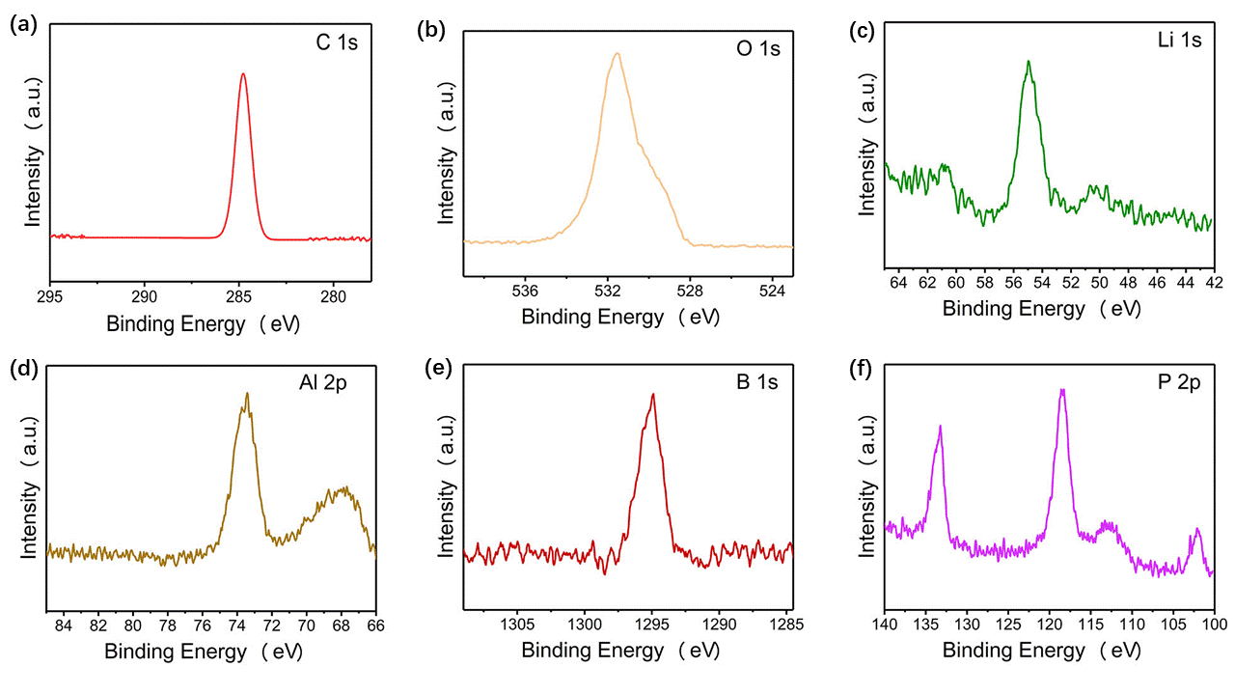
Figure S2. The XPS spectra of a) C 1s, b) O 1s, c) Li 1s, d) Al 2p, e) B 1a, and f) P 2p.

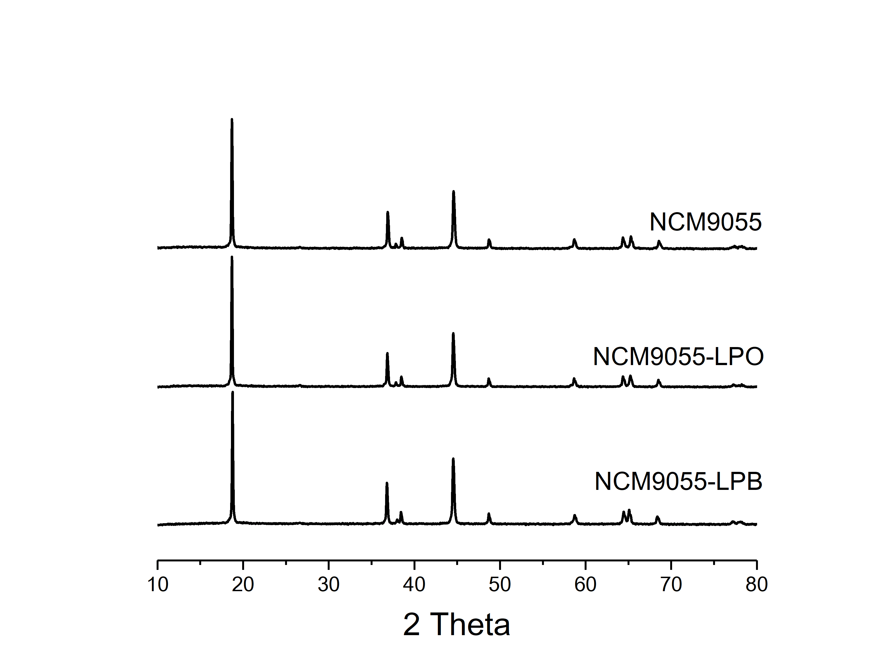
Figure S3. The XRD of cycled NCM9055, NCM9055-LPO, and NCM9055-LPB.

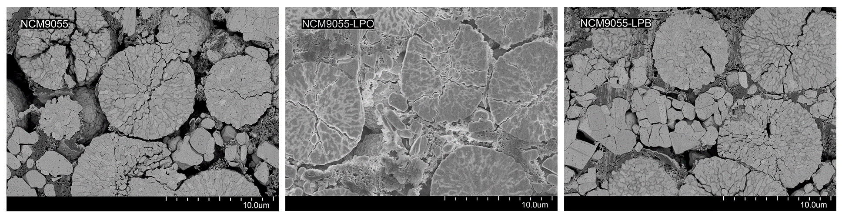
Figure S4. The SEM of cycled NCM9055, NCM9055-LPO, and NCM9055-LPB.

Table S1. The physical and chemical properties of NCM9055, NCM9055-LPO, and NCM9055-LPB.

Samples | Items | Unit | NCM9055 | NCM9055-LPO | NCM9055-LPB
Physical &Chemical Properties | Li | wt % | 7.23 | 7.24 | 7.22
 | Ni | wt % | 90.27 | 90.30 | 90.31
 | Co | wt % | 5.03 | 4.98 | 4.79
 | Mn | wt % | 4.70 | 4.72 | 4.90
 | Li₂CO₃ | wt % | 1.1035 | 0.1082 | 0.2444
 | LiOH | wt % | 0.5592 | 0.2432 | 0.2550
 | BET | m²/g | 0.2991 | 1.1127 | 0.3846
 | pH |  | 12.07 | 11.38 | 11.20
 | D_{min} | μm | 4.78 | 4.80 | 4.78
 | D_{max} | μm | 21.67 | 21.65 | 21.65
 | D₅₀ | μm | 10.38 | 10.42 | 10.21
 | (D₉₀-D₁₀)/D₅₀ | - | 0.67 | 0.67 | 0.67
Coin cell  (4.25~2.5V) | 0.2C-rate Charge | mAh/g | 230.6 | 230.3 | 235.6
 | 0.2C-rate Dis. | mAh/g | 200.9 | 206.9 | 213.4
 | Eff. | % | 87.1 | 89.8 | 90.6

