**Supporting Information for “Flow Electrosynthesis and Molecular Weight Control of Polyphenylene Deriving from 1,4-Bis(trimethylsilyl)benzene: Effect of a Silyl Substituent on the Coupling Position” Published in *Electrochemistry*, 2020, 88, 336-339.**

Yuto Nakamura,a Kenta Tanaka,a,† Yoshimasa Matsumura,b and Mahito Atobea,*

a *Graduate School of Science and Engineering, Yokohama National University, 79-1 Tokiwadai, Hodogaya-ku, Yokohama, 240-8501, Japan.*  
b *Graduate School of Science and Engineering, Yamagata University, 4-3-16 Jonan, Yonezawa, Yamagata, 992-8510, Japan.*

*\*Corresponding Author: atobe@ynu.ac.jp*

† Present address: Faculty of Pharmaceutical Sciences, Tokyo University of Science, 2641 Yamazaki, Noda, Chiba, 278-8510, Japan.

**CC BY 4.0**



|  |  |  |
| --- | --- | --- |
| **Figure S1** | Schematic illustration of preparation procedure for the electrochemical flow microreactor. | **p3** |
| **Table S1** | B3LYP/6-31G(d) calculated mulliken charges and spin densities with hydrogens of 1,4-bis(trimethylsilyl)benzene radical cation summed into heavy atoms | **p4** |
| **Figure S2** | 13C-NMR spectrum of polyphenylene synthesized by electro-oxidative polymerization of 1,4-bis(trimethylsilyl)benzene and following desilylation procedure. | **p5** |
| **Figure S3** | 1H-NMR spectrum of polyphenylene synthesized by electro-oxidative polymerization of 1,4-bis(trimethylsilyl)benzene and following desilylation procedure. | **p6** |
| **Table S2** | 13C-NMR data of polyphenylene synthesized by electro-oxidative polymerization of 1,4-bis(trimethylsilyl)benzene and following desilylation procedure. | **table_s2.csv** |
| **Table S3** | 1H-NMR data of polyphenylene synthesized by electro-oxidative polymerization of 1,4-bis(trimethylsilyl)benzene and following desilylation procedure. | **table_s3.csv** |

**Preparation procedure for the electrochemical flow microreactor**

The reactor was constructed from Pt plate anode and cathode (3 cm width, 3 cm length). A spacer (80 μm thickness double faced adhesive tape) was used to leave a rectangular channel exposed, and the two electrodes were simply sandwiched together (area of the two electrodes: 1×3 cm2). After connecting Teflon tubing to inlets and outlet, the reactor was sealed with epoxy resin (Figure S1).

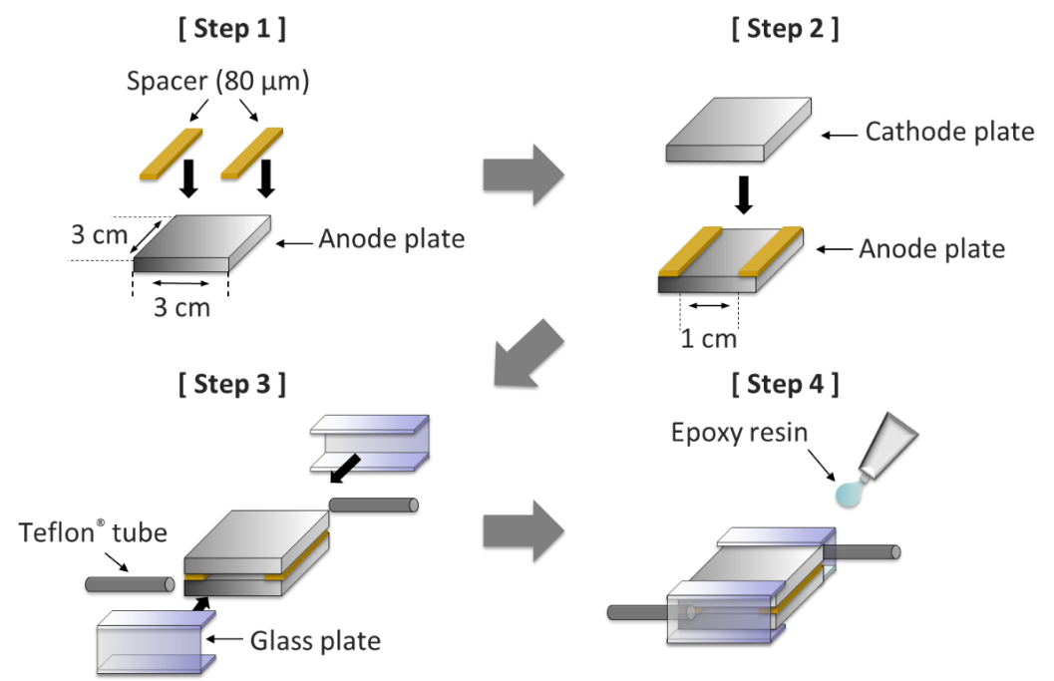

**Figure S1.** Schematic illustration of preparation procedure for the electrochemical flow microreactor.

**Computational Data**

Computation was carried out in the Gaussian 09 Program suite (7) at the B3LYP/6-31G(d) level of theory.

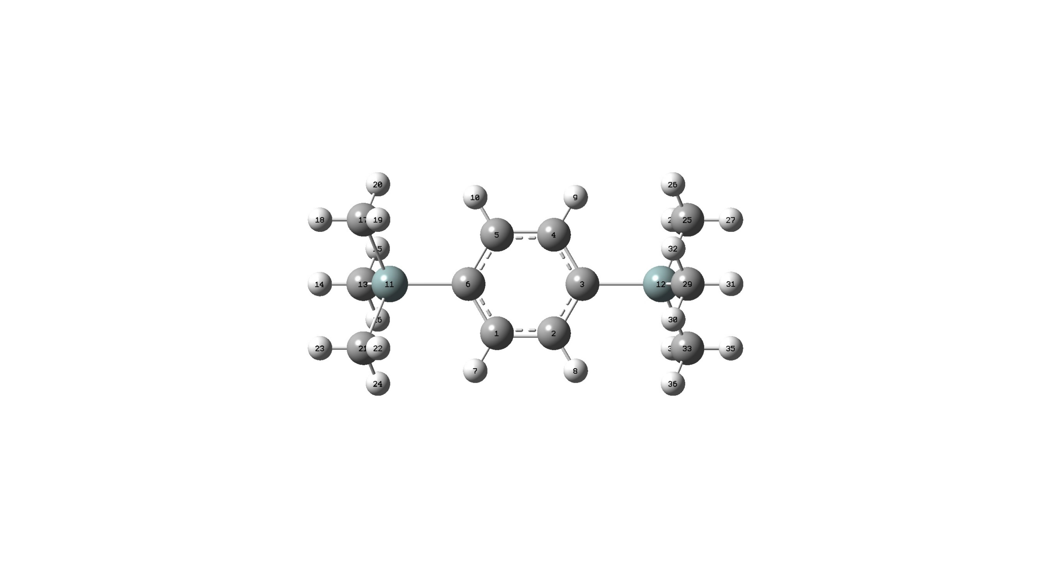**Table S1** B3LYP/6-31G(d) calculated mulliken charges and spin densities with hydrogens of 1,4-bis(trimethylsilyl)benzene radical cation summed into heavy atoms

|  |  |  |  |
| --- | --- | --- | --- |
| Label | Atom | Mulliken charges | Spin densities |
| 1 | C | 0.048445 | 0.022015 |
| 2 | C | 0.048458 | 0.022065 |
| 3 | C | -0.015823 | 0.364736 |
| 4 | C | 0.048445 | 0.022015 |
| 5 | C | 0.048458 | 0.022064 |
| 6 | C | -0.015823 | 0.364736 |
| 11 | Si | 0.688605 | -0.008061 |
| 12 | Si | 0.688606 | -0.008061 |
| 13 | C | -0.062503 | 0.087811 |
| 17 | C | -0.103588 | 0.005725 |
| 21 | C | -0.103594 | 0.00571 |
| 25 | C | -0.103594 | 0.00571 |
| 29 | C | -0.062503 | 0.087811 |
| 33 | C | -0.103588 | 0.005725 |

**13C-and 1H- NMR spectra**

Each raw data is set in csv data.



**Figure S2**. 13C-NMR spectrum of polyphenylene synthesized by electro-oxidative polymerization of 1,4-bis(trimethylsilyl)benzene and following desilylation procedure.



**Figure S3**. 1H-NMR spectrum of polyphenylene synthesized by electro-oxidative polymerization of 1,4-bis(trimethylsilyl)benzene and following desilylation procedure.